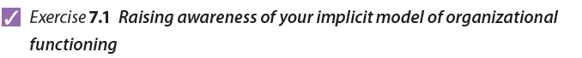
This exercise is based on a procedure for collaborative model building devised by Tichy and Hornstein (1980) and involves five steps. The first step requires you to prepare a short assessment of the current state of your organization. The next four steps involve reflecting on how you arrived at this assessment in order to tease out the main features of your implicit model of organizational functioning.
Step 1 Assess the current state of your organization
Prepare a short note that describes your organization (either the total organization or an important unit that you are familiar with) and assesses or diagnoses its current state. Make reference to the issues you feel require attention, which could be problems or opportunities. If you feel there is a need for some kind of change to ensure that these issues will be managed more effectively, justify this view.
Do not explain the kinds of interventions you think may be necessary to bring about any required changes. The aim of this exercise is to diagnose the current state of the organization (and assess whether it is and will continue to perform effectively), not to provide a prescription of actions required to improve matters.
Step 2 Identify the information you used to make this assessment
Think about the things you considered when making your assessment in the first step of this exercise. Identify and list the ‘kinds of information’ you attended to. Focus on the information you did actually attend to, rather than the information you think you ‘should’ have considered. If possible, identify at least 25 different entries and record them in the space provided in Table 7.2. Table 7.1 provides some examples of the types of information that people might attend to when assessing the state of their organization. These are only offered to stimulate your thinking; your own list may contain none of these.
Table 7.1 Example of the kind of information that might be attended to
Quality of boss-subordinate relationships | Production/operations systems | The way activities and staff are grouped together | Awareness of competitive threats
Effectiveness of coordinating mechanisms | Quality of communications | Level of commitment to the organization | Training and staff development
Knowledge and management | Reward systems | Costs | Inventory levels
Margins | Staff turnover | Customer satisfaction | Cash flows
The extent to which people feel challenged in their present jobs | Match between staff competences and task requirements | Extent to which staff understand the central purpose of the organization | Awareness of possible future sources of income/revenue
The way the business is financed | Attitudes towards quality assurance | The way conflicts are managed | Level of bureaucracy
Effectiveness of IT system | Number of levels in the hierarchy | Marketing procedures and policies | Management accounting systems

Table 7.2 Information you attended to
Click here to enter text. | Click here to enter text. | Click here to enter text. | Click here to enter text.
Click here to enter text. | Click here to enter text. | Click here to enter text. | Click here to enter text.
Click here to enter text. | Click here to enter text. | Click here to enter text. | Click here to enter text.
Click here to enter text. | Click here to enter text. | Click here to enter text. | Click here to enter text.
Click here to enter text. | Click here to enter text. | Click here to enter text. | Click here to enter text.
Click here to enter text. | Click here to enter text. | Click here to enter text. | Click here to enter text.
Click here to enter text. | Click here to enter text. | Click here to enter text. | Click here to enter text.
Click here to enter text. | Click here to enter text. | Click here to enter text. | Click here to enter text.
Click here to enter text. | Click here to enter text. | Click here to enter text. | Click here to enter text.

Step 3 Group related bits of information together
Some of the bits of information you used to make your assessment might be related, and it might be possible to group them together into some more inclusive categories that reflect the main elements of your subjective diagnostic model.
- Do this by grouping related kinds of information into the ‘element’ boxes provided below. Typically, people identify 4-12 elements, but there are no restrictions on the number of elements you might identify.
- When you have done this, describe the rationale you used for grouping together the different bits of information.
Name of element | Name of element
Items included:  Click here to enter text.  Rationale for grouping these bits of information together:  Click here to enter text. | Items included:  Click here to enter text.  Rationale for grouping these bits of information together:  Click here to enter text.

Name of element | Name of element
Items included:  Click here to enter text.  Rationale for grouping these bits of information together:  Click here to enter text. | Items included:  Click here to enter text.  Rationale for grouping these bits of information together:  Click here to enter text.

Name of element | Name of element
Items included:  Click here to enter text.  Rationale for grouping these bits of information together:  Click here to enter text. | Items included:  Click here to enter text.  Rationale for grouping these bits of information together:  Click here to enter text.

Name of element | Name of element
Items included:  Click here to enter text.  Rationale for grouping these bits of information together:  Click here to enter text. | Items included:  Click here to enter text.  Rationale for grouping these bits of information together:  Click here to enter text.

Use additional boxes if required.
Step 4 Specifying relationships between elements
Step 4 of the model-building process focuses on the interdependencies and causal relationships between the elements. These can be identified by considering whether a change in any one element will have an effect on any other element:
- Using the format of Table 7.3, list the elements (categories) identified in step 3 down the left-hand column and across the top of the table.
- Take each element down the left-hand column in turn and assess the impact a change in this element might have on every other element, using a three-point scale, where 0 = no or slight impact, 1 = moderate impact and 2 = high impact.
- Sum the scores for each row.
- Rank the scores (1 = highest). The rank order of the elements indicates your assessment of the key drivers of performance.
Note: Double click inside Table 7.3 to edit it.

Table 7.3 Interdependencies between elements

NB: Although elements might be interrelated and affect each other, one element, for example A, can have a greater effect on another, for example B, than vice versa. This is illustrated in Table 7.4, where element A has a high impact on element B (score = 2), but element B has only a moderate impact (score = 1) on element A.
Table 7.4 An example of a matrix of interdependencies
Elements | A | B | C | D | E | Sum | Rank
A | - |  | 1 | 0 | 2 | 5 | 2
B |  | - | 1 | 0 | 1 | 3 | 4
C | 0 | 1 | - | 0 | 1 | 2 | 5
D | 0 | 0 | 2 | - | 2 | 4 | 3
E | 2 | 1 | 1 | 2 | - | 6 | 1

Your implicit model can be represented diagrammatically:
- Draw a circle for each of the elements you identified in Table 7.1.
- Label each circle with the name of the element it represents.
- Draw lines between those elements that have a moderate or high impact on each other. Use a solid line to show a strong (high-impact) relationship between elements, with the arrowhead indicating the direction of a cause-and-effect relationship, and a dotted line to show a moderate link. Do not join elements that have only a slight or no impact on each other.
- Insert the rank order of each element to indicate its impact on other elements.
The model represented by Table 7.4 is presented diagrammatically in Figure 7.1.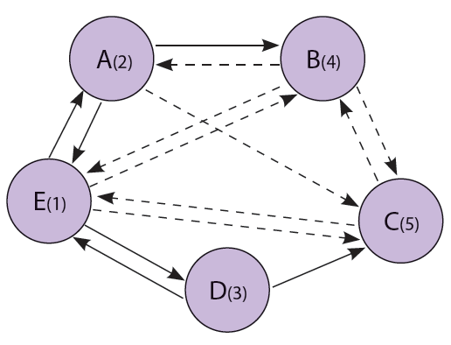
Figure 7.1 A casual map of a diagnostic model
Source: Adapted from Noel M. Tichy and Henry A. Hornstein. From ‘Collaborative model building’. In Organizational Assessment: Perspectives on the Measurement of Organizational Behaviour and the Quality of Work Life, page 311. Copyright © 1980 by John Wiley & Sons Inc.

