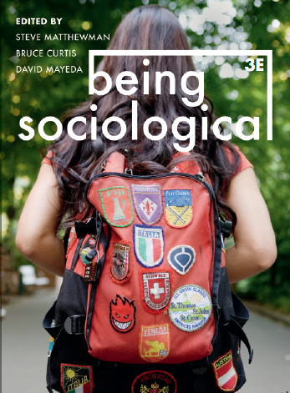**Suggested Weblinks**

**and**

**Extra Resources**

**Chapter 1: On Being Sociological**

Beautiful Solutions gathers the most promising and contagious strategies for building a more just, democratic and resilient world: https://solutions.thischangeseverything.org/

The Real Utopias Project explores a wide range of proposals and models for radical social change: https://www.ssc.wisc.edu/~wright/RealUtopias.htm#:~:text=The%20Real%20Utopias%20Project%2C%20begun,pragmatic%20problems%20of%20institutional%20design.

The American Sociological Association has an introductory glossary for sociology: https://www.asanet.org/sites/default/files/savvy/introtosociology/Documents/Glossary.html

Dr Zuleyka Zevallos' OTHER Sociologist includes some more current terms: https://othersociologist.com/sociology-glossary/

Everyday Sociology Blog: https://www.everydaysociologyblog.com/

The Society Pages: https://thesocietypages.org/ (Be sure to also check out Sociological Images)