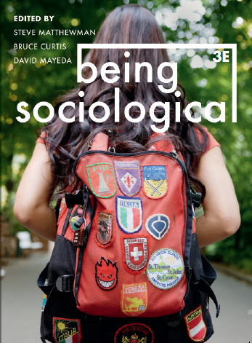**Suggested Weblinks**

**and**

**Extra Resources**

**Chapter 10: Gendering**

Gender & Society Blog: https://gendersociety.wordpress.com/blog/

Sex and Gender, Everyday Sociology Blog: https://www.everydaysociologyblog.com/sex_and_gender/

Me Too Movement: https://metoomvmt.org/

More info from Blackwell Encyclopedia of Sociology:

<http://www.sociologyencyclopedia.com/subscriber/tocnode.html?id=g9781405124331_chunk_g978140512433115_ss1-39>

Pointlessly Gendered Products, Reddit: https://www.reddit.com/r/pointlesslygendered/

‘Human Sexuality is Complicated’: https://www.youtube.com/watch?v=xXAoG8vAyzI

Judith Butler: Your Behavior Creates Your Gender:

<http://youtu.be/Bo7o2LYATDc>

Paul Fry, Queer Theory and Gender Performativity, Yale University Lecture: https://www.youtube.com/watch?v=7bkFlJfxyF0

Documentary, Sut Jhally - The Codes of Gender:

<http://vimeo.com/40682960>

Jennie Livingston, Paris Is Burning: http://www.imdb.com/title/tt0100332/

United Nations Sustainable Development Goals: Gender Equality: https://www.un.org/sustainabledevelopment/gender-equality/