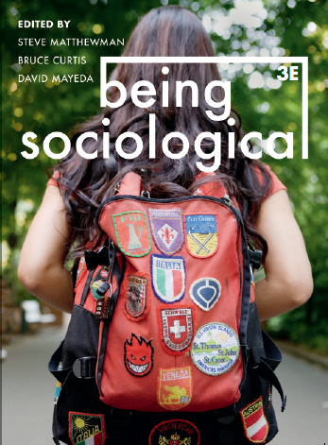**Suggested Weblinks**

**and**

**Extra Resources**

**Chapter 13: Believing**

Karen Armstrong, What is Religion? https://www.youtube.com/watch?v=Yp4ZaNpU-nY

Peter Kivisto, Sociology of Religion: https://www.youtube.com/watch?v=d9W0q6RqdV0

Ron McGivern, Religion, Introdution to Sociology: https://opentextbc.ca/introductiontosociology/chapter/chapter-15-religion/

Sociology of Religion Resources: https://www.sociologyofreligion.net/

Association for the Sociology of Religion, Links and Resources: https://www.sociologyofreligion.com/links-resources/

Richard Dawkins, 'Somebody as intelligent as Jesus would have been an atheist':

<https://www.youtube.com/watch?v=dQ5QG3MUTtg>

Peter Berger on the failure of the secularization hypothesis: https://www.youtube.com/watch?v=62zSU-U9GGE

Christine Tamir et al., The Global God Divide, Pew Research Centre: https://www.pewresearch.org/global/2020/07/20/the-global-god-divide/

Religion and Global Society, LSE Blog: https://blogs.lse.ac.uk/religionglobalsociety/