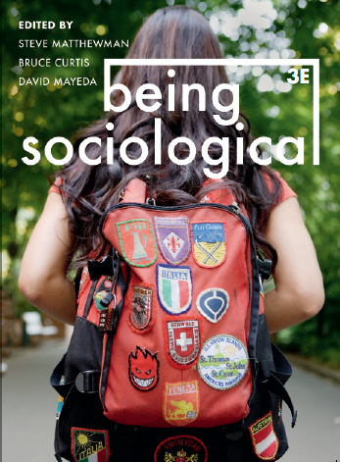**Suggested Weblinks**

**and**

**Extra Resources**

**Chapter 14: Educating**

What is education for and who decides?

Video: Student Protests at University of Auckland

<http://www.youtube.com/watch?feature=player_embedded&v=yWiYhoGGliQ>

* Who should be involved in the decision making process about the type of education and/or schooling for a specific community?
* Are there any groups in your country who reject the mainstream educational system? If so, what are their justifications?

The PSIA international study

Video: PISA - Measuring student success around the world

<http://www.youtube.com/watch?v=q1I9tuScLUA>

* What ideological presuppositions can you extrapolate from this video?
* Is education simply ‘the learning of skills’?
* What are the knowledge and skills necessary for full participation in society? How do we know that and who should decide?
* What are the reasons and imperfections of trying to impose a standard curriculum and qualifications worldwide?
* Given the results in 2009, what could the first four contexts (Shanghai, Korea, Finland and Hong Kong) have in common that could explain their success? Do you think the survey results can predict whether learners in these countries are better prepared to face future challenges than learners in other countries?

**Youtube video/documentary**

RSA Animate - Sir Ken Robinson - Changing Education Paradigms

<http://www.youtube.com/watch?v=zDZFcDGpL4U>

http://sirkenrobinson.com/skr/rsa-animate-changing-education-paradigms

Paulo Freire - An incredible conversation

<http://www.youtube.com/watch?v=aFWjnkFypFA>

Lecture Series- Jason Campbell - Paulo Freire Pedagogy of the Oppressed

<http://www.youtube.com/watch?v=DvHi328_mYI&NR=1&feature=fvwp>