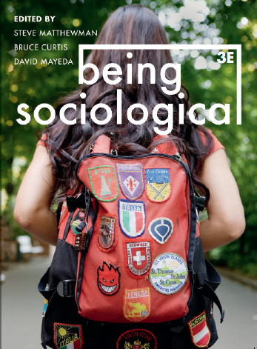**Suggested Weblinks**

**and**

**Extra Resources**

**Chapter 16: Communicating**

Shoshana Zuboff on Surveillance Capitalism: https://www.youtube.com/watch?v=hIXhnWUmMvw&vl=en

Cory Doctorow Interview, It's Monopolies, Not Surveillance: https://www.youtube.com/watch?v=Zy4VU5natys&feature=share

Manuel Castells, Power and Counter-power in Digital Society: https://www.youtube.com/watch?v=ZOIGzD7tmco&feature=share

Siva Vaidhyanathan, Antisocial Media: How Facebook Disconnects Us and Undermines Democracy: https://www.youtube.com/watch?v=5IpI6PCPE7c&feature=share

Safiya Umoja Noble, Algorithms of Oppression: https://www.youtube.com/watch?v=Q7yFysTBpAo&feature=share

Frank Pasquale on The Black Box Society: https://www.youtube.com/watch?v=f_PFhJrPxoU

Evgeny Morozov, Digital Capitalism: https://www.youtube.com/watch?v=nJ1W5_OQZLA&feature=youtu.be

Christian Fuchs, Raymond Williams’ Communicative Materialism: http://fuchs.uti.at/wp-content/RaymondWilliams_CommMat.pdf

Thomas M. Hanna and Matthew Lawrence, Ownership Futures: Towards Democratic Public Ownership in the 21st Century: https://uploads-ssl.webflow.com/5e2191f00f868d778b89ff85/5e4ac426585b238b0d40c5fb_CW_DPO_Ownership-Futures%20Final.pdf