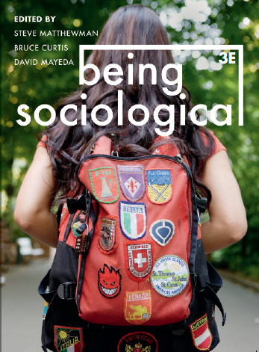**Suggested Weblinks**

**and**

**Extra Resources**

**Chapter 19: Mobilizing**

Social Movements That Changed Our World For The Better: https://www.globalcitizen.org/en/content/movements-social-change-apartheid-civil-rights-suf/

Mobilizing Ideas: https://mobilizingideas.wordpress.com/

Resources for Organising and Social Change: https://resourcesforsocialchange.org/

The Change Agency, Resources for Activists and Organisers: https://www.thechangeagency.org/campaigners-toolkit/links/resources-for-activists-and-organizers/

Global Justice Now, Activist Resources: https://www.globaljustice.org.uk/activist-resources

Social Movements and Social Change: https://opentextbc.ca/introductiontosociology/chapter/chapter21-social-movements-and-social-change/

How Online Social Movements Translate to Offline Results: https://www.youtube.com/watch?v=_DTOc1uMOIU

Nick Lee, Four Types of Social Movements: https://www.youtube.com/watch?v=U-uYfZkq5SA

A Spark of Hope: The Ongoing Lessons of the Zapatista Revolution 25 Years On: https://nacla.org/news/2019/01/18/spark-hope-ongoing-lessons-zapatista-revolution-25-years