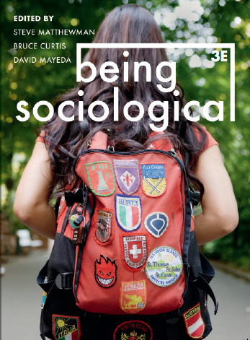**Suggested Weblinks**

**and**

**Extra Resources**

**Chapter 20: Impacting**

Simon L. Lewis and Mark A. Maslin, Defining the Anthropocene: https://www.nature.com/articles/nature14258

Verso, Welcome to the Anthropocene: A Reading List: https://www.versobooks.com/blogs/2502-welcome-to-the-anthropocene-a-reading-list

e-Waste Video: Greenpeace ‘Where does e-waste end up?’ https://www.youtube.com/watch?v=0JZey9GJQP0

Video: TED talks - Will Steffen - The Anthropocene:

<http://www.youtube.com/watch?v=ABZjlfhN0EQ>

Anthony Giddens on The Politics of Climate Change:

<http://www.youtube.com/watch?v=pe-NMGgWv-A>

Ulrich Beck, Living In and Coping with World Risk Society: https://www.youtube.com/watch?v=PeKiD5JLGIE

Slavoj Zizek: The Delusion of Green Capitalism

<http://www.youtube.com/watch?v=yzcfsq1_bt8>

RSA Animate - Slavoj Zizek - First as Tragedy, Then as Farce.

<http://www.youtube.com/watch?v=hpAMbpQ8J7g>

The Pacific Adaptation to Climate Change: Vital Water: Pacific Adaptation to Climate Change Tuvalu

<http://vimeo.com/43423877>