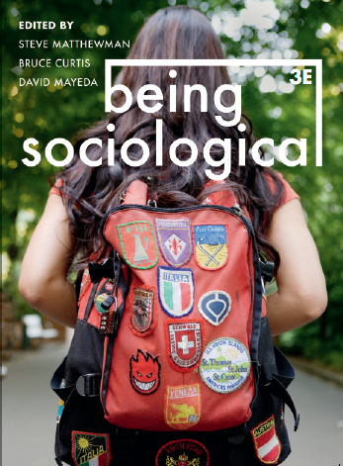**Suggested Weblinks**

**and**

**Extra Resources**

**Chapter 5: Urbanizing**

A Brief History of Urbanization (University of Minnesota): https://open.lib.umn.edu/socialproblems/chapter/14-1-a-brief-history-of-urbanization/

Cities and Urbanization (Everyday Sociology Blog): https://www.everydaysociologyblog.com/citites-and-urbanization/

Urban Life (Boundless Sociology): https://courses.lumenlearning.com/boundless-sociology/chapter/urban-life/

Urban Sociology Theories (York University): http://www.yorku.ca/lfoster/2006-07/sosi3830/lectures/URBAN_SOCIOLOGY_THEORIES.html

Fran Tonkiss, Divided Cities: Urban Inequalities in the 21st Century: https://www.youtube.com/watch?v=r4iXe5l4whY

The Right to the City (Urban Synergies Group): http://uploads.habitat3.org/hb3/file_58322.pdf

David Harvey, The Right to the City: https://davidharvey.org/media/righttothecity.pdf

Richard Sennett, Narratives of Inclusion:Can Cities Help us Live Together? https://www.youtube.com/watch?v=1p4Qxc6pMeo&list=PLYFWOmpZG818Cxuo_VMVmtQ_Yl1pPGBNR

Saskia Sassen, Owning the City: https://www.youtube.com/watch?v=qjK1VzaFzdA