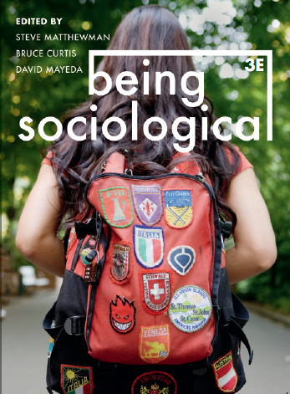**Suggested Weblinks**

**and**

**Extra Resources**

**Chapter 9: Racializing**

‘Racialization’

The term Racialization was coined by Michael Banton and John Rex. Racialization aims to explain how race, in conjunction with other factors like gender or class, shape our social existence. Effectively, it is examining the social construction of race.

It is argued that racialization is another process by which the global capitalist system organises and legitimates the inequitable allocation of resources, focussing on the way in which different ethnicities are privileged or marginalised to different degrees.

See: *Structural and Institutional Racism*, from Blackwell Encyclopedia of Sociology

<http://www.blackwellreference.com/subscriber/tocnode.html?id=g9781405124331_chunk_g978140512433124_ss1-13>

*‘The Social Construction of Race Explained’* - Norton Sociology.

<http://youtu.be/_qaWp8_z81w>

*‘Eminem 8 Mile Rap Battles’* from the film *8 Mile*. (Warning: Explicit Lyrics)

<http://youtu.be/uh9LGytJOHk>

* What does the excerpt from the film tell you about the willingness of minorities to accept someone from a different ethnicity?
* Do you think the same processes of adopting identities exists in New Zealand? What do you think about the interrelationship of Pakeha and Maori or Pakeha and Pacific Islanders for example?

*‘The Vilification of Arabs in Hollywood Movies’*

<http://thesocietypages.org/socimages/2010/12/31/the-vilification-of-arabs-in-hollywood-movies/>

* How do you think this affects Arabs in the long term?
* Do you think this will alter everyday perceptions of Arabs? Or is it mere entertainment and shouldn’t be taken seriously?
* When you think about events such as Richard Prosser’s racist rant, do you think that this racialization of strangers has played a part in views of this sort? (See: <http://www.stuff.co.nz/national/politics/8295162/Wogistan-MP-should-resign-Islamic-leader>)

*‘We Need To Talk About An Injustice’* - Bryan Stevenson

<http://on.ted.com/Stevenson>

“We have a system of justice in [the US] that treats you much better if you're rich and guilty than if you're poor and innocent. Wealth, not culpability, shapes outcomes.”

* Do you believe this statement is true? If so, what do you think about this fact?

Stevenson states that in too many countries, ‘the opposite of poverty is justice’.

* What does Stevenson mean by this? What does the interrelation of poverty and ethnicity therefore mean?
* Mechanisms such as Stevenson’s “Equal Justice Initiative”, are they a good way to challenge the systematic racial bias in places such as the criminal justice system?
* What is holding back these initiatives from being widely successful when people clearly enjoyed his talk?
* What other institutions do you think systematically disadvantage ethnic groups?
* Do you think that the status of Mr. Stevenson may undermine his viewpoints for some people; Can “exceptions” (such as Mr. Stevenson) to the disproportionate number of poor African-Americans be used to fuel neoliberal discourse?

**Online Content**

Stuart Hall:

Lecture: “Race, the Floating Signifier”

<http://youtu.be/bRk9MZvOd2c?t=2m14s>

All 7 parts are on YouTube.

Blogs:

*“NYPD’s Stop-and-Frisk Policy”*

<http://thesocietypages.org/socimages/2012/10/15/nypds-stop-and-frisk-policy/>

Watch the video included in the post too.

*“Gender, Race/Ethnicity, and the Pay Gap”*

<http://thesocietypages.org/socimages/2012/10/04/gender-raceethnicity-and-the-pay-gap/>

*“Another Look at Racial Violence After Katrina”*

<http://thesocietypages.org/socimages/2012/08/30/another-look-at-racial-violence-after-katrina/>

**Offline Material**

Documentaries:

*‘Central Park Five’* (2012)

<http://www.imdb.com/title/tt2380247/>

*‘The Interrupters’* (2012)

<http://www.imdb.com/title/tt1319744/>