Power Mapping Exercise

Introduction:
Many issues we are trying to change (e.g., reduction of greenhouse gases) are complex and are difficult to influence as an individual or even as a group of committed citizens. The important decisions are made by influential people with access to key leverage points within the system, such as politicians and executives. Thus, if we want to create meaningful change we need to be able to influence those key people who hold the power to make a difference. It is relatively easy for us to think about how to convince a friend to be greener but most of us don’t really know how to have an impact at these higher ecological levels. While the ecological model and system thinking will help with the conceptualization of these levels, power mapping is a useful tool to figure out how to influence different ecological levels by targeting key decision makers, which can be individuals or institutions. Below are general instructions for how to do power mapping. Please adapt these to the specific focus of a project you are working on.
Materials:

- White board, chalk board or flip chart papers (white boards or chalk boards are ideal because everyone can see them and you can change them as you go)
- Markers of different colours (enough different colours for all groups)
- Tape to hang up the completed maps on the wall

Overview:
Power mapping is a visual process tool that helps you determine who you want to try to influence in order to have the best chance possible of moving your cause forward. This could be a member of the city council, an executive director of a company, a religious institution, or any other person or institution who is an important stakeholder and has the power to influence key decisions on the issue that you are trying to address. For example, your city council is about to vote on a new initiative that will make it easier for people to purchase and install solar panels. The council is split on this issue and there are a couple of members in the council that are undecided. These two members would be a good target to influence so that they vote in favour of the initiative. Rather than trying to directly advocate with the members, power mapping will help you determine who you may know who has an influence on the decision maker. You will then take advantage of those connections. Power mapping will help you answer these types of questions:
- Who has the power to make the change you want, and is most vulnerable to the kinds of pressure you can mount?
- Who are your allies? Who could be your active supporters?
- How can we reach the people in power?
Your power map will change over the course of your action project as you have new ideas, meet new people, and strengthen connections. Every power map is different, but there are some common steps and elements that will help you to get your own map together. For the purpose of this exercise we organized this into six steps that are described in detail below (see Figure 1 for an overview).
Step by Step Instructions:

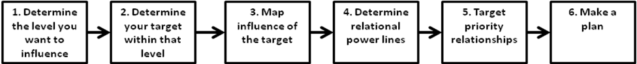
Figure 1: The 6 steps for power mapping exercise

Step 1: Determine the level you want to influence
A good way to consider the multiple levels of influence on an issue such as recycling or renewable energy is the ecological model. The ecological model (see Figure 2 below) was originally developed by Uri Bronfenbrenner to conceptualize and visualize the important contextual factors that influence the development of a child. By clearly identifying those factors one shifts from blaming the individual (which is always the easiest thing to do) to consider the contextual influences in a person’s life. The basic idea is that the individual is nested in a rich context which can be conceptually organized in multiple ecological layers or spheres. There is the immediate social context such as family, friends, teachers, coworkers and peers. Then, there is the organizational context which includes schools, religious groups, the work place etc. Then there is the layer of localities or communities, which could be your neighborhood, your local town, an online community, and many other things. Finally, there is the political and economic context such as laws, taxes and the economy. This also includes cultural norms and practices.

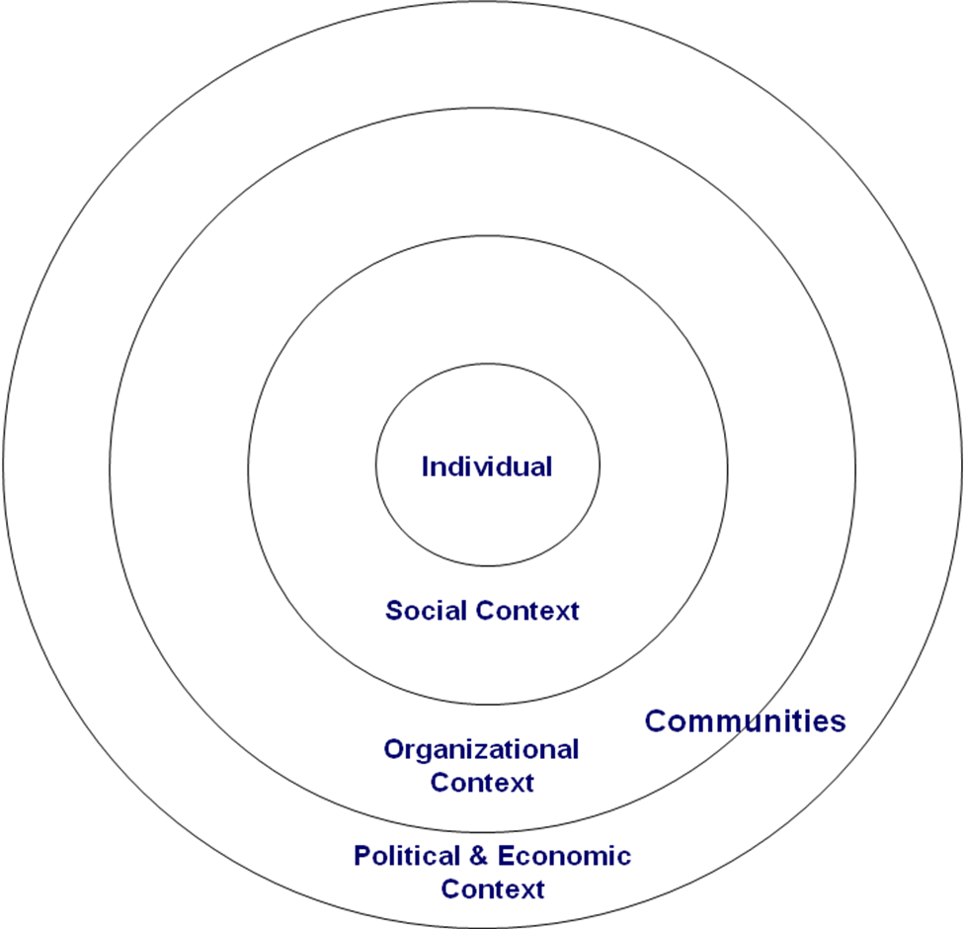

Figure 2: Ecological model

Example
Figure 3 below provides an example of the ecological model applied to the issue of promoting recycling. After the group who created this overview reviewed it, they decided that a key issue would be to make curb-side recycling available in their neighbourhood. That is, they wanted to influence the city to send trucks into their neighbourhood that would pick up the recycling directly in front of peoples’ houses. As a next step they were trying to identify who they needed to influence in order to make this happen, which leads us to the next step in this exercise.

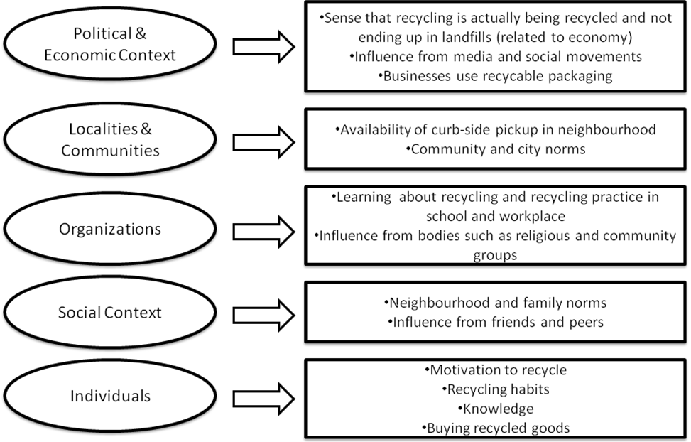

Figure 3: The ecological model applied to the issue of recycling

In order not to get paralyzed it is useful to focus on an achievable core goal in trying to address the larger issue. The core goal must be important to the community, linked to larger community issues, achievable with current resources, and agreed upon by the group. As an example, ending homelessness is not an achievable core goal (unless you have a lot of resources!); instead, focusing on improving access to existing services or working to change housing policy would be achievable and relevant to the same issue. Or, as in the example mentioned above, the group did not focus on recycling per se but on providing curb-side recycling in a specific neighbourhood.

Step 2: Determine the target

Once you have identified the operating ecological level and the specific core goal you can begin with developing the power map. This process starts with a person or institution you want to influence – the target. Who is the person or institution that can solve your problem or address your issue? Who can actually make the change that you want happen? In most cases these are decision makers or committees. For example, it could be the university president or senate. If you have a few potential targets, research all of them to determine who holds the most decision-making power, and who you are most likely to move or influence. In some cases it may be difficult or not very effective to focus on just one person or institution. In that case, you can place the core goal into the centre of the power map.

Example
In the recycling example above, the group determined that it was the city council that would have the ultimate decision about which neighbourhoods would receive curb-side recycling. They did some research online and learned that the best way to get the council to vote on issues like this is having a member sponsor the initiative. Next, they determined who within the council would most likely support their initiative but at the same time is also influential in regard to the other council members. Based on this research they decided that their target will be council member Tequisha Moza. This target will be at the center of the map (see Figure 4 below).

Step 3: Map influence of the target

Next, you brainstorm the people or groups who can influence your target. These are the people, organizations, and groups who are either associated with your target (e.g., business partners and work colleagues) or who have a stake in the issue and might become allies in your attempt to influence the target and work toward your goal (e.g., an existing advocacy group).

As you brainstorm, keep these things in mind:
- Think broadly of all the associations that have a relationship with the target. These can include work, political, family, religious, and neighborhood ties. Anyone who can exert influence on this individual should be mapped.
- Be creative. Even if you decide you do not want to target a person or group, for example, the council member's family, putting them on the list might give you ideas on other avenues of influence.
- Be strategic. Elected officials are fun to brainstorm about—look at all the major donors and constituency groups they have interacted with in the past, are currently interacting with, and are likely to interact with in the future.
- Be thorough. Think about your target from every different angle. Once you are satisfied, start thinking about who these people and institutions are connected to. A good power map will have major influences mapped out, as well as many sub-categories of influence as shown in Figure 5 below.

Figure 4: Example of a power map
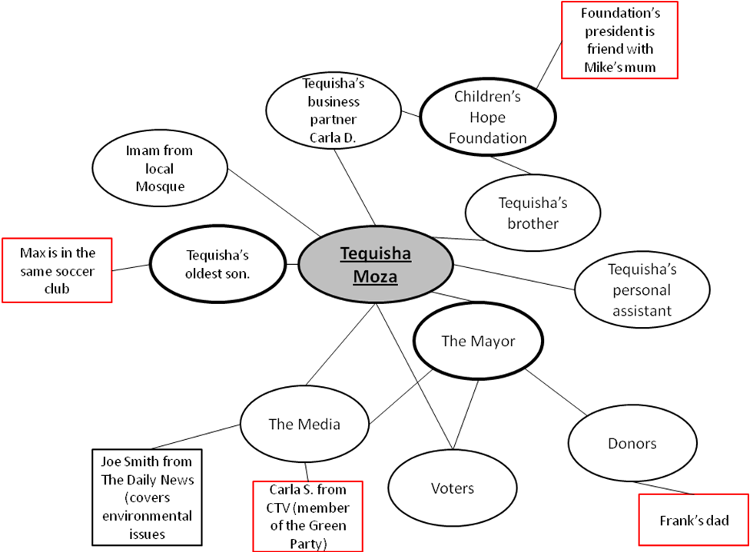

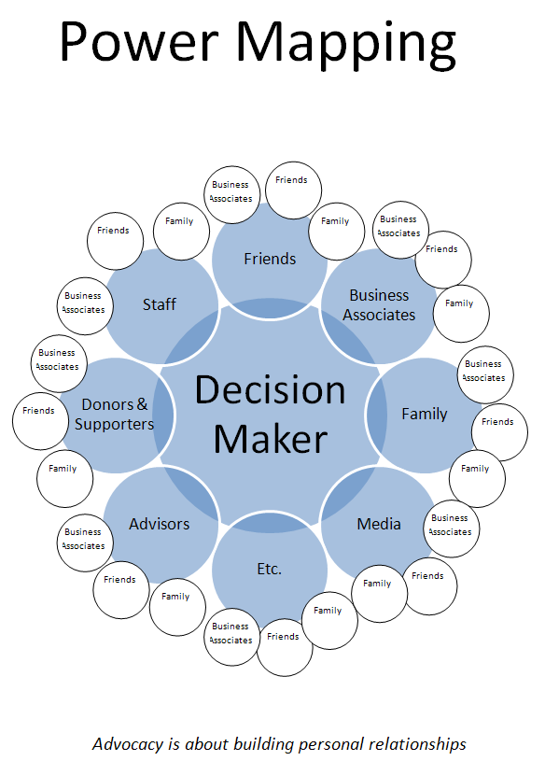
Figure 5: Spheres of influence
(from: http://mobikefed.org/content/advocacy-101-power-mapping-key-effective-advocacy)

Below is a list of possible people, organizations and groups you can consider including in your power map. This list is not meant to be exhaustive.
- Small-business owners
- Donors
- Students
- Parents
- Teachers
- People directly impacted by the issue you're working on (e.g., neighborhood associations)
- Organizations that represent voters (e.g., AARP, Democratic clubs and unions)
- Organizations with political capital (e.g., they helped elect the target)
- Chamber of Commerce and other business institutions
- Media outlets
- Celebrities
- Elected officials
- Stockholders and board members of companies
- Faculty and administrators at local colleges and universities
- Organizations impacted by the campaign issue
- Clergy and religious leaders
- Churches, synagogues, mosques, and other religious institutions
- Parent Teacher Associations and school boards
- Community and social justice organizations
Then you start drawing the actual map (see Figure 4 for an example). Write the target in the middle and put a circle around it (remember this can be a person or the specific goal you are pursuing). Then write each of the identified individuals, organizations and groups next to the circle with the target. Draw a circle around each. Distribute these around the centre so that they form a circle around the target. Connect each one with the target through a line. You can place individuals or groups with higher influence on the target close to the target and those with less influence further out. Each of the circles is considered a node in the power network of your target.

If you identified organizations or groups rather than individuals, you will need to identify specific people connected to those organizations or groups. Ideally these are people that members of your groups know. This can be done with different colors or extra nodes. Do whatever makes sense and works for you – as long as you remember what your method is.

Example
The group identified a few people and organizations that are either directly or indirectly connected to council member Tequisha Moza. Each of them represents a node represented as a circle or a box in the map below.

Step 4: Determine relational power lines

Once you have established who is connected to the target, take a step back and review your map. There may be some people who are not only connected to your target, but also to each other. For example, they all belong to the same fundraising organization. These clusters of power might be a good way to get to the target. This is true even if the target is not directly connected to that organization, but people closely affiliated, such as a family member or a good friend, are. A member of your group might be directly related to one of the clustered. For example, one of you is also an active member of the same fundraising organization.

Example
The group found that both Ms. Moza’s brother and her business partner are part of the Children’s Hope Foundation. The foundation’s office is in the same neighbourhood as the one that the group is trying to get curbside recycling for. As it turns out, the mother of group member Mike is a close friend with the president of that organization. They have dinner together once a month. A good opportunity to talk about the group that her son Mike has been involved in ...

Step 5: Target priority relationships

In certain circumstances there could be quite a bit of people on your map. Many of those will not be very useful to you because you either have no connection to them, they are not very influential or they would not support your cause. Thus, an important next step is to prioritize. You need to decide who the most influential actors are and who will be most likely to help. If you are lucky, some people will be both! You can be creative how you want to identify these people. You can use different colours, for example, and circle the ones your group has already connections to. These are likely the ones that will help you. If you don’t have any direct links, you may want to think about indirect links and add those to the power map. For example, you might know the daughter of the mayor who in turn has a direct connection to the target. You can use a different colour to identify those who are very influential, if you did not already drew them closer to the target as suggested above. People can be influential either because they have strong direct connection to the target, because they are connected to the target in multiple ways or because they hold some form of power over the target. In the end, you want to come up with just a few people that you will approach about influencing your target and supporting your goal. These will be your allies.

Example
Based on their power map and some intensive discussions, the group decided to win the president of the Children’s Hope Foundation, Frank’s dad (Frank is another member of the group), Tequisha’s oldest son, and Carla S. from CTV as allies for their cause.

Step 6: Make a plan

The power map is just a first step in how to work toward your goal and it is likely to change a few times as you start your action. Next, it is important to develop a plan for action. There are few things that can help with this:

- Write an elevator speech. An elevator speech is a short statement of purpose to convey your core goals to potential collaborators, focusing on what their role might be. The name comes from trying to get your point across to someone during an elevator ride. The elevator speech should be concise, positive, and should show advantages to everyone involved (your group, the community, the potential collaborator).
- Develop a strategic plan. You need to decide who in your group is contacting whom with what objective. A timeline might also be helpful to ensure you have the support needed in the time that is required (e.g., before a council meeting).
- Set up one-to-ones. A one-to -one is a meeting between one of the group members and the identified people on your power map. The point of the meeting is to link the self-interest of the person on the map with the goals of your project. This should be about 30 minutes and should expand on your elevator speech. Try to anticipate the self-interest of the person and quickly work to establish it further in the one-to-one. This can be done by asking questions about their work and why they do it. It can also be done by connecting your motivation and story to theirs. The one-to-one is part conversation and part interview. You should leave with a commitment from the person to become involved in the project in a meaningful way or to support your cause with the target person. You should also leave with more connections from your power map. If they can't become involved, ask them who they think would want to get on board. If you can't leave with a new supporter, leave with new contacts to find another collaborator.
Note: To set up a one-to-one, you will likely need to email, call, or quickly meet the person to convince them they should give up their time. This is the perfect time to use the elevator speech. Get them interested and get your foot in the door. If you must, arrange a phone meeting, but in-person meetings are always best. You may also want to post fliers or send out emails to lists to recruit people to your group.

Example
The group developed a half-page elevator speech together and decided that Frank will talk to his dad, Mike to his mum, Max to Tequisha’s son, and Maria would approach Carla S. from CTV. They goal was to have the support together before the next council meeting which was scheduled four weeks later.

Tips:
- Create sustainable relationships. Who is going to be able to continue this project over the long term?
- Reciprocity. How can everyone involved help each other?
- Continuously evaluate progress. What have you learned from your action and your one-to-ones?
- Utilize group members’ knowledge of community, relationships, expertise, and area of study.
- Reassess! Don't be afraid to change your goal or connections if they aren't working.

Credit and Resources

Besides the input from my collaborator and friend Dr. Courte Voorhees, the following helpful online references were used to create this exercise. You may find them also to be useful resources.

http://www.moveon.org/team/campaigns/powermap.html
http://www.moveon.org/team/campaigns/GuideToPowerMapping.pdf
http://phrtoolkits.org/toolkits/student-chapter-toolkit/advocacy-and-education/advocacy/
http://mobikefed.org/content/advocacy-101-power-mapping-key-effective-advocacy

