Chapter 3: Common Defects in Buildings

3.1 Origins and mechanisms of defects …………………………………………….2
3.2 Analysis of Defects ……………………………………………………………..4
3.3 Substructure defects …………………………………………………………….5
3.4 Defects in walls, claddings and frames …………………………………………7
3.5 Roof Defects ……………………………………………………………………10
3.6 Defects in Floors ………………………………………………………………..11
3.7 Timber Defects ………………………………………………………………….12
3.8 Dampness in walls ………………………………………………………………17

Note: Answers to review tasks are coloured blue

3.1 Origins and mechanisms of defects
Reflective Summary
- The true origins of building defects can often be confused due to the wide range of potential failures
- The origins of defects can be categorised into three broad groupings; failure of materials, design defect and workmanship error.
- The distinction between an element which has failed prematurely and one which is simply 'worn out' is rather academic, since both will produce the same end result ie. a failed building element.
- Effective remedial action relies on having a clear understanding of defect origin
- The owner and/or occupier of a building is likely to be more concerned with the immediate effects of the defect, rather than its origin.
- The effects of defects in the fabric and structure of a building can be considered within a number of categories
- Most of the buildings which survive today were constructed from the industrial revolution onwards.
- The long-term performance of buildings is dependent upon a variety of factors
- Buildings are required to fulfil a variety of functions in order to be considered as satisfactory
Review Task
Outline the categories within which the effects of defects in the fabric and structure of buildings can be considered
Origins of Defects | Examples of Defects
Material failure or component failure | Deterioration of finishes such as paintSulphate Attack of Ordinary Portland Cement in Walls & FloorsMetal Fatigue of in FixingsSpalling of clay brickworkFailure of bitument felt roofing
Workmanship Failure | Joint SealsDPC LapsManufacturing FaultsAbsence or incorrect use of fixings and restraints
Design Failure | Tolerance FaultsMaterial Combinations and Aggressive EffectsDifficult Weatherproofing DetailsInsufficient sizing of structural elements
External Agencies | Impact Damage from VehiclesVandalismArson
Wear and Tear | Natural Degradation of Materials
List the functions that buildings need to provide in order for them to be considered as satisfactory
Generally buildings are considered to be required to provide a set of functions that combine to make them acceptable. Should any or all of these areas fall below standarda they may be considered as unsatisfactory: These will include:
Structural stability
Durability
Exclusion of moisture
Thermal insulation
Acoustic insulation
Environmental moderation

3.2 Analysis of Defects
Reflective Summary
- The analysis of defects will obviously be affected by the structural form of the building being examined but there can be a uniform methodology for defect analysis which takes these forms into account.
- There has been much research relating to the analysis and rectification of defcts and there is a vast array of publications from sources such as the Building Research Establishment and the Royal Institution of Chartered Surveyors relating to possible methodologies.:
Review Task
Outline a typical structured methodology that will enable a detailed examination and analysis of defects to be undertaken
A commonly accepted methodology is as follows:
Broad brush appraisal of condition.: general familiarisation with the building form and structure, assessment of the general state of condition of the building. This allows the specific defect and its analysis to be placed in context
Monitoring of specific defects: some defects are dynamic in nature and it is useful to initiate a programme of monitoring to ensure that the state of defect 'activity' can be confirmed. There is little point in undertaking work to rectify a defect that is dormant.
Collation of overall survey results: bringing together information from the broad brush assessment and the monitoring exercise will allow the generation of a realistic view of the condition of a building and the possible linkages between apparently independent defects.
Detailed further inspection of problem areas: the foregoing stages will normally give indications of specific areas that need to be given more detailed attention. This may include exposure of areas of the building fabric and structure, specific specialist tests and detailed localised examination.
Analysis of specific failures: having identified the defects specifically a processof analysis is required to identify the true cause if the problem and to allow selection of appropriate remedial action.
With the adoption of such a structured methodology the detailed examination and analysis of defects will be possible in a wide range of buildings and relating to a wide range of building elements.

3.3 Substructure defects
Reflective Summary
- Subsidence occurs to buildings when the loads applied exceed the bearing capacity of the ground.
- The effect of subsidence is not normally uniform throughout an entire building
- Generally subsidence cracking will be present in a recognisable pattern rather than as individual, isolated cracks
- Heave results from the expansion of the ground beneath the building and its symptoms are the same as those of subsidence, but in reverse.
- All new structures settle a little in the period following construction, although this should be limited to slight movement over a fixed period and the building should not continue to move.
Review Task
Compile a matrix to compare the causes, effects and identification of subsidence and heave
 | Settlement | Heave
Causes | loads applied exceed the bearing capacity of the ground. This may be as a result of insufficient foundations, poor ground strength or localised issues such as leaking drains | expansion of the ground beneath the building.
Symptoms | CRACKING MAY APPEAR AS SHEAR CRACKING IF VERTICAL MOVEMENT ONLY IS PRESENT  TAPERED CRACKS MAY BE VISIBLE IF ROTATION HAS OCCURRED  TAPERED CRACKS MAY BE WIDER AT TOP THAN BOTTOM DEPENDING ON MODE OF BUILDING FAILURE  UPSETTING OF ROOF AND COVERINGS MOVEMENT BETWEEN CLADDING AND BRICKWORK  SETTLEMENT OF SURROUNDING AREAS SUCH AS PAVING AND HARD-STANDING  INTERNAL CRACKS AT CEILING/WALL JUNCTIONS ON SETTLED WALLS  DROPPED HEADS TO OPENINGS  DOOR AND WINDOW OPENINGS OUT OF SQUARE  TWISTING OF WALLS DUE TO ROTATION OF FOUNDATIONS | symptoms are the same as those of settlement, but in reverse.

3.4 Defects in walls, claddings and frames
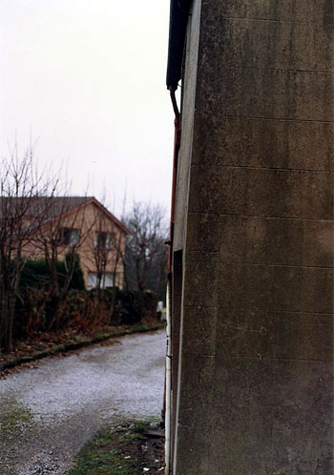
Here we see a deformed wall section that has resulted from the absence of sufficient lateral restraint in the building structure. Such deformation is normally arrested by the use of steel restraint fixings tying the external wall to internal floors or walls.

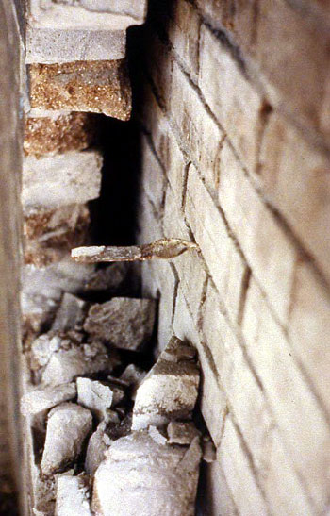
Here we see a twisted steel wall tie that is suffering from corrosion to the section embedded in the outer leaf

Reflective summary
- The vast range of cladding and walling options makes it impossible to consider each variant individually
- The majority of defects afflicting masonry walls are associated with some form of cracking..
- Typical forms of cracking found in buildings tensile cracking,
compressive cracking, shear cracking and tapered cracking
- Most building materials are subject to dimensional variations under the effects of changes in ambient thermal and moisture levels.
- The movements which are experienced within masonry external wall and cladding components are likely to result in the occurrence of cracking due to shrinking or expansion, or buckling due to constrained expansion of localised materials.
- In framed construction there is little likelihood of defects associated with failed beams and supports occurring as the frames are based upon detailed calculations.
- In older buildings, in which softer lime mortars were used it is often the case that although movement has taken place there will be no visible cracking as the soft mortar is capable of accommodating the movement.
- A common defect in framed buildings, is the failure to include sufficient numbers of ties or restraint fixings during construction.
- Materials containing ordinary Portland cement can suffer from aggressive action of soluble sulphates which affect the structure of the material.
- One of the most common causes of defects in cladding is the occurrence of differential movement between elements of the structure and fabric
Review Task
Outline the main reasons for defects occurring in building frames.
Assembly problems
The requirement for a degree of tolerance in the position of connections and fixings can sometimes lead to mis-aligned connections and difficulties in ensuring that all fixings are secure.
Creep in concrete frames
In the period after construction concrete frames undergo a process of 'relaxation' which results in 'creep' or shortening of the frame.
Corrosion of reinforcement
In some situations there can be major problems associated with the deterioration and degradation of the frame as a consequence of corrosion of the reinforcing steel.
List the causes of the following in masonry walls
a.tensile cracking
Dimensional change of materials due to moisture/temperature changes
b.compressive cracking
Overloading of wall sections
Localised overloading of sections
Dimensional change of materials due to moisture/temperature changes
c.shear cracking
Failure of narrow wall sections
Differential movement between adjacent components
d.tapered cracking
Settlement/heave causing rotation of sections of the building

3.5 Roof Defects
Reflective Summary
- The roofs utilised in the construction of commercial and industrial premises tend to be restricted to two types those being flat roofs and low pitch roof
- Modern flat roof design has been largely successful in eradicating the large scale flat roof failures of the past
- Many cases of apparent 'roof leak' are associated with problems at junctions and within external walls
- When first introduced, profiled metal roofing tended to adopt site assembly details which combined traditional construction materials such as timber spacers and battens with the external cladding sheets and internal linings.
- Defects in this form of roof cladding tend to be associated with moisture penetration or more commonly condensation resulting in moisture presence internally.
Review Task
List the most common causes of defects in flat roofs
Ponding due to insufficient gradient
Poor edge detailing
Differential movement
UV Radiation
Entrapped moisture

3.6 Defects in Floors
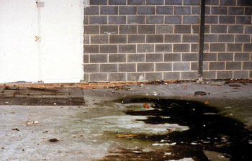
The exposed section of brickwork to the centre of this photo illustrates the degree to which the floor has suffered structural movement in this industrial building.

Reflective Summary
- There are numerous defects associated with floors to buildings and the nature of the defects will vary depending upon the construction form of the floor.
- Typical defects in concrete floors may include the following: Surface abrasion, surface crazing, structural movement, curling of screeds and sulphate attack
Review Task
Explain the causes of common defects in concrete floors
Surface abrasion:
Surface crazing
Structural movement
Curling of screeds
Sulphate attack

3.7 Timber Defects
Examples of dry rot are seen here. Note the presence of mycelium, the changed appearance of the surface of the wood, reflecting hollowness and the large fruiting body which is releasing spores into the air (seen as copper dust settling on the skirting board)
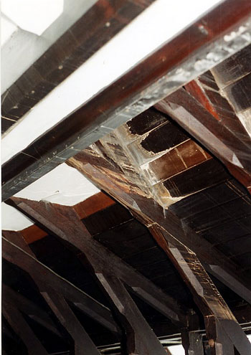
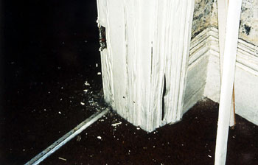
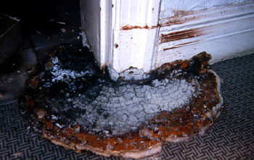
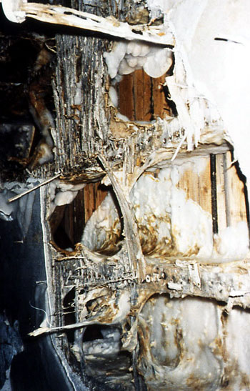
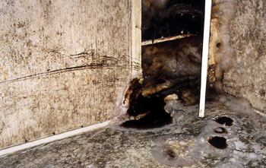
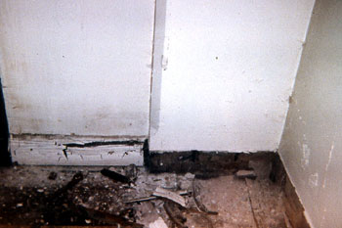
Dry Rot Examples

Reflective summary
- Timber is an inherently durable material and is resistant to most forms of degradation if maintained in a dry condition.
- The effects on timber arising from the attack of fungi and insects range from total physical deterioration to simple staining
- There are several forms of fungus which can affect timber in buildings, but which may not necessarily cause wood 'rot'
- The fungal attack of timber in buildings can be split into two generic groups; Wet Rots and Dry Rot.
- The identifiable characteristics of different fungus types are linked to their life cycle and the stages of development which they undergo.
- There are two main categories of rot: brown and white
- Within the category of brown rots is undoubtedly the most serious form of fungal attack, dry rot
- As in the case of fungal attack, the extent of damage caused by insect attack, and the level of remedial action necessary, is variable
- As in the case of fungal attack on timber the identifiable characteristics of insect species are linked with their life cycle
Review Task
Produce a matrix to compare the causes, features, identification methods and remedies of dry rot and wet rot
 | Dry Rot | Wet Rot
Symptoms | Loss of strength, disintegration or softening of the wood  Discolouration of the affected area  Presence of mycelium strands and fruiting bodies  Musty smell  Hollow sound when struck  Cross-grain cracking | Loss of strength, softening of the wood  Discolouration of the affected area  Fibrous appearance of wood and sometimes cross-grain cracking
Causes | Moisture presence in combination with lack of ventilation and fungal spores | Moisture presence in combination fungal spores
Remedies
List the most common types of insect attack on timber, and explain how and when insect attack is likely
Insects of different species will favour different forms of wood, hardwoods or softwoods etc. Other will tend to infest only wood which is already affected by fungal attack.
Insect infestation will typically produce the following symptoms:
- Flight holes at the surface of the timber
- Bore dust in surrounding areas
- Insect Frass
- Presence of larvae
- Fungal Attack
The types of insect found in buildings will fall into one of three categories defined by the level of treatment required to prevent deterioration of the timber as follows:
- Insecticidal treatment is required (Insects in this category include Common furniture beetle or 'woodworm' (Anobium punctatum), House Longhorn beetle (Hylotrupes bajalus) and Powder post beetle (Lyctus brenneus)
- Treatment is required to control an associated fungal attack (Insects in this category include- Wood-boring weevils and Wharf borers)
- No treatment is required (insects in this category include bark borers and wood wasps)

3.8 Dampness in walls
Reflective Summary
- The penetration of moisture to the interior of a building can lead to significant deterioration of the building structure and fabric.
- The existence of moisture or dampness in walls is one of the most common and potentially damaging building defects encountered.
- In general we can consider moisture in the walls of a building under four broad headings:
  - a. Rising damp
  - b. Penetrating damp
  - c. Condensation
  - d. Entrapped moisture
- The occurrence of rising damp is generally associated with older properties of traditional construction.
- In such properties it may well be the case that there was no effective damp-proof course installed in the original construction.
- The occurrence of penetrating damp is highly dependent upon the levels of exposure of the building
- Condensation on surfaces is sometimes mistaken for rising or penetrating damp, but is distinguished by being limited to the surface of the affected material
- The shift towards dry processes has alleviated the problem of entrapped moisture to a large extent
Review Task
List the main causes of damp in buildings and detail how the occurrence of damp can be avoided when constructing new buildings
Rising Damp
Causes of rising damp
The occurrence of rising damp is generally associated with older properties of traditional construction. In such properties it may well be the case that there was no effective damp-proof course installed in the original construction.
Examples of other potential causes of rising damp include:
- By-passing of the DPC caused by bridging internally by a porous floor screed
- By-passing of the DPC externally by raised paths, planting borders etc
- By-passing of the DPC with external render coating
- Rain splashing on the external ground and passing above the DPC level
- Build-up of debris in a cavity allowing by-passing of the DPC
- Failure to link the DPC with the impervious membrane or DPM in adjacent solid floors.
Penetrating Damp
The occurrence of penetrating damp is highly dependent upon the levels of exposure of the building and it is often the case that moisture penetration occurs only on certain areas or elevations of the building.
Some typical examples of reasons for penetrating dampness include:
- Rain driving through exposed masonry walls that have insufficient thickness to resist the passage of water to the interior
- Problems associated with cavity trays in cavity walls
- Failure of joints in cladding systems
- Failure of rendered finishes
- Leakage of externally mounted rainwater goods
- Saturation of inappropriate insulation material in cavity walls
Condensation
It is often the case that the internal environment of a building is warmer than the external environment. As such the air within the building will hold greater levels of moisture vapour before reaching saturation.
Entrapped moisture
The construction process has traditionally relied on the use of 'wet trades' such as plastering and concreting, which introduce high levels of water into the building during construction. In the period following construction there will be a natural drying process and this may take a considerable period of time before all of the construction moisture is removed from the building fabric.

