**Chapter 4: Common Refurbishment Technologies**

4.1 Underpinning ………………………………………………………………….. 2

4.2 Waterproofing of Basements ………………………………………………….. 4

4.3 Façade retention ………………………………………………………………. 6

4.4 Overcladding ………………………………………………………………….. 10

4.5 Over roofing and Re-roofing ……………………………………………......... 15

4.6 Upgrading and retrofit of building services …………………………………… 17

4.7 Remedying Dampness ………………………………………………………… 20

4.8 Repairs to masonry ……………………………………………………………. 22

4.9 Treatment of timber defects …………………………………………………… 23

***Note: Answers to review tasks are coloured blue***

**4.1 Underpinning**

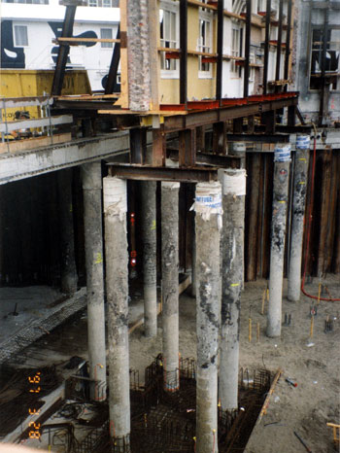

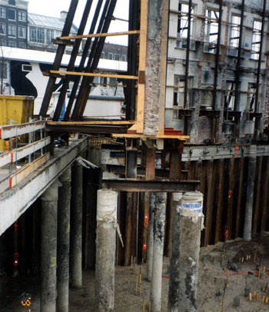

Above we see steel UB sections spanning between pairs of piles to act as underpinning to an existing wall whilst the construction of a basement takes place. This is in conjunction with a façade retention scheme in this instance.

**Reflective Summary**

* The main reason why underpinning is used is because of subsidence
* Underpinning may be undertaken for the whole or part(s) of buildings
* The systems used for underpinning are largely the same for domestic buildings and large span, high rise commercial and industrial buildings, only on a larger scale
* Underpinning is very expensive and costs increase if there is damage to the interior of a building and/or building occupiers have to relocate whilst the work is being undertaken
* The main systems use for underpinning are:  
  1. Mass concrete  
  2. Pier and beam  
  3. Piles  
  4. Pile and beams
* Very competent contractors and designers are required for underpinning works

**Review Task**  
  
Produce sketch details of:  
a. Mass concrete underpinning  
b. Pier and Beam underpinning   
  
  
  
What are the three most common pile-underpinning systems? List the advantages and disadvantages of these systems.  
  
In pile underpinning, piles are installed either:

* At each side of the wall
* By one side of the wall-
* Inclined at both sides of the wall-

The advantage of piled systems is that no excavation of soil is required and therefore there is less chance of a collapse whilst the work is being undertaken.   
The use of pies ate each side of the wall ensures consistency of load and balance across the structure, however access to the building interior is required which will be disruptive.  
The advantage of using the cantilever system (one side of the wall) is that no work is required within the building and therefore there will be little remedial work required inside the building. This will reduce costs and may also mean that the building can remain occupied whilst work is ongoing.   
The use of inclined piles removes the need to break into existing brickwork in order to install a beam. Piles are drilled through the existing foundations and slab and take over the role of the existing foundation and slab support. The brickwork should remain intact and there will be little evidence of the work being undertaken.  
**4.2 Waterproofing of Basements**  
  
  
**Reflective Summary**

* There are many older buildings including domestic properties that have basements, but they tend to have problems with damp.
* Existing basements are already constructed and therefore it is either not possible or would be very costly and difficult to waterproof them externally and would require extensive excavation to the outside of the building.
* All of the works required for damp proofing existing basements need to be carried out internally.
* Issues that need to be considered before the decision to waterproof is made include the ability of the basement to achieve the required thermal performance, ventilation options for the basement and the potential problems that could occur regarding condensation.
* Before any damp proofing work is specified, the cause of existing damp needs to be identified.
* The use of waterproofing systems is not suitable if the main cause of damp in basements is leaking pipes or condensation.
* Basement damproofing systems include drained cavities, mastic asphalt, cementitious render, self adhesive membranes, liquid applied membranes and ventilated dry linings
* Special attention needs to be given to the details at reveals, thresholds, partitions, ceilings and at points where services are fixed to ensure that these do not become weak points that will encourage localised water seepage in waterproofed basements.

**Review Task**  
  
Produce a comparative study matrix for different systems that can be used to waterproof basements, and compare each system against the following criteria:  
1. Durability  
2. Potential for use where high water table  
3. Skill levels required for installation  
4. Space penalty  
5. Health and Safety issues

|  |  |
| --- | --- |
| **Description** | **Details** |
| Bonded sheet membranes | Durable  Possible problems internal with high water table due to need to apply to dry surface  Medium skill level  Space penalty associated with protective inner wall  Health and safety issues with volatile bonding agents and cutting |
| Cavity drain membranes | Durable  Possible problem with high water table due to need to remove high levels of water  Medium skill level  Space penalty associated with protective inner wall  Health and safety issues with volatile bonding agents and cutting |
| Liquid applied membranes | Durability still to be proven  Possible problem with high water table due to need to apply to dry surface  Low skill level  No space penalty Health and safety issues with volatile bonding agents |
| Mastic asphalt membranes | Durable  Possible problems internally with high water table due to need to apply to dry surface  High skill level  Space penalty associated with protective inner wall  Health and safety issues with volatile agents and working with hot materials |
| Cementitious renders and toppings | Durable  Possible problems internally with high water table due to need to apply to dry surface  High skill level  Little space penalty Health and safety issues low |

**4.3 Façade retention**

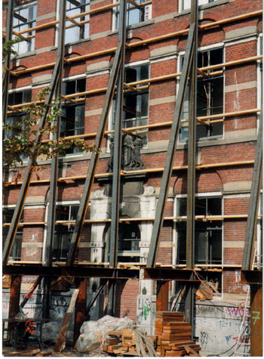

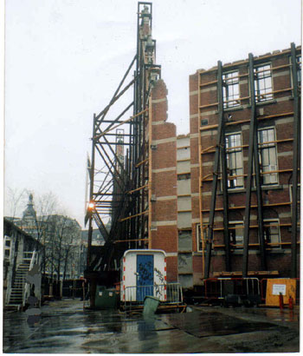

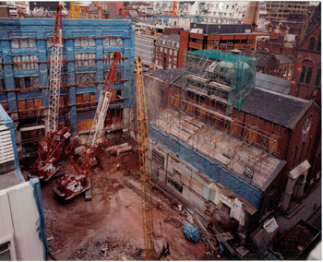

This photograph shows the advantage of using an external system. Access to undertake the new build work is

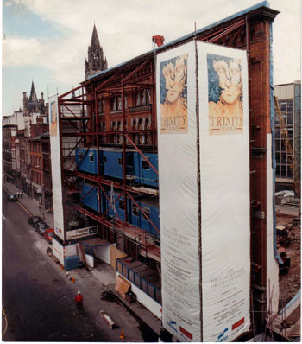

This photograph shows how the footpath has been preserved for the duration of the construction work

**Reflective Summary**

* Façade retention is the term used when some or all of the existing external walls of a building are retained during a refurbishment, whilst the internal structures are removed, leaving a hollow shell or even a single external wall
* Several systems are available for providing the required temporary support during façade retention schemes.
* Systems can be classified as internal or external
* Initially an assessment of the existing façade is required in order to determine the most appropriate system to use.
* When the external walls are the main load bearing element of a building, if you remove the floors the walls are liable to collapse and need to be supported during this operation.
* Differential settlement can be a problem in façade retention schemes.
* When undertaking façade retention schemes there is usually problems with access.

**Review Task**

What factors will affect the choice of façade retention system?

* the accessibility of the site
* the degree to which pavements or roads may be obstructed
* the structural form and condition of the existing façade
* the amount of building structure to be retained
* the scale and proportions of the retained sections

What needs to be considered during the initial assessment of a façade if retention of the façade is proposed?  
  
The following will need to be investigated before any choice of façade retention system can be made:

* Are there any defects internally, externally or within the facade? Some defects may be obvious such as cracking, but there are others which may be hidden
* Is the façade load bearing or is the main support for the building a structural frame
* Which materials have been used to construct the façade
* Have any remedial works that have been undertaken previously including remedial works to foundations
* How plumb is the façade? Modern buildings are generally designed as perfectly square and if the façade bows or tilts forwards or backwards then any modern building work behind the façade will have to be designed accordingly. Also the stability of the façade during this work could create further problems.

**4.4 Overcladding**

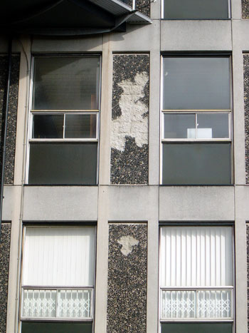

Over cladding is often undertaken to upgrade the existing building façade. Here we see examples of typical over cladding systems before and after application.

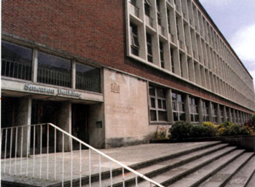

Before

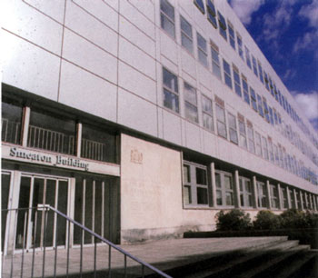

After

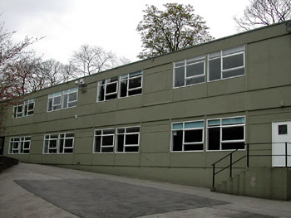

Before

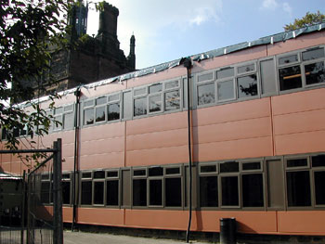

After

**Figure 4.25 Components of overcladding systems**

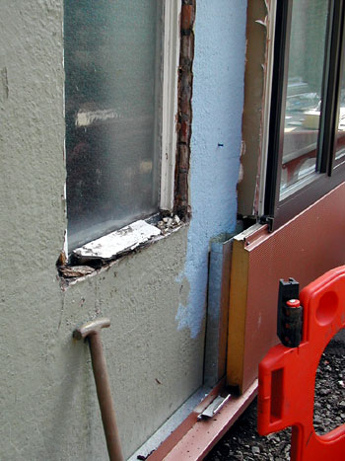

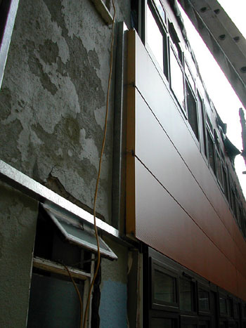

Here we see some of the component parts of a cladding system. Note the insulated outer panels and the supporting rails fixed to the building. The profile of the cladding panels is designed to allow interlocking to avoid moisture penetration at the junctions of panels.

**Reflective summary**

* There are many existing buildings that have a structurally sound frame, but the external façade has deteriorated to the extent that it requires extensive repair or replacement, which can take the form of over cladding.
* Over cladding can not only improve the thermal and sound insulation of a building, but dramatically change appearance.
* The major reasons why building owners may choose to over clad buildings are as follows:  
  1. Inadequate weather tightness of the external envelope  
  2. Deterioration of concrete and external finishes  
  3. Improving thermal insulation  
  4. Improving appearance  
  5. Reducing noise levels
* Over cladding Systems can be classified as those with voids and those without voids
* Possible Problems in Over cladding systems include fatigue, impact damage, overloading of the foundations, weather tightness and fire spread

**Review Task**  
  
List the reasons why over cladding may be a preferred option for a building owner who wishes to undertake a large scale refurbishment contracts  
  
The major reasons why building owners may choose to over clad buildings are as follows:  
1. Inadequate weather tightness of the external envelope  
2. Deterioration of concrete and external finishes  
3. Improving thermal insulation  
4. Improving appearance  
5. Reducing noise levels  
  
  
Produce a detail for an over cladding system that:  
a. Includes a void  
b. Does not include a void



**4.5 Over roofing and Re-roofing**

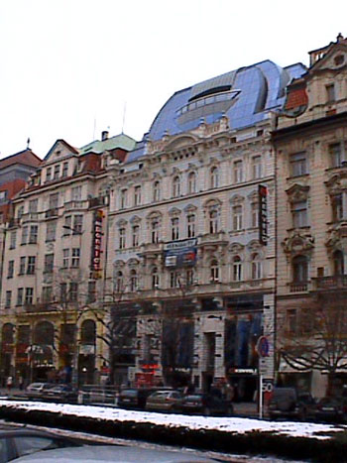

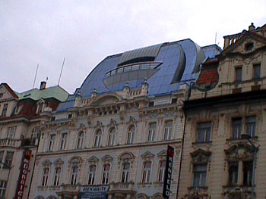

In this example form Prague, we see how imaginative over-roofing has been used to facilitate the provision of additional space to an existing building. Effectively an additional storey has been added to the building.

**Reflective Summary**

* The term over roofing relates to the operation of providing a new roof structure and covering over the top of an existing roof.
* Re-roofing refers to the repair or replacement of an existing roof
* There are several reasons for the consideration of over-roofing in addition to simply repairing a defective existing roof.
* Over-roofing is sometimes used when the existing roof is not defective but for improving the properties of the roof.
* Structural forms of over-roofing include rafter and purling roofs, trussed roofs and structural frames.
* Re-roofing may be required for a number of reasons and it may be that repairs to the existing roof are feasible, and over roofing is not necessary.
* The main advantage of liquid waterproofing systems are the lack of disruption as the existing substrate is usually left in place, the homogenous nature of a seamless coating, the ability to cope with irregular surfaces and the ease of installation.

**Review Task**

For what reasons could over roofing be preferred as opposed to reproofing?  
  
There are several reasons for the consideration of over-roofing in addition to simply repairing a defective existing roof. Typically the reasons for considering over-roofing may include:

* Rectification of long-term flat roof failure
* Improving weather tightness.
* Aesthetics; pitched roofs are often considered more attractive that flat roofs.
* Minimising disruption in building operation; over roofing can take place without disturbing the building interior.
* Creation of extra usable space; which could include habitable space or space for services in a void created by pitched trusses to support a new roof
* Improvements in the thermal insulation properties of the roof.

What are the advantages of using liquid waterproofing systems to recover a roof, and in what circumstance can a LWS not be used?  
  
The main advantage of liquid waterproofing systems are the lack of disruption as the existing substrate is usually left in place, the homogenous nature of a seamless coating, the ability to cope with irregular surfaces and the ease of installation.  
  
This is not suitable for use if:

* The substrate is not clean and dry
* The existing deck and any insulation is not dry and structurally sound
* The existing membrane will not bond with the new material
* The existing deck will not take the additional loadings
* The height of upstands and details will not allow for the additional thickness of the waterproofing material

**4.6 Upgrading and retrofit of building services**

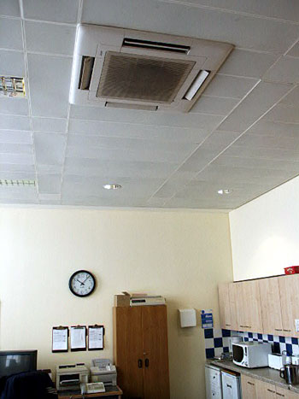

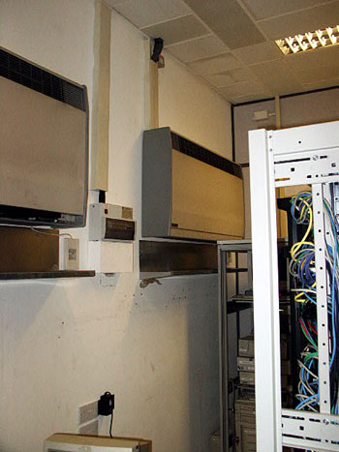

The photographs above show a Retrofit Air Conditioning System

**Reflective Summary**

* Modern buildings rely on sophisticated environmental control services and the ability to cope with IT infrastructure in order to be commercially competitive.
* It is unlikely that the services installed in a building at the time of its construction will serve the users needs fro a long period of time.
* It is probable that the services installation of a modern commercial building will be replaced several times during the functional life of the structure and fabric.
* It is common to come across the need to provide services installations on the basis of a retro-fit approach.
* As with all operations involved in refurbishment work there is a scale of intervention, and this is also relevant to retrofitting of services.
* The level and amount of retrofitting will depend on a number of factors.
* When designing a retrofit service installation, the first action that needs to be taken is an evaluation of the currently installed system.

**Review Task**

Consider the probable life spans of the following building services installations and propose ways in which they may be upgraded during the life of the building:

Passenger lifts  
Air-conditioning  
IT/Data infrastructure

|  |  |  |
| --- | --- | --- |
|  | **Life span** | **Upgrade options** |
| **Passenger lifts** | 20 years | Renew motors  Refurbish cars  Upgrade control systems |
| **Air-conditioning** | 15-20 years | Retrofit cassette units  Improved chillers etc  Environmental improvements  Upgrading of control systems  Links with BMS |
| **IT/Data infrastructure** | 5-15 years | Expanded infrastructure with structured cabling  Extension and expansion to existing systems |

**4.7 Remedying Dampness**

**Reflective Summary**

* The technology associated with remedying dampness is simple and there a relatively few steps required to ensure an effective solution to most damp problems.
* The key to effective treatment is the accurate diagnosis of the cause of the dampness.
* In practice the mis-diagnosis of damp problems is common and many remedial DPC installations have been undertaken when they have been unnecessary.
* The use of remedial DPCs to address the problems of rising damp is well established and over the years has taken many forms.

**Review Task**

Outline the principles of the following remedial DPC systems, and suggest where their use may be most appropriate.

* Atmospheric syphons
* Electro-osmotic systems
* Physical DPCs
* Chemical DPCs

**Atmospheric siphons**  
A series of porous ceramic tubes are inserted into the body of the affected wall. The hollow tubes provide an enlarged interface area between the damp wall and the surrounding air, thus promoting increased levels of evaporation from the surface. The intention is to remove excess moisture from the fabric of the wall by allowing the improved evaporation. The main problem with this approach is that the natural migration of soluble salts to the surface will block the pores of the tubes and the level of evaporation of the moisture will be drastically reduced. Hence, they have a limited effective life span.  
  
**Electro-osmotic systems**  
These operate on the principle of creation of an electrical charge in the body of the wall repelling the charged ions of moisture that are attempting to rise through the wall. This effectively acts in the same way as a magnetic force, in which like charges repel and opposite charges attract. There is considerable scepticism about the effectiveness of these systems.  
  
**Physical DPCs**  
The use of this form of remedial DPC is recommended by BRE as it represents a robust and reliable solution to the problem of rising damp. Installation must be carefully undertaken to ensure that a continuous barrier to moisture is created and that there is no adverse effect upon the structure of the wall. This is a laborious and painstaking process and must be undertaken by skilled operatives.  
 **Chemical DPCs**  
There are two broad categories of chemical DPC installation, infusion, which is based upon a chemical liquid being introduced into the wall under the action of gravity and injection,. Most systems work on the principle of either filling the pores within the walls construction with a water resistant material (pore fillers) or lining the pores with a non-wettable surface to reduce capillary attraction (pore liners).  
The effectiveness of these systems relies in their effective penetration to the full depth of the wall and the provision of sufficient injection/infusion points to ensure complete coverage of the wall area.

**4.8 Repairs to masonry**  
  
**Reflective Summary**

* The extent of cavity wall tie renewal that is still required in the UK is significant.
* Replacement of damaged or defective ties will ordinarily be with non-ferrous materials such as stainless steel, or copper for example.
* In practice the use of stainless steel is almost ubiquitous although the use of plastic forms of remedial tie is on the increase.
* A key point when selecting a replacement tie system is that the different ways in which the ties can be secured in the body of the wall may be more or less appropriate in given situations.
* It is important to recognise that cracking in masonry is generally a symptom of some other defect arising from problems above or below ground.
* Non-structural cracking can be rectified by simply repointing the affected area.
* Structural cracking requires more significant treatment.
* In buildings of considerable age it is not uncommon for external and internal walls to suffer deformation due to oblique or lateral loads and the absence of sufficient lateral restraint within the structure

**Review Task**  
  
Describe the two basic principles that can be adopted for fixing remedial wall ties into an affected wall:  
  
Two basic principles are adopted for fixing the remedial ties into the affected wall:

* Expanding bolts
* Resin or grout fixing

In both instances the remedial tie is inserted into the body of the wall from the outside. Holes will be drilled through the body of the bricks on the outer leaf and into the brick or block inner leaf to an appropriate depth. The remedial tie is then installed and either tightened to expand the external sleeve of an expanding bolt type, or grouted into position with an epoxy resin to secure both inner and outer ends of the tie. In all cases it is recommended that the existing corroded tie is removed from the outer leaf in order to reduce the potential for continued corrosion, lamination and deterioration of the outer leaf by cracking.

**4.9 Treatment of timber defects**  
  
**Reflective Summary**

* In the context of timber defects we are generally concerned with softwoods, which are less durable than hardwoods.
* The main information source for remedial procedures and identification are the BRE Digests 299 for Dry Rot and 345 for Wet Rot.
* There have been recent developments in the treatment of dry rot in buildings, with some specialist firms now advising that the traditional, destructive remedies for dry rot be replaced with alternatives.
* However more traditional methods will be most common in all but buildings of particular architectural interest for some time to come.
* Wet rot is far more easily treated than dry rot, but again it is important to recognise the need to locate and eliminate the source of moisture that caused the problem in the first place.
* One of the aspects of recognition and treatment of insect infestation is the Categorisation class in Digest 307.

**Review Task**  
  
Refer to the relevant guidance that is mentioned in the above text and produce a detailed plan of how to treat dry rot.  
  
The BRE guidance suggests the following methodology for treatment of dry rot:

* Eliminate moisture sources
* Attempt to dry affected areas rapidly
* Remove rotted wood to within 450mm of visible outbreak
* Irrigate surrounding brickwork etc with fungicide
* Adopt Support Measures, such as increased ventilation levels