**Chapter 7 Refurbishment Case Study**

**7.1 Major Refurbishment Case Study**

Introduction  
This chapter sets out to provide an illustration of the complex nature of refurbishment projects. After studying it, you should have developed an appreciation for the unknown elements that are typical of such contracts. You should also be aware of the financial and programming implications of design decisions and discovery of unforeseen items upon the contract. Finally, you should be made more aware of how important a thorough initial survey is to the successful of refurbishment contracts.  
  
Overview  
This section gives an overview of a major refurbishment contract. Hopefully the case study will illustrate some of the problems associated with refurbishment work detailed in earlier chapters, plus highlight some of the solutions applied to relatively complex problems. The risks to the client and contractor are discussed and the merits of keeping of good records illustrated.   
  
  
Overview of Client Requirements and Existing Building  
The existing building was constructed in the early 17th century and situated in central London. The client and building owner was a major auction house, with an existing property in use at the rear of the proposed development site. Figure 7.1 shows the location of the building to be developed, the owner/client's original building and surrounding properties.

**Figure 7.1 Proposed Development Site**  
  
The existing building was deemed to be structurally sound in the front area as shown on the diagram, but the rear of the building was showing signs of significant structural problems.   
  
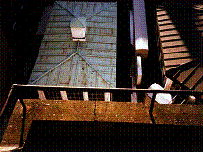

Cracks in the parapet at roof level were evidence that there was structural movement. These were monitored to see if they were recent or longstanding, and movement was still ongoing

The client brief to the designer was to allow for the following in the refurbished building:

* Basement to be used for storage
* Ground floor-Provide one new sales room and a prestigious entrance
* 1st Floor- Provide 2 new sales rooms
* 2nd-5th floor- Provide flexible use office space
* New male and female toilets on each floor
* Repairs and renewal to front elevation in keeping with surrounding area
* Provision of 2No. goods lift, plus one passenger lift
* New services installation

Planned Operations  
The planned operations for the scheme were as follows:  
  
1. Remove some of the existing features of the building and refurbish away from the site for replacement after major works were complete   
2. Demolish the rear half of the building and expose existing steelwork, plus demolish the entire roof

**Figure 7.2 Demolition parameters**  
3. Undertake bored insitu concrete piling in the area shown in order for a new pile cap to be constructed  
4. Erect a new steel frame on the pile cap and connect this new frame to existing steelwork at the rear of the building up to 1st floor level. Continue with the erection of the steel frame to the entire rear half of the building up to roof level

**Figure 7.3 Extent of new steel frame**  
5. Fix steel decking to the new steel frame  
6. Concrete in steel beams and columns  
7. Construct brickwork cladding to the rear of the building  
8. Repair and renovate the front elevation of the building  
9. Build three lift shafts and install lifts  
10. Install modern mechanical, electrical and plumbing systems  
11. Build roof structure and coverings  
12. Provide finishes to upper floors and basements  
13. Provide high quality finishes to sale room and reception areas  
  
 **Extra activities required, problems and site management issues**

Access to the site  
Access to the site was severely restricted with the road where the site entrance was located being very narrow. This meant that the size of lorry that could deliver to the site was relatively small and large materials orders had to be staggered. This had a cost implication, because suppliers required additional payment for the extra deliveries. It also meant that many deliveries had to occur out of traditional working hours so as to not inconvenience the occupiers of the surrounding buildings.  
It was planned that a chute would be formed through the pavement, and materials would be lowered into the basement. Holes were then to be broken through the existing floor slab on every floor in order for a materials hoist to be installed. Materials would be loaded in the basement and lifted to each floor using the hoist.  
  
**Figure 7.4 shows the position of the chute(e) and the location of the hoist(a).**  
  
Figure 7.4 Access for materials  
The hole was broken out and steel Universal Beam sections fixed onto the sides of the opening using bolts.. The gap between the steel and the floor was made good using concrete. The intention was that after the back of the building was rebuilt, the hoist would be moved to the position of the new passenger lift shown in figure 7.4 location (b)

It is common practice to install hoists in the location of new lift shafts  
  
The hole in the existing floor would then be made good by placing steel decking in the void, shot firing it to the steel trimmers, placing anti cracking mesh on the decking and concreting to the original floor level.

**Figure 7.5 shows how the void was created and then made good.**  
  
Figure 7.5 Forming void through floors for hoist and making good when moved to a new location   
  
The photographs below show the floor when it was being broken out, and the hoist-supporting scaffold at the roof level.

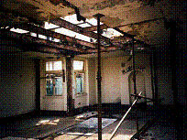

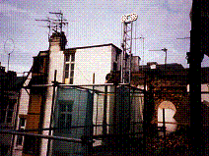

During the breaking out of the floor activity, a problem arose. The existing floors were not was they seemed! They were constructed using a framework of steel beams, and alternative floor panels were concrete and then a mixture of straw and plaster. These had stood the test of time and showed no evidence of excessive cracking or deflection, but would not comply with current building regulations. All of these panels had to be located, broken out and replaced with new concrete. This was a significant extra and there were cost and progress implications.  
  
The new steel frame that was to be constructed at the rear of the building had to be lifted into place, and it was not possible to use a tower crane due to objections from the surrounding building owners about a crane going over the top of their buildings. It was therefore planned that a mobile crane be used to enable erection of the steel frame. It was planned that the location of the mobile crane would be as shown in figure 7.4 position c. In order to facilitate this, closure of the road was required. It was planned to erect the frame over four consecutive weekends and closures were applied and paid for. However due to delays, these dates were missed and the result was that the steel frame was carried into position by the steel erectors. The erection of the frame took a great deal longer and therefore cost more to erect.  
  
Once the steel frame was erected and steel decking fixed in place, the floors needed concreting. It was planned that a vehicular concrete pump would be used, but on the day of the first pour, the pump was clamped due to it partially blocking the road. A smaller, mobile pump had to be used that had to be stored within the site boundary when not is use and pulled into position every time it was required. The pump was slower than the vehicular pump and therefore the concreting activity took longer than was anticipated. The pump was located when required for concreting at location d on figure 7.4.

It was impossible to get an excavating machine into the building and therefore all demolition waste had to be loaded into and carted out of the building in wheelbarrows.

The photograph below was taken at first floor level from the remaining first floor slab. The rubbish that can be seen is demolition rubble that has built up from the basement, approximately 10m!  
  
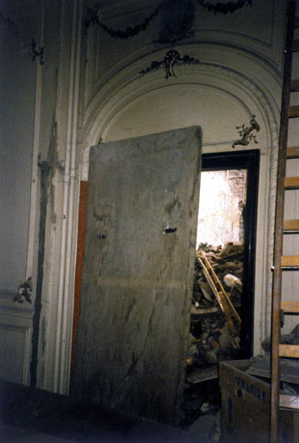

Piling  
The initial scheme proposed that 9 new piles would be required. However when the piling activity started two old wells were discovered. These had to filled with concrete and an additional two piles were required in order to stabilize the pilecap.  
  
Underpinning  
During excavation work at the rear of the building it was discovered that the building adjacent to the site and the back end of the building that was to remain in place, required underpinning. This was due to the fact that their was no foundations under these areas. Mass concrete underpinning was carried out in these areas and this caused an increase in cost and delayed the project. The area that required underpinning is shown in figure7.6

**Figure 7.6 Extent of Underpinning Works**  
  
Setting Out  
This was a refurbishment contract and part of the existing building was remaining, but a new steel frame was being attached to an old structure. The tolerances for the setting out of new steelwork is +/- 3mm and therefore the setting out needed to be very accurate. Also the new interior design of the remaining half of the building required a perfectly square grid system. The setting out line positions are shown in figure 7.7.

**Figure 7.7 Proposed Gridlines**  
  
However it was impossible to sight from the front of the building to the rear with a theodolite due to the existing structure. The only option was to break holes through the floors and drop down a plumb line from the roof level to the basement as shown in figure 7.8.

**Figure 7.8.Establishing grid lines using a plumbline**  
  
When this was carried out it was found that the external wall of the building was out of plumb by 150mm. The interior design of the existing building then had to be revised significantly to account for this and some additional steelwork was required in order to allow the new frame to attach to the old. There were significant cost and delay implications because of this.

It is fairly common for existing building walls to be out of plumb and out of square  
  
Additional Steelwork   
Figure 7.9 Shows the remaining half of the building after demolition, with floors broken out, some of the new steelwork fixed to the pile cap and existing steelwork running along gridline C and between gridlines 1 and 3.

**Figure 7.9 Steelwork details**  
  
It was proposed that in the area where piling had been undertaken (enclosed by gridlines CDEF/123), a new steel frame would be constructed the whole height of the building. In the adjacent areas(enclosed by gridline CDEF/345), new steel would be connected to existing steel goal posts that had been  
  
exposed during demolition at first floor level. However, when the original steel was exposed, what was not anticipated was that the goal posts would not be connected to the steel work in the remaining structure. Additional steelwork therefore needed to be designed and fixed to the goal posts and the steelwork in the existing half of the building to provide stability. The photograph shows this additional steelwork

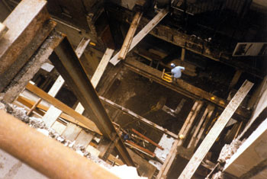

Basement slabs  
Whilst the contractor was undertaking an initial survey of the building, it was identified that the floor to ceiling height was not as shown on the drawings. After installation of the new services the floor to ceiling height would be unacceptable. Therefore an instruction was given to the contractor to lower the existing basement floor levels by 300mm. The existing floors were to be broken out and soil excavated down a further 300mm. Traditional slabs were then to be installed comprising of a layer of hardcore, blinding, DPM, steel mesh and concrete. Due to problems with access the breaking out of the slabs and excavation had to be carried out by hand. This again was very costly and took a great deal of time. This particular activity did not however cause a significant delay as no work was planned in the basement at this stage of the contract.  
  
Works to the front elevation of the building   
The specification for the front elevation of the building works was simply to clean, and undertake minor repairs. However once the building was cleaned, the balconies were different colours. This was due to the fact that during the Second World War, some of the balconies had been demolished due to bomb damage and replaced with balconies made from precast concrete as opposed to the originals that were carved out of stone. The cleaned façade actually looked worse than before. The designer therefore specified the need to extensive painting of all of the balconies. The photographs below show the balconies after cleaning and then after repainting.

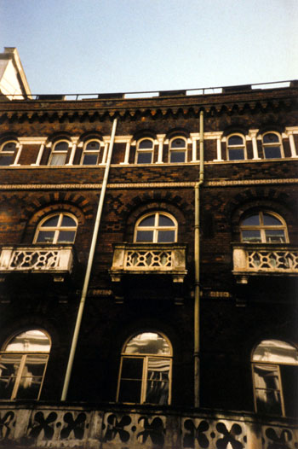

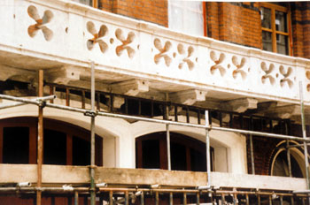

The interior design for the sales rooms required perfectly square rooms. However, after setting out in all three sales rooms, it became apparent that this was not the case. Therefore to make the room perfectly square, metal studding was fixed to metal sole and soffit plates and plywood sheets fixed to the studs to form partitions that act as false walls.

Figure 7.10 illustrates how this was achieved and the extent to which the existing room was out of square

**Figure 7.10 Plan layout of room and jumbo studwork layout**  
The photographs show how important it was that the room was made to be square, because if this had not been done, there would have been unsightly 'cuts' around the perimeter of the ceilings.   
  
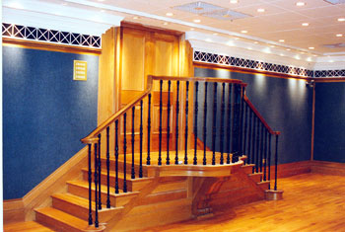

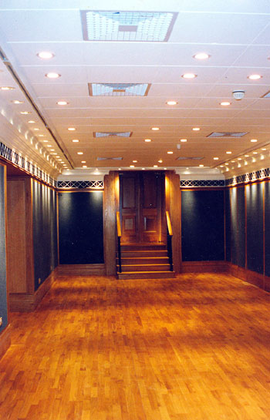

Floor to ceiling heights in older buildings tend to be greater than required in new buildings and this allows for the inclusion of raised access floors and suspended ceilings  
  
The suspended ceiling is a 600x600m modular concealed grid system with plaster tiles that have then been painted white.  
The floor is a shallow batten raised access floor finished with timber strips that can be removed to gain access to the services underneath which is mainly electrical wiring. The restricted floor to ceiling height in the original building limited the floor void depth to 50mm.   
The majority of the services are enclosed behind the partitions and within the suspended ceiling.  
  
An interesting feature of this room is that the wall covering is carpet. The reason for the choice of this material as a wall covering is due to the fact that pictures are to be hung and changed regularly. Using nails will damage virtually every alternative covering, but when nails are removed from the carpet, no sign of it is evident.  
  
In the ground floor of the existing building marble had been used extensively as a finish. The client wished to retain this marble and it was protected before any construction work began. However when the protection was removed, it looked very shoddy when compared to the new finishes. Initially the client tried to blame the contractor for damaging the marble, but the contractor had undertaken a very detailed schedule of conditions before work commenced and could therefore prove that the damage was not caused by them.  
The cost of replacing the original marble, plus the very long lead in time required to procure the material meant that an alternative was required. It was decided that all marble would be replaced with plywood that would then be painted to look like marble. This required the skills of very specialist painters who required a large sum of money in order to undertake the works.  
  
The photographs below show the main staircase when complete. All the areas highlighted have been painted to look like marble-columns, staircase post, wall beneath the dado rail and stair treads and risers.

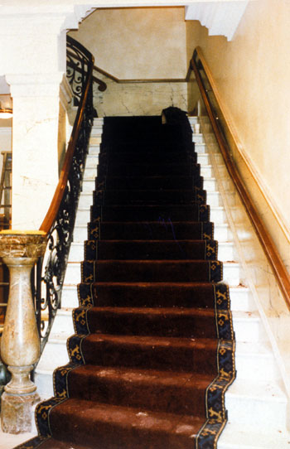

Accommodation  
The site was very restricted and work was planned in every area of the site. Therefore the use of portacabins for a accommodation was impossible. The site was in central London and therefore the only office space available in the area was extremely expensive. It was therefore decide that the existing parts of the building would be used for accommodation. Figure 7.11 shows the location of offices over the contract duration.

**Figure 7.11 location of accommodation over the duration of the contract**  
  
Initially accommodation was located on the 4th floor because extensive works were being undertaken on the lower floors and the hoist was located in the other half of the building. On the second floor was a planned control room that was not going to be fitted out until late in the contract. Once the walls were built the accommodation moved to this area for nine months. When it was time to fit out the control room the accommodation needed to move and went into the basement for the next three months. Then it was time to undertake internal finishes to the basement so the accommodation needed to move and went to the 1st floor for the next three months. Once the basement works were complete, the accommodation moved back from the ground floor to the basement for the final month of the contract. Every time the accommodation moved it would take a gang of labourers three to four days to move everything and caused serious disruption. There was a cost implication and other activities had to stop to facilitate the move.  
  
Cost and Duration Implications   
All of the above required additional funding to be made available, and caused serious disruption to the programme. The completion date could not be changed as the client had planned and been advertising auctions 3 days after the original planned completion date.  
The original tender value was £5,200,000 which include the planned profit to the contractor of 2%, £104,000. The actual final costs of the work were £6,100,000, an increase of £900,000 (17%). There was no extension of time given but a £500,000 acceleration package was negotiated by the contractor. Due to the competence of the contractor's management team, the actual profit to the contractor was £1,330,000 which is 25.5% of the original contract value. This was achieved by careful management and the keeping of good records.

**Reflective Summary**

* It can be seen from the details of the case study that the points made in chapter 7 about the need for detailed surveys before the design of refurbishment work is undertaken
* It can also be seen that the points made regarding successful management of refurbishment work were all adopted by the contractor and resulted in increased profits
* The increase in costs because of unknowns is clearly illustrated
* This building was a refurbishment contract, but it was also a conversion because the building had planned different usage. There were elements of the building that were renovated and/or repaired. Elements were renewed and a complete new services installation installed, hence retrofit. Therefore this contract was a combination of all terms that are sometime mistakenly applied to refurbishment contracts

**Review Task**  
  
What could have been done to avoid all of the extras and variations that occurred on this contract? Deal with each point individually and refer back to chapter 1, figure 1.5 for guidance as to what should be undertaken when undertaking a feasibility study.