CHAPTER 1 CASE STUDY:
Functions and requirements of industrial and commercial buildings

Fig 1.3, page 9

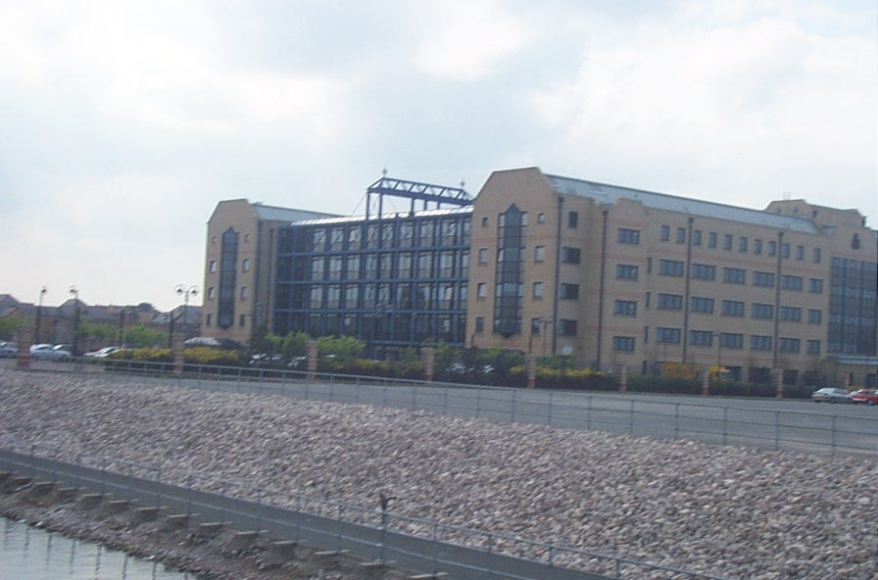
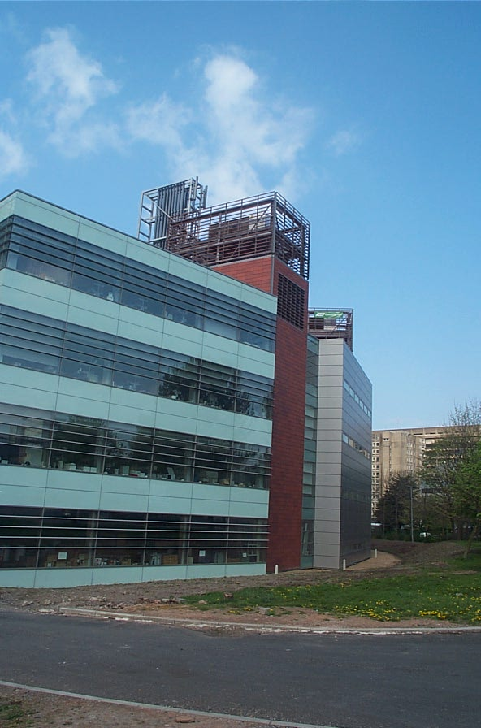

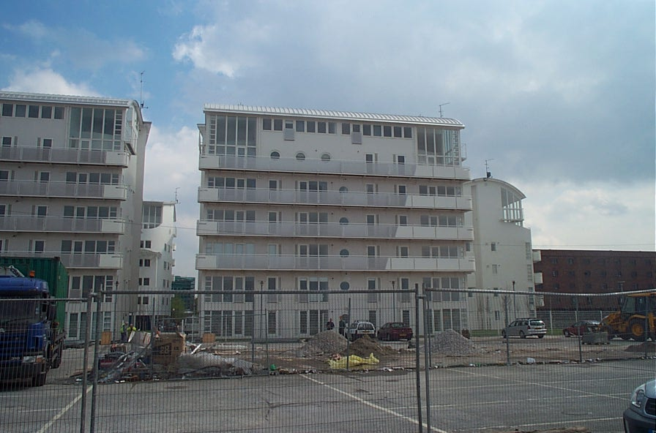

Modern, sophisticated buildings require careful design of structure fabric and services to ensure that they meet user requirements. Here we see three quite different buildings. Each has a different use: offices, apartments and education. Although they differ in their external appearance as a result of the shape, selection of cladding material, etc., they share a common structural form in that they are framed buildings.

