CHAPTER 10 CASE STUDY:
External Walls and Claddings for Multi-storey and Large-span Commercial Buildings
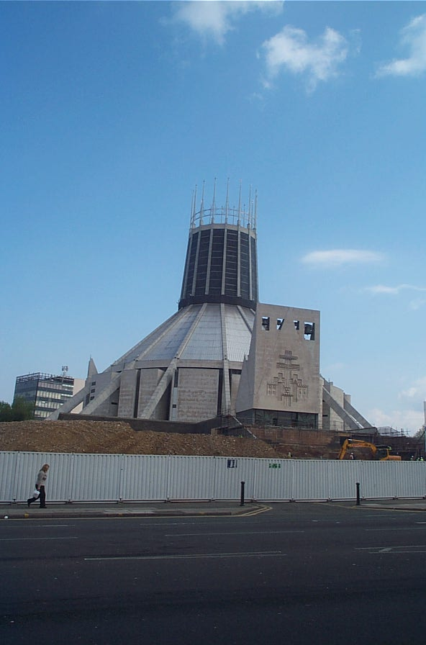
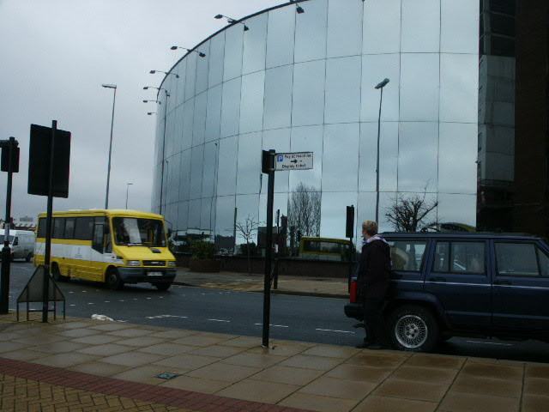

The cladding system used for the Liverpool Cathedral uses reinforced concrete and metal roof coverings to create a striking appearance.
Above we see a mirrored glass curtain walling system used to clad a curved building. Note that none of the frame or structure is visible as the glazing creates a completely obscure appearance.

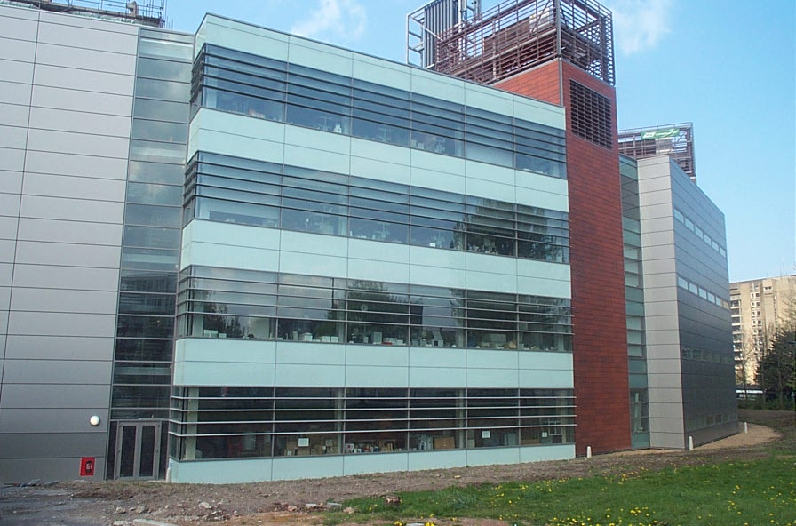

These two examples of curtain walling create quite different visual effects. The building above is clad using a mixture of pre-finished panels and glazing to give a relatively traditional appearance. The building on the right utilises a glazed curtain walling system that allows the frame to remain visible. Clearly when using a cladding of this type great care must be taken to ensure that the requirements for energy conservation are achieved for the building as a whole.

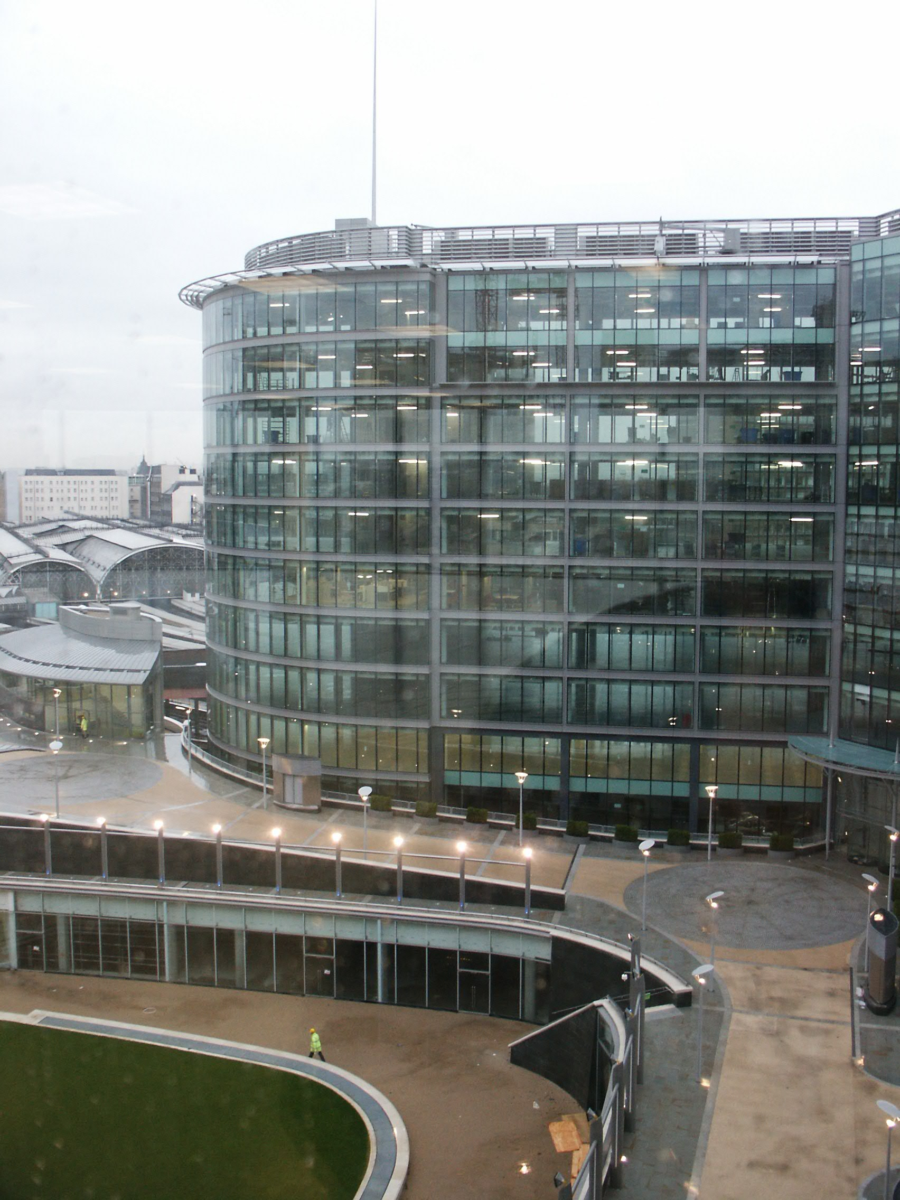

The photograph shows a multi storey hotel building that is being clad with concrete cladding panels. The panels are pre-finished and need no further treatment. You will note that you cannot see the internal beams and columns as you would if infill panels had been used
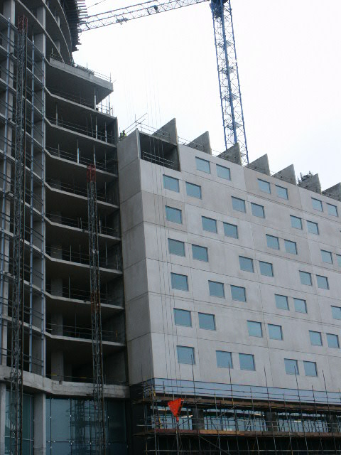
This photograph shows the front elevation with one panel of the 7th floor left to fix in place. The cross walls for the 8th floor are in position and the panels will be fixed shortly
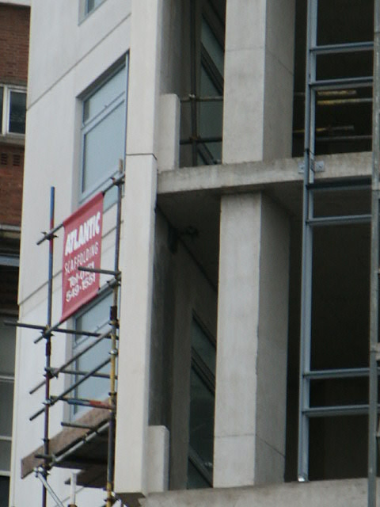
This photograph shows a close up detail for the cladding panels
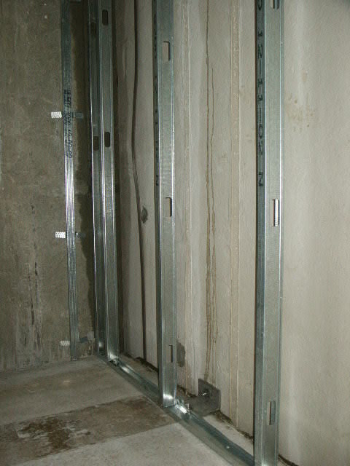
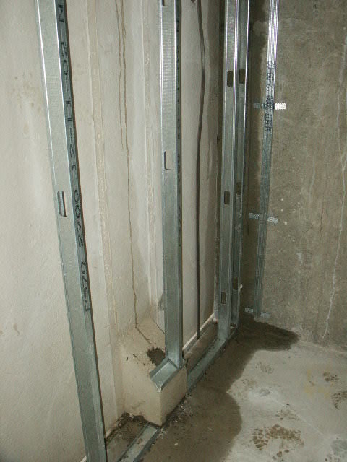
The two photographs above show the cladding panel connection details at the rear face of the panel.

At the bottom a corbel has been formed into the back of the panel and this rests on the concrete slab, and is bolted into place.

At the top a steel angle plate has been bolted onto the back of the panel and this then bolts onto the underside of the slab.

The metal studs that you can see running vertically up the inside of the cladding panels are used to fix plasterboard to. This will give a good finish to the interior of the building.
The photographs below show a different type of cladding that is being used here in conjunction with a multi storey steel frame. The steel posts shown are brickwork sliding anchors, but are being used additionally as wind braces.

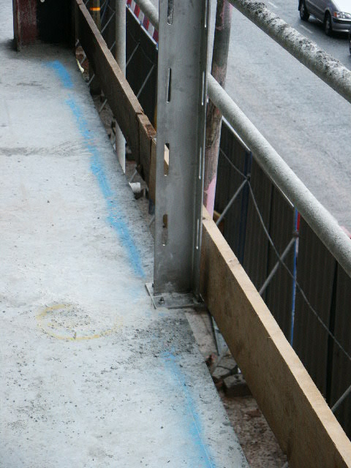
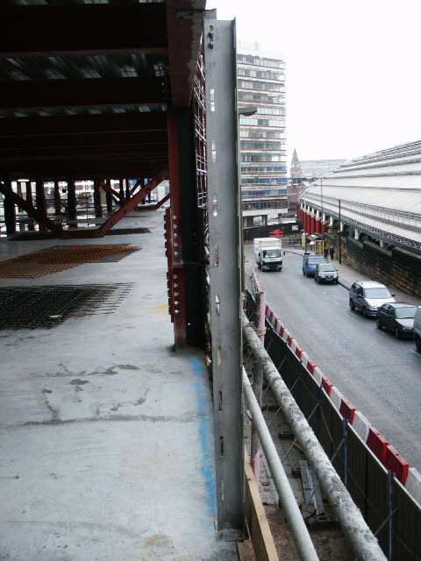

The blockwork forms the internal leaf of the wall and you can see in the photograph above that blockwork ties have been built into the blockwork as it is built. Another skin of blockwork will be tied into these to form the external wall, which is to have a paint finish.
The slots in the posts are oval and therefore give some tolerance for movement of the block ties to correspond to the horizontal joints of the blockwork.
