CHAPTER 11 CASE STUDY:
Upper Floors and Internal Access

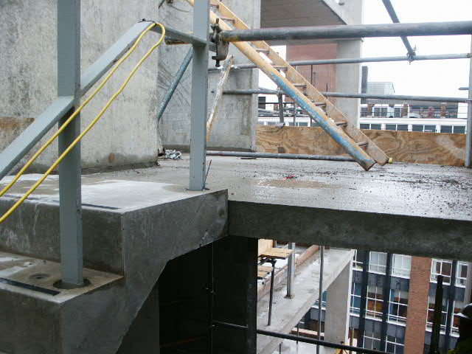
The photograph shows pre-cast stairs being used for a multi-storey building. Here we see the stair at the junction with the landing. Note the difference in surface level due to the need to accommodate a screed finish to the landing.
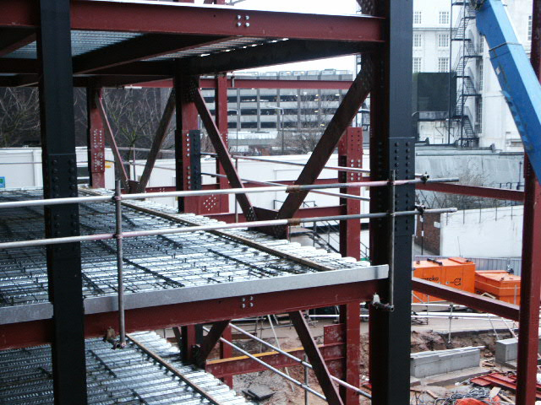
The photograph shows the holorib decking fixed onto the steel floor beams.
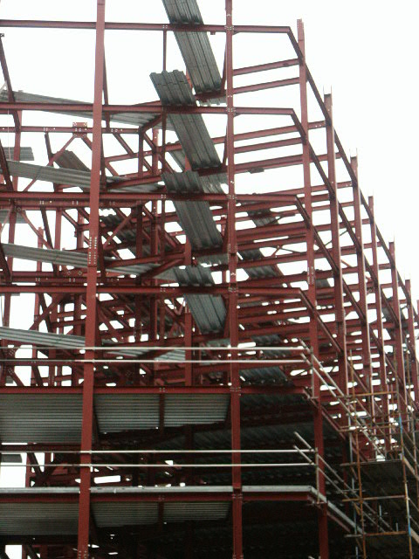
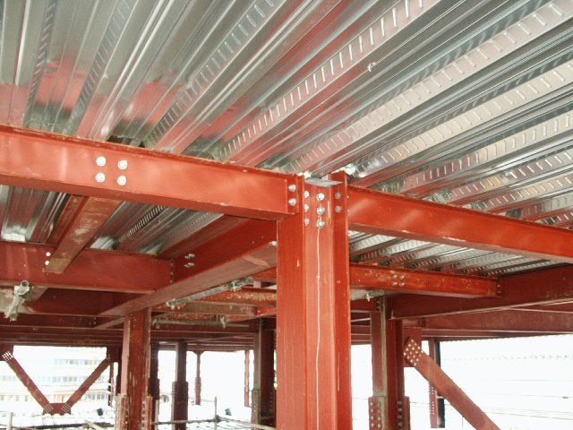
Here we see the profile of the steel decking from the underside.
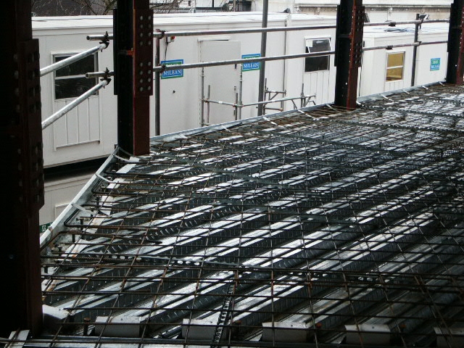
After the decking sheets have been shot fire fixed onto the steel frame, the steel mesh reinforcement is laid on the decking supported by spacers.
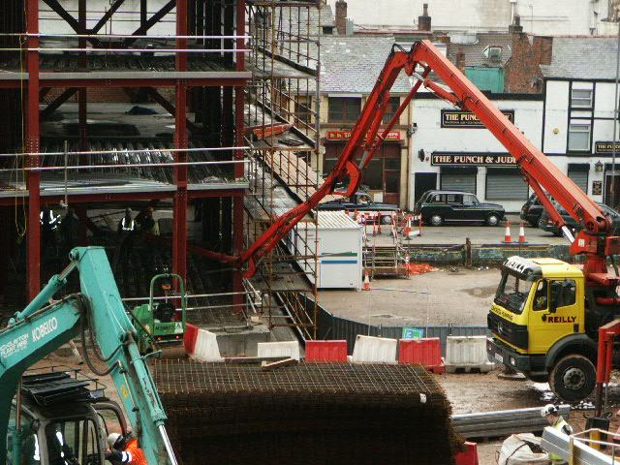
This photograph shows the concrete being placed using a vehicular concrete pump.
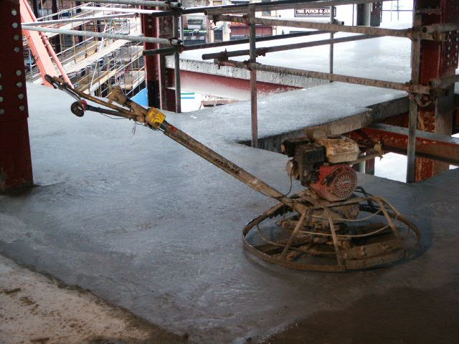
This is a power float that is used to create a smooth finish to the concrete. The concrete is poured in the morning and will be ready for power floating by the late afternoon.
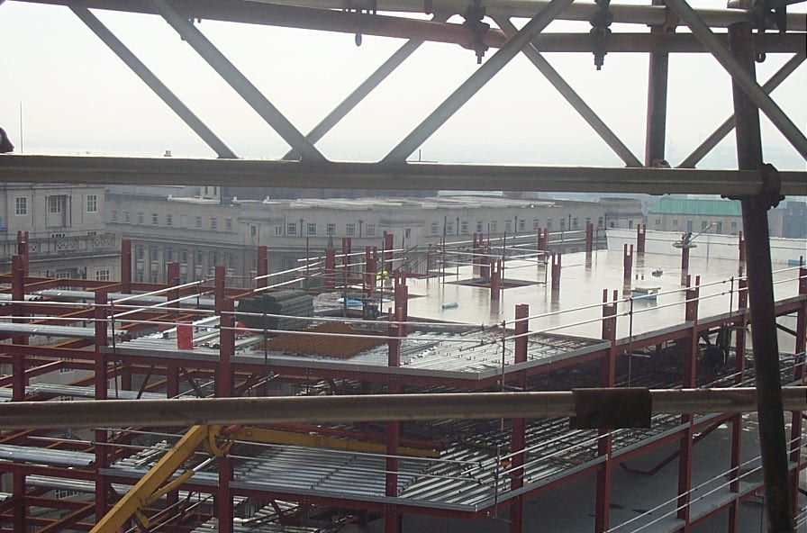
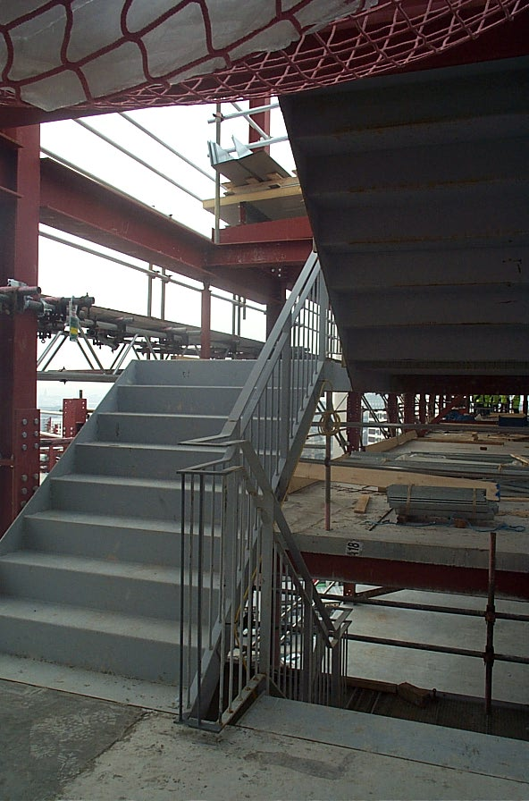
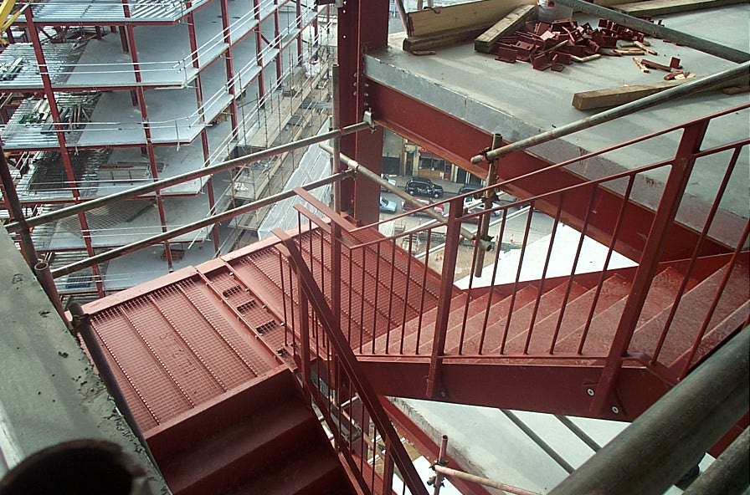
This is a steel frame building that also incorporates steel staircases. The staircases are fabricated off site and then bolted in place on site, in the same way as other steel frame elements. The staircases have been treated with intumescent coatings to provide protection from possible fire damage. The only finish required to the risers is for aesthetic and sound reduction purposes. The landings are to be grouted, before the final covering is applied.
The power floater has been used on the top floor and the concrete left to fully cure, whilst the floor below is being concreted.

