CHAPTER 12 CASE STUDY:
Roof Construction


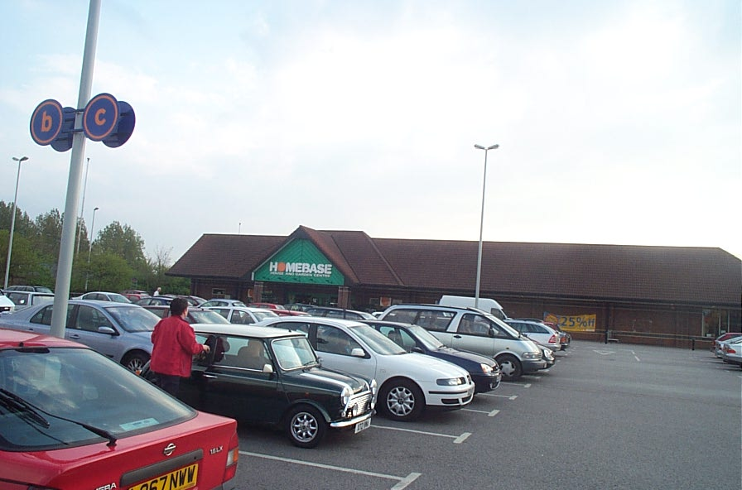

The desire to create a familiar aesthetic often drives designers to adopt a pitched roof appearance for buildings. In the examples above the perimeter of the roof uses a pitched form whilst the main area is of flat roof formation.
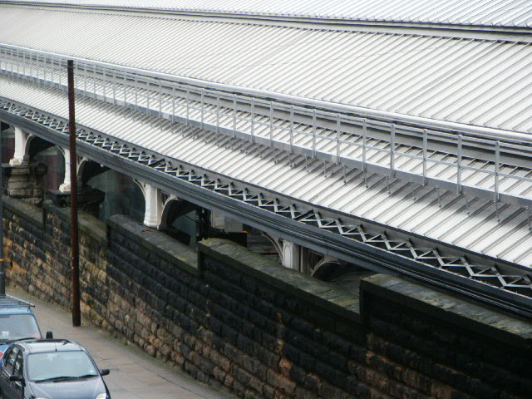
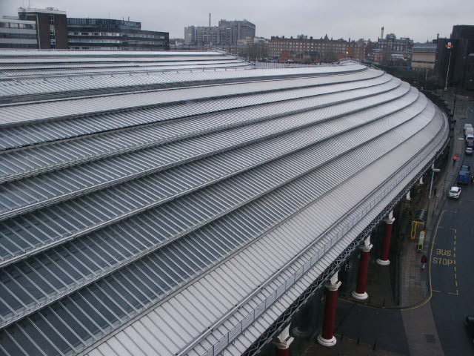
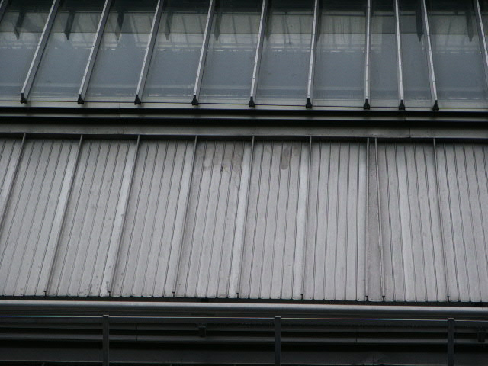
The roof shown above is located above a major railway station and adopts a combination of metal ‘standing-seam’ cladding and glazed panels to allow natural light to penetrate to the interior.

The roof shown in the following photographs is being used on a 7-storey steel frame building. The roof boards are composite, bonded, pre-assembled panels that incorporate the insulation.

The main support for the roof is a steel frame which comprises beams bolted to the columns of the previous floor. The only difference between the roof and floor structure is that the roof beams are fixed with an incline to allow the roof to drain. Bracing has also been incorporated in between the beams to give additional support against wind loading.
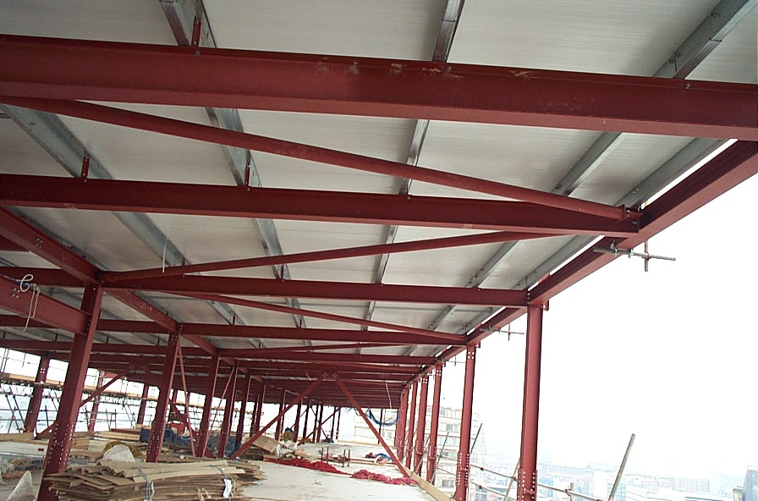
The photograph shows the underside of the roof structure, showing beams and bracing, the roof support beams and the underside of the roofing boards.

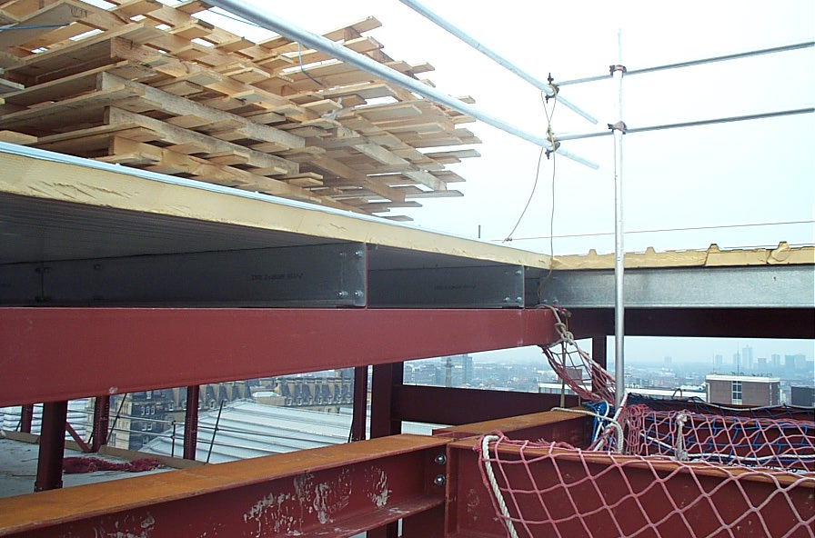
A section through the roof. The purlins are connected to the steel frame, and then the boarding to the purlins. The void will allow for further insulation of the roof.
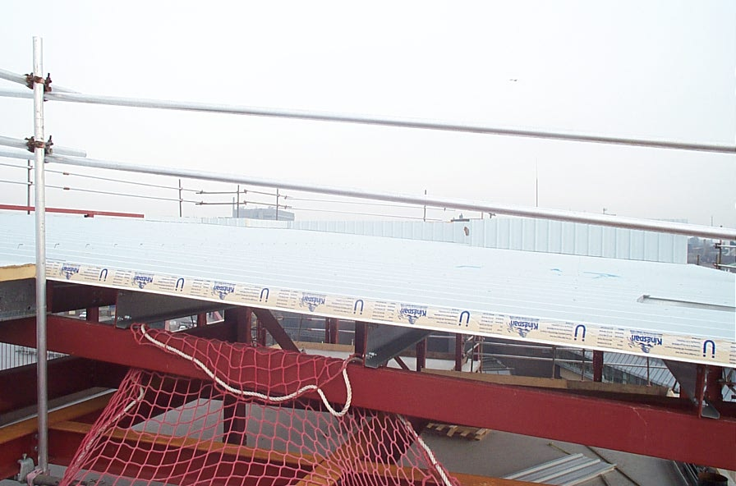
This photograph shows the actual roof finish. Aesthetically this in not very pleasing, but given the height of the building, the low pitch of the roof and the location of the building, the roof finish will not be visible to people other than those undertaking roof maintenance.
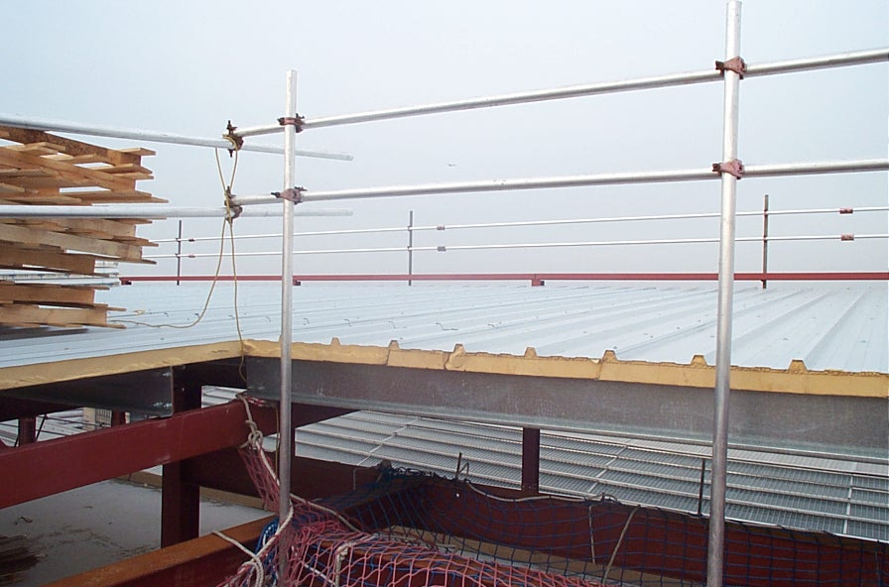
In this photograph the ridged effect of the roof finish is more visible. The ridging will allow for rain water to drain down the roof in channels to the rainwater pipes.

