CHAPTER 13 CASE STUDY:
Internal Division of Space and Integration of Services

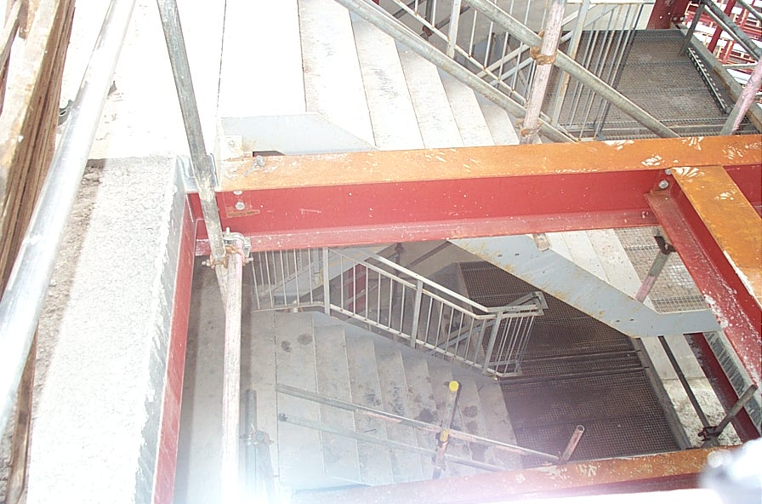
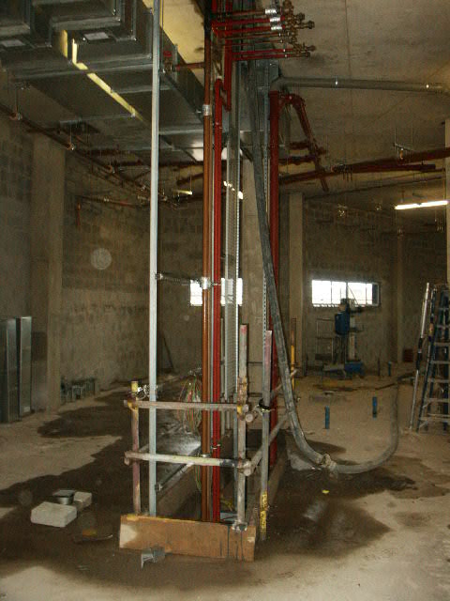
These photographs show how a service void is created in a steel frame building. The voids are usually positioned next to the lifts and staircases as in this case.

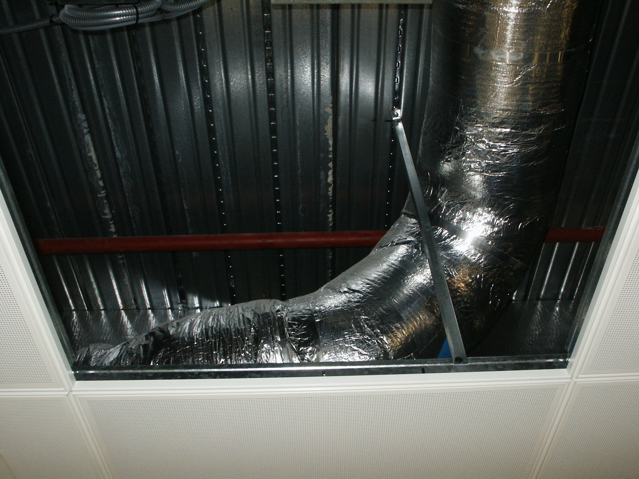
Here we see ducted services for ventilation/air-conditioning housed within the ceiling void. Access is easy using the jointed ceiling.
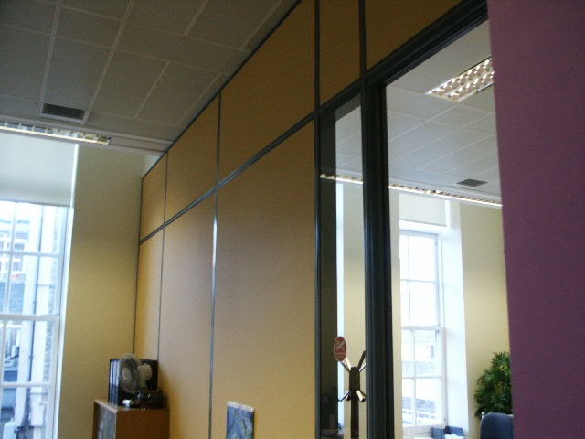
The photograph shows a typical demountable partition. The partitions can be moved around, to form pods the size required. They can then be moved to change the pod sizes and little making-good work will be needed.

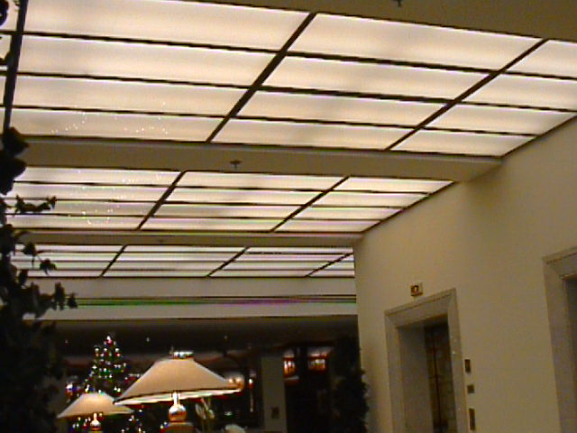

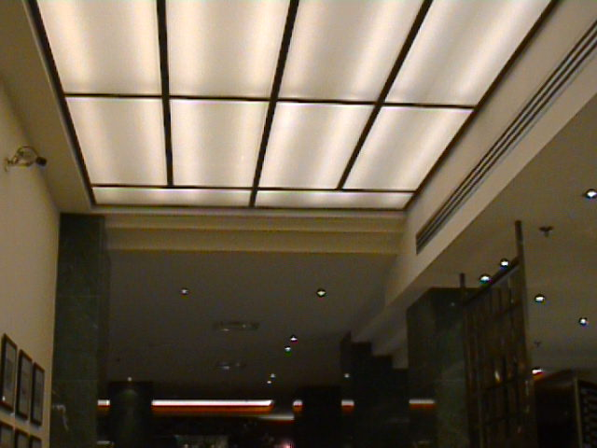

In the above example the suspended ceiling is made up of a series of translucent modular panels that incorporate lighting elements. This gives a high-quality feel to the interior of this hotel.
The following photographs illustrate how the interior space within a building can be moderated to give a uniform appearance. A room has been created within a larger irregular-shaped space using a range of partition and suspended ceiling systems.
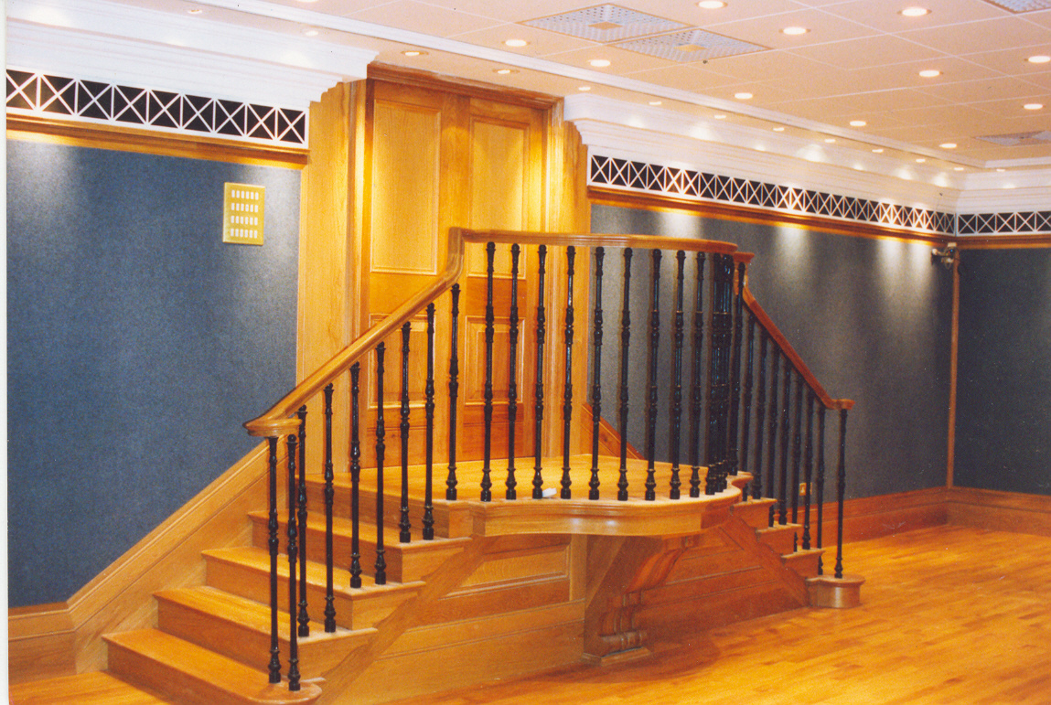
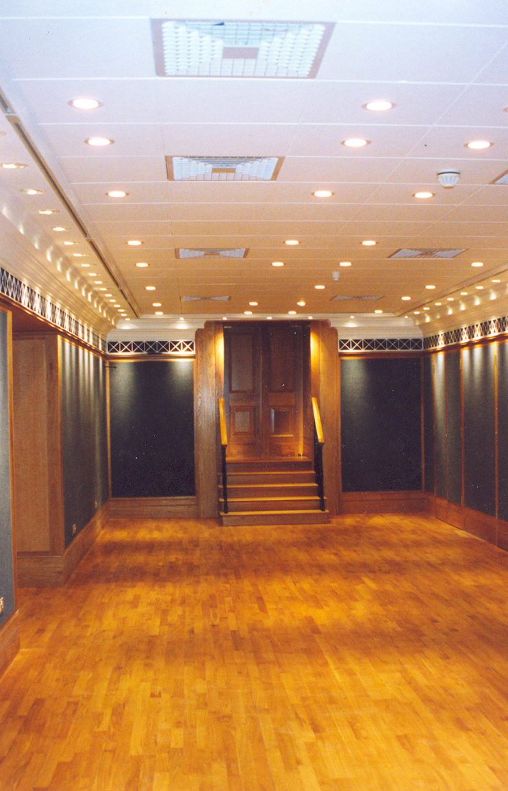
The suspended ceiling here is formed using a high-quality tegular grid system, allowing ready access to the services within the void. The walls are formed using a simple studded partitioning system using galvanised steel members clad with plasterboard.
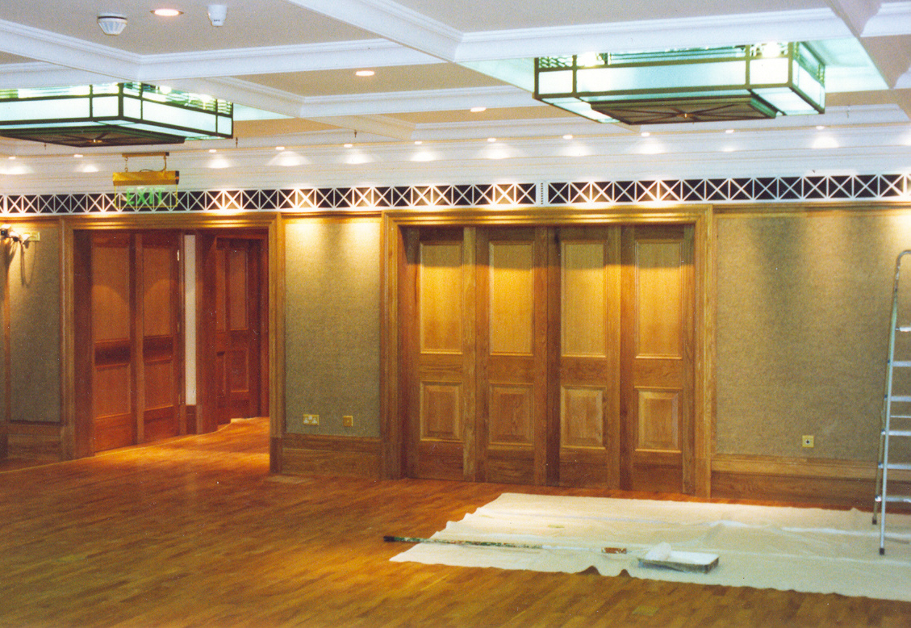
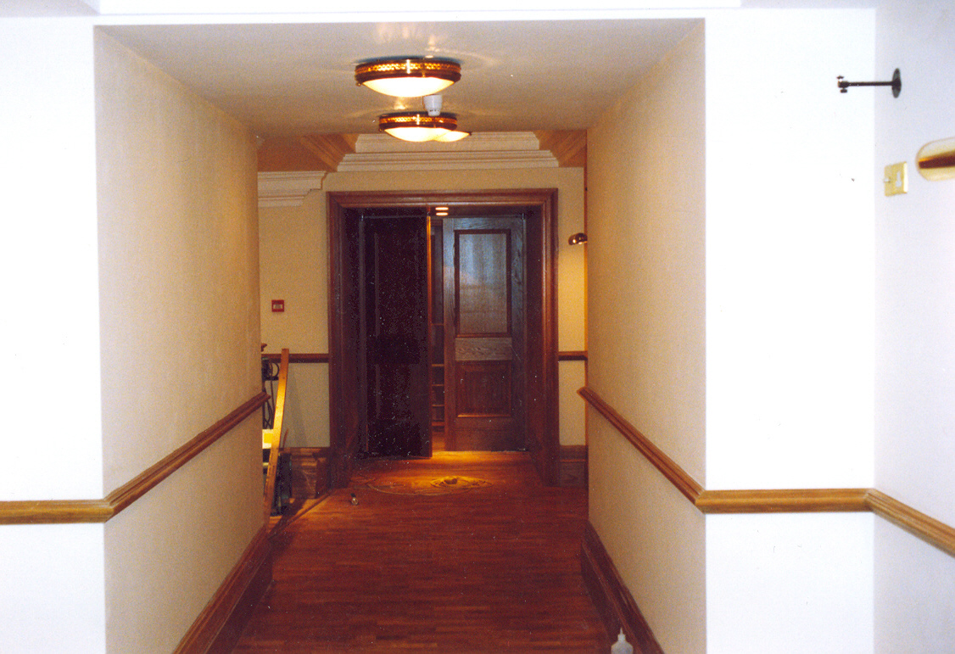
The use of a jointless ceiling in the corridors and display spaces allows quite different effects to be achieved.

