CHAPTER 2 CASE STUDY:

The building process

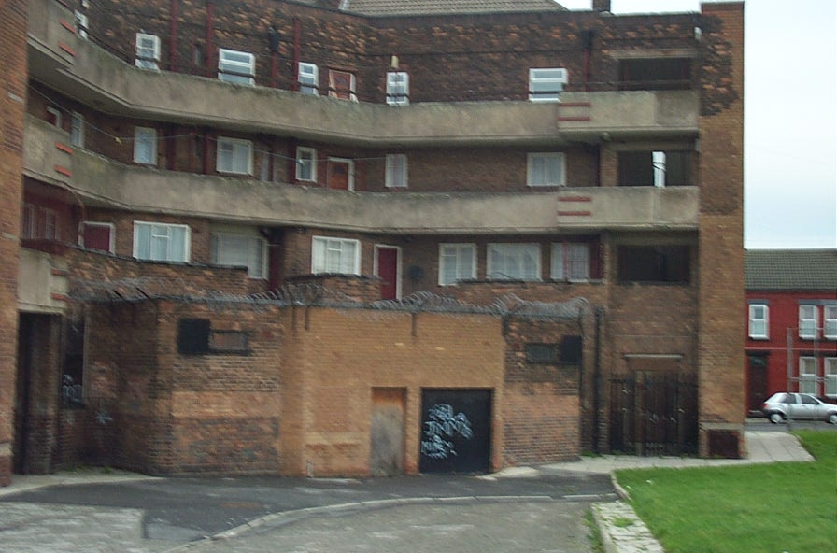
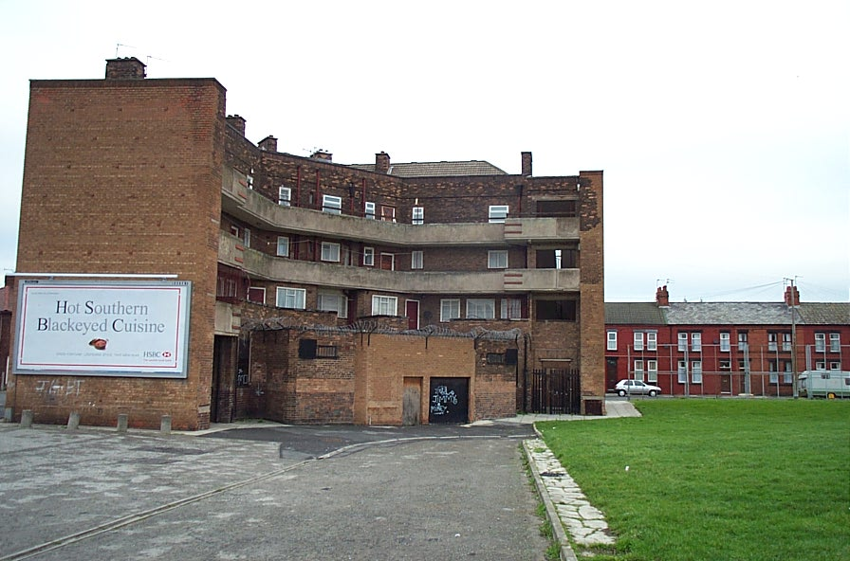

Here we see a building that has been constructed using a ‘cross –wall’ form of construction. The walls that run from front to back are formed in reinforced concrete; the front and rear walls are then constructed in masonry to create the enclosure and the gable walls are clad using masonry to give a traditional appearance. This system was common for dwellings in the 1960s and this typical ‘deck access’ form is characteristic of its time.

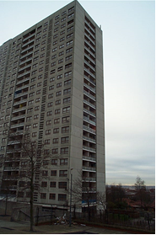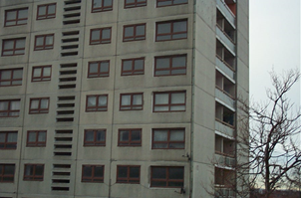

This high-rise accommodation block is constructed using a panelised system. The reinforced concrete panels forming the external enclosure are structural elements of the building. Similar panels are utilised internally to create a cellular construction form.

The following photos are to be used with the case study on page 53 of the book.

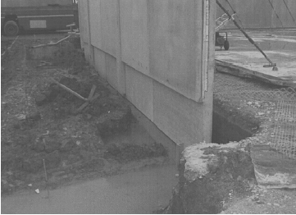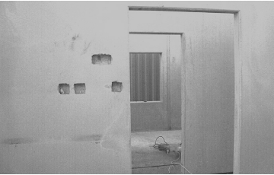

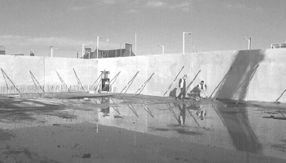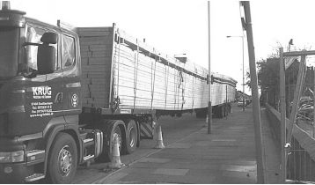

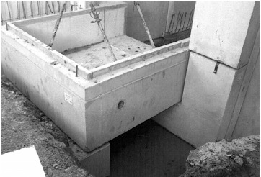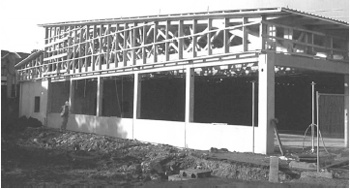
This is a case study of a single-storey commercial building, constructed using a number of MMC techniques.

