CHAPTER 4 CASE STUDY:

Foundations

Case study page 120
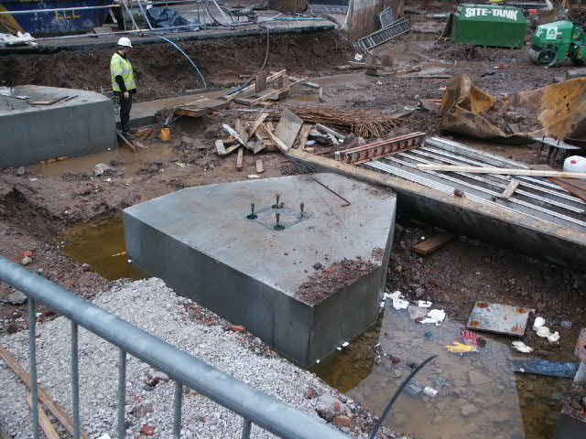
Here we see a pile cap for a group of three piles. This forms the base for the support of columns for the building superstructure.

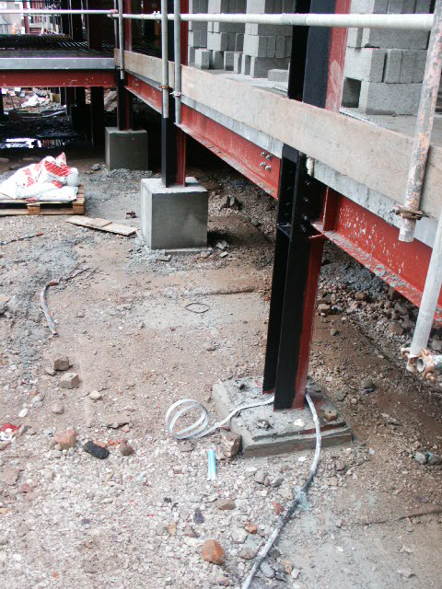

This photograph illustrates a series of independent pile caps supporting steel columns. Note that the column bases to the rear have been encased in concrete for protection from damage and corrosion.

Here we see a pile cap for a group of three piles. This forms the base for the support of columns for the building superstructure.

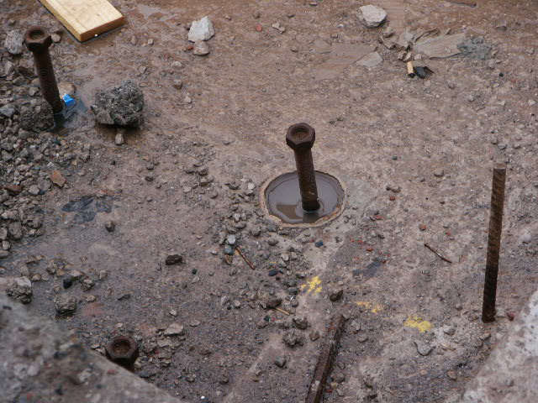
Here we see the captive bolts that will secure the column bases to the foundation. Note the enlarged hole, which allows adjustment of the bolt position.
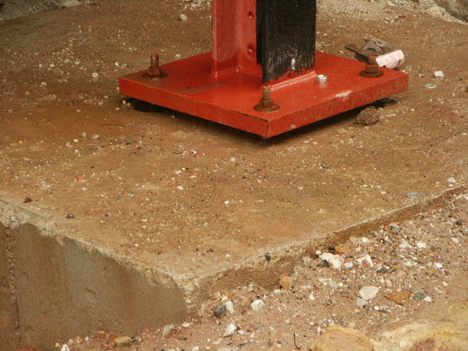

In the image above, note the gap beneath the column base plate in this photograph. This is due to the method of vertical adjustment based on metal shims placed between the concrete and the base plate. The gap will now be filled with grout.

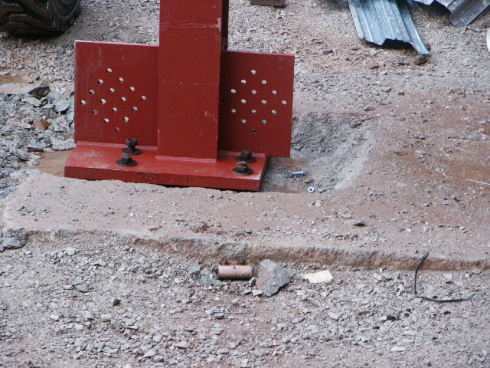
The picture to the left illustrates the consequences of getting the position of the foundation wrong. The pad has been cast too high and it is necessary to chip away some of the concrete to allow the column base to be seated at the correct height.

