CHAPTER 5 CASE STUDY:
Walls below ground and basement construction

Case study page 146
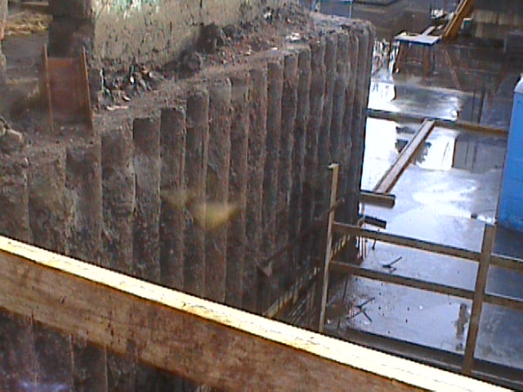
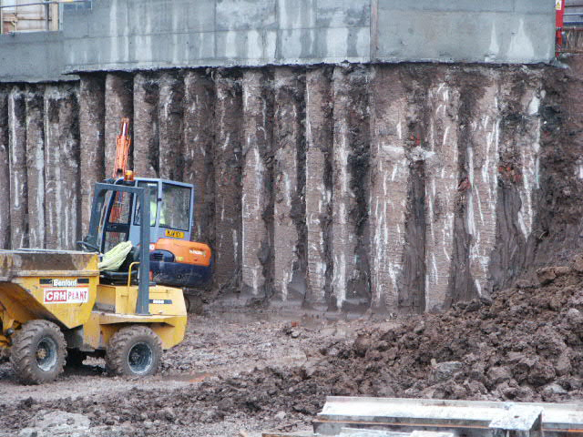

Here we see examples of contiguous and secant piling used to form basement walls. Note the concrete capping/ring beam which connects the piles and provides a sound base upon which to form the superstructure walls.

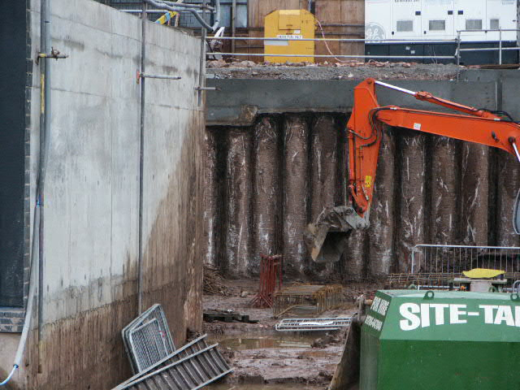
In this case we also see pre-cast, reinforced concrete sections used in conjunction with the secant piles.

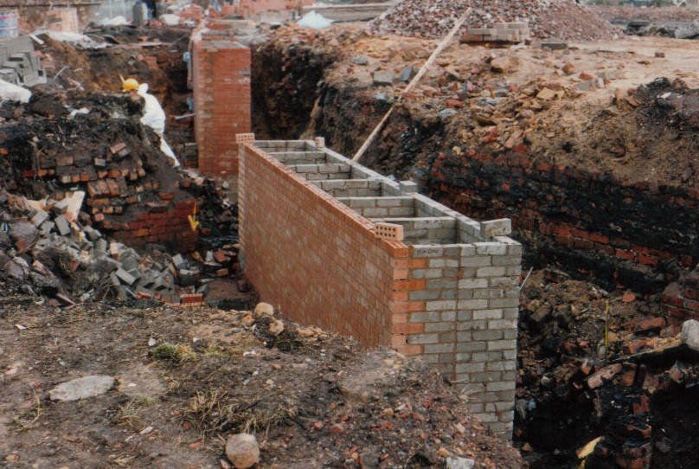
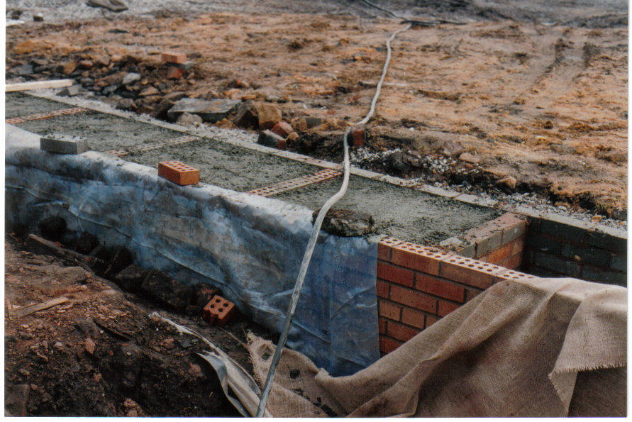

The photos above show a masonry diaphragm wall being used as a retaining wall between differing ground levels. Note the connecting fins between the inner and outer skin of the wall. The resulting voids are filled with concrete to ensure sufficient strength.

