14.5.1 Graphical Presentation with Minitab
During this tutorial you will learn how to use Minitab to explore data graphically and also how to edit your graphs. In this tutorial screen prints have been included initially help you understand the instructions. We shall use the data in Tutorial Question 2.2.
(More graphics follow in Worksheet 14.5.2)

14.5.1.1 Opening Minitab
Menus on your local network may be set up in a variety of ways and the method of opening Minitab will differ from one to another.

Open Minitab for Windows
You are now in Minitab with two windows open: the Worksheet window into which you will put all your data and the Session window which holds the record of all your commands and the resulting output. (See the diagrams in Section 14.4 - Introduction to Minitab.) Later you will use the Information window and the Chart window. Each of these windows can be saved and/or printed out during or at the end of the session.

14.5.1.2 Putting your data into Minitab
The following figures represent the ages of a sample of 60 employees of a firm Merlin plc:
35 44 54 33 46 20 32 19 50 39 33 37
42 40 20 25 34 52 27 22 18 40 23 17
41 45 21 34 49 27 60 46 32 58 23 52
24 64 41 47 54 37 40 41 40 36 46 29
34 39 39 40 37 50 41 34 47 34 45 36

Place the cursor over the data window, the Worksheet, in the first cell of the row below C1, column 1, and click the mouse. You are now in the cell which will contain the column heading for the first variable. You can move around the worksheet using the arrow keys.

Type the word Age and then, with the down arrow, move the cursor down to row 1 of C1. Type all the values in the table into column 1, one number per cell, using the down arrow between each. Work down the first column from 35 to 34 then continue down with 44 to 39, etc., until you have all 60 ages in the first column. Be very careful not to type any words into the data cells. Check that your final number is in row 60.
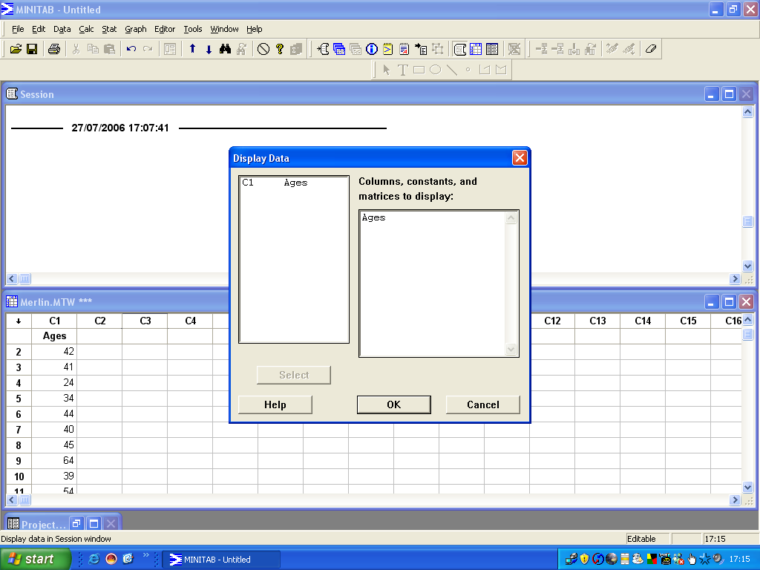
14.5.1.3 Checking your input
By printing the data into the Session Window you can check it at this stage and also have a record of it printed out at the end of the session.
Data / Display Data Click on AGE to select your variable and then Select. This variable is entered into the Display box.

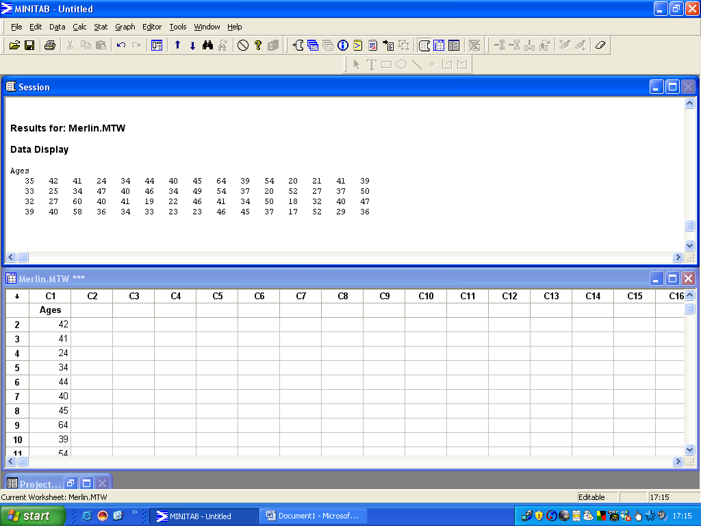
On pressing OK the data is printed into the Session window. Check the values with those above. If any is incorrect, just overtype the correct version into the worksheet.

14.5.1.4 Saving your data as a file
Once you are happy with the data, save it onto a disc, CD or onto your hard disc.
File / Save Current Worksheet as Merlin1. This has now been saved as a Minitab data file Merlin.mtw on the storage of your preference.

14.5.1.5 Producing a Histogram
We shall produce a simple histogram and then refine it.
Graph / Histogram / Simple Click on AGE, then Select; Labels / Title / Histogram of Ages then OK.
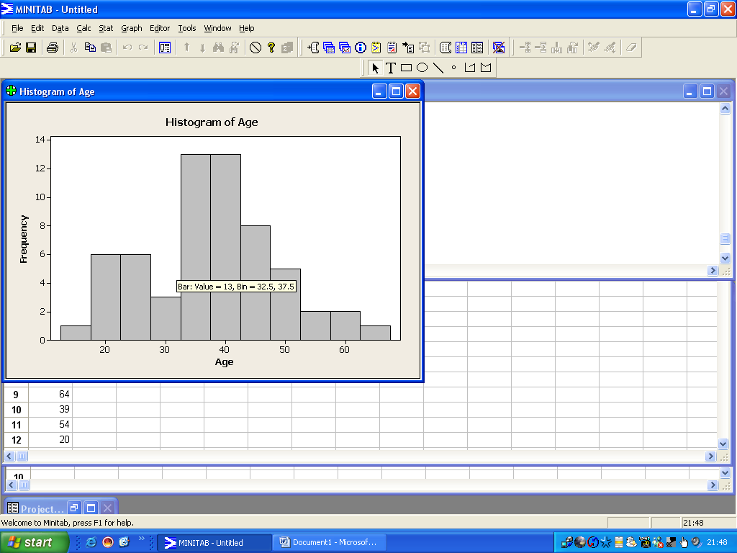
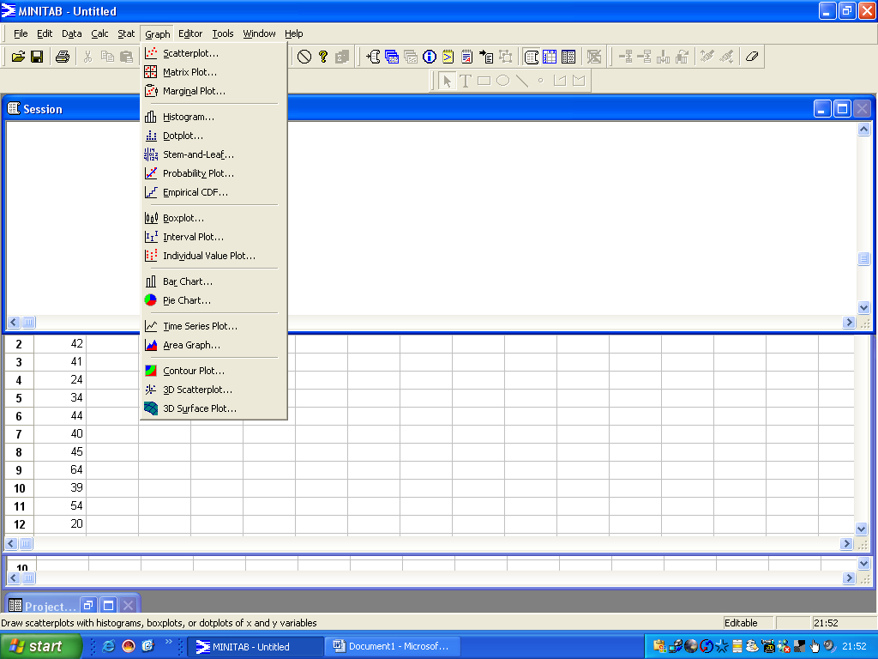
Double click on one of the X axis values to use the editor:
Binning: Interval type / Cutpoint

Interval definition: Midpoint/Cutpoint positions 15 20 . . . . . . . 60 65

Scale: Major tick positions / Position of ticks 15 20 …………..60 65 OK
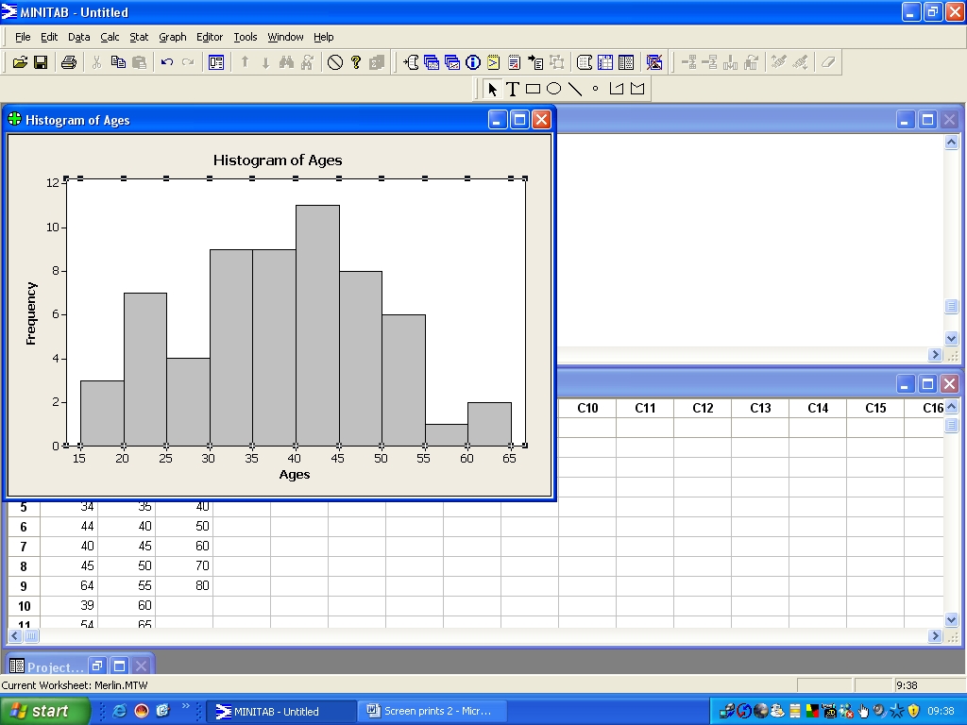
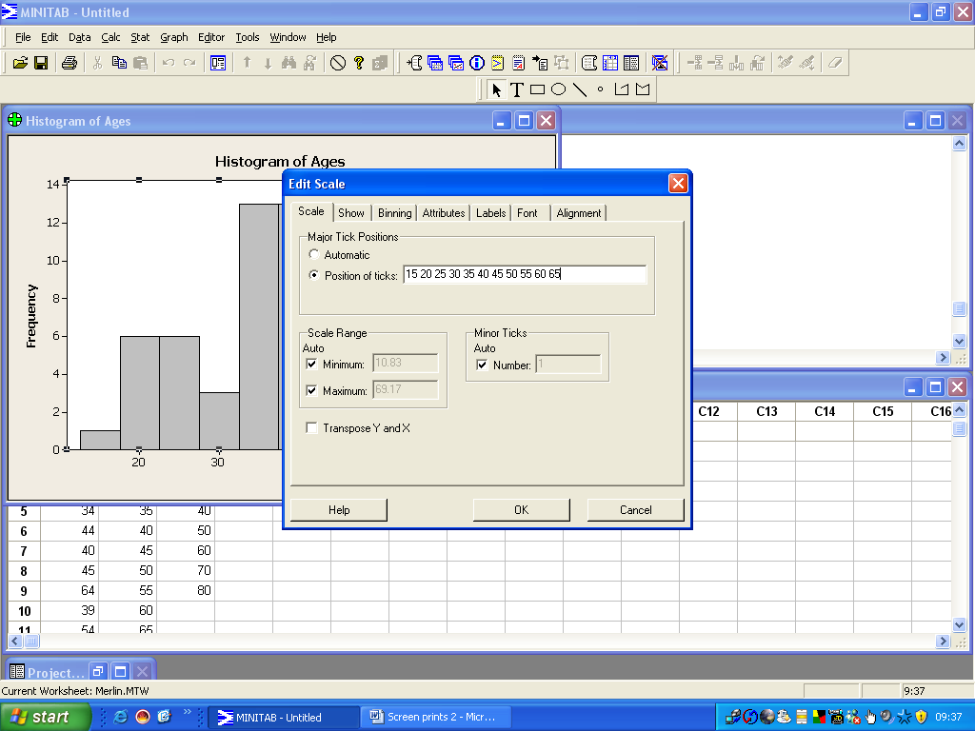

Have we too many bars?
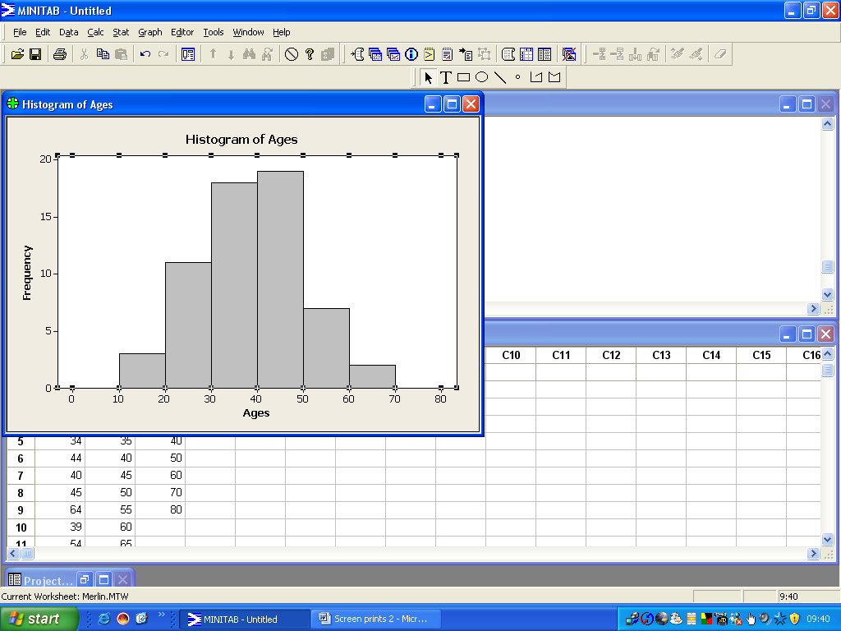
Try a different grouping: Type a new set of cut-off points and Major tick positions: 0 10 20 30 40 50 60 70 80, and produce a new histogram.
Which histogram do you prefer? We shall use the second one for the following tasks.
Note that all your graphs can be viewed using the 'Show Graphs Folder' icon on the top toolbar.

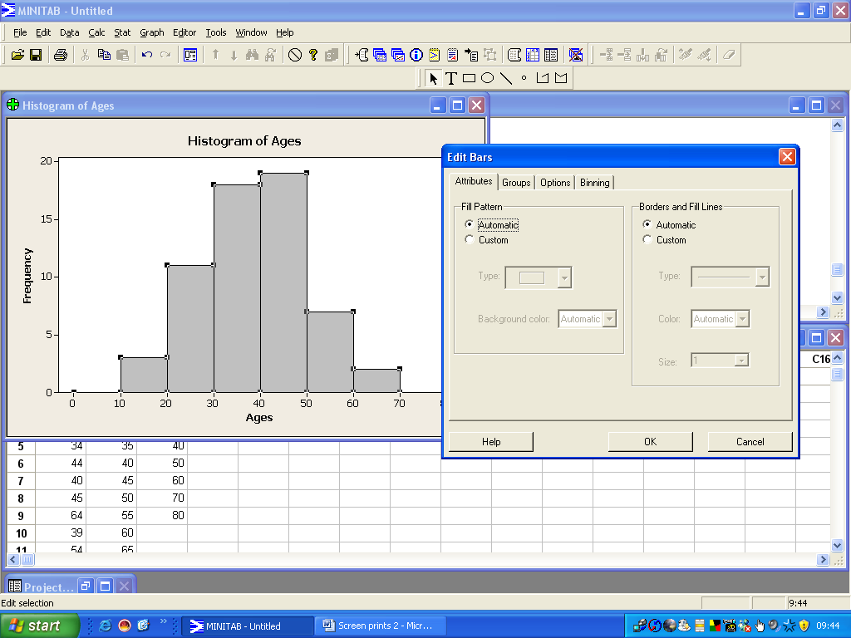
14.5.1.6 Editing a Graph
Right click anywhere within the graph to use editing mode. Edit bars. Colour and pattern can be applied to the histogram bars using the Fill pattern and Borders and Fill line options. Text and fonts can be altered, lines added to the graph, and so on. Try making many changes!

Save this graph before editing it further: Right click on the green cross in the top left corner and Save graph as: Histogram of Ages.

14.5.1.7 Adding a Frequency Polygon to a Histogram
Right click the title: Edit title / add polygon to the title.
Click on your histogram for editing mode. In the editing toolbar, click on the open polygon icon to use the line drawing tool. In the graph click on the position (5,0), then, in turn, on the centre of the top of each bar and finally on position (75,0). Double click on the final point to drop the line drawing tool.

14.5.1.8 Producing a Cumulative Frequency Ogive
The F3 key will clear the contents of the dialogue box. Produce a histogram as in Task 5.1.5 but from Scale select Y scale / Accumulate values across bars. Give it a suitable title. Alter the intervals as in Task 5.1.5. Edit as for the polygon using the open ended polygon icon to click on the cumulative frequencies at the end of each interval starting with (10,0), then (20,3) through to (80,60).
Does the ogive look a bit untidy? It would be clearer if the histogram were removed. Double click within the histogram to select it; from the Edit bars dialogue box select Custom for Fill patterns and borders. Select blank fill pattern, white background, white colour and no lines. You will be left with just the cumulative frequency polygon.

14.5.1.9
Next split the employees into two separate groups, male (1) and female (2), by coding the data. If the worksheet is not visible click the Show worksheets folder on the top toolbar.
Type the word Sex in the heading of the first empty column. Type 1 in the first 40 cells of the column and 2 in the remaining 20 cells.

14.5.1.10 Producing a Histogram of subgroups of data
Data / Split worksheet by / Sex You now have two extra separate worksheets
Repeat Task 5.1.5 for each new worksheet.

14.5.1.11 Producing a Barchart of the subgroups of data

Graph / Barchart / Simple / Select SEX

14.5.1.12 Producing a Stem-and-leaf plot from Worksheet Merlin1

Graph / Stem-and-leaf Select AGE and OK.
You probably have stems of width 5. If you would prefer wider ones, repeat the command for the plot but, this time, type 10 in the increment box.
As with the histograms, either of these plots is quite acceptable. Make sure you can interpret this output.
This graph appears in your session window and can be printed out with the rest of this output at the end of your session.

14.5.1.13 Producing a Dotplot

Graph / Dotplot / Simple Select AGE and OK.
For this plot each case is represented by a single dot, that is, the data is ungrouped.
Replace the major ticks at 0 10 20, etc.

14.5.1.14 Producing a Boxplot
Graph / Boxplot / Simple Select AGE and give your graph a title.
We can see that the middle half of the data ranges from about 31 to about 46 and that the extreme values are at about 17 and 64.

14.5.1.15 Printing out the Session contents and your graphs
When you have completed your tutorial you probably have some errors in your session window. These can be deleted by highlighting the unwanted sections and deleting them as you would in Word. When you are happy with the remaining material print it out, make sure that your cursor is in the session window; then print it out:

File / Print Session Window / OK
Each graph needs printing separately when on top.

File / Print Graph / OK

14.5.1.16 Saving your work onto your preferred type of storage
All your work (data, session and graphs) can be saved as a project:

File / Save Project as Merlin1.MPJ to save as a project file.

The data can be saved separately as a datafile:
File / Save Current Worksheet as Merlin2.MTW to save as a datafile. (Already saved.)

The session output can be saved separately as a text file:
File / Save Session Window as Merlin1.TXT to save your session window as a text file.

