14.2.1 Graphical Presentation with SPSS
During this tutorial you will learn how to use SPSS to explore data graphically and also how to edit your graphs. In this tutorial screen prints are included initially to illustrate some of the instructions. We shall use the data from Tutorial Question 2.2. (More graphics follow in Worksheet 14.2.2)

14.2.1.1 Opening SPSS
The main menu on your local network may be set up in a variety of ways and the method of opening SPSS will differ from one to another.

Open SPSS for Windows
You are now in the opening dialogue box. Select Type in Data / OK for a new file. The SPSS Data Editor opens in either Data View or Variable view.

14.2.1.2 Entering your data into SPSS
The following figures represent the ages of a sample of 60 employees of a firm Merlin plc:
35 44 54 33 46 20 32 19 50 39 33 37
42 40 20 25 34 52 27 22 18 40 23 17
41 45 21 34 49 27 60 46 32 58 23 52
24 64 41 47 54 37 40 41 40 36 46 29
34 39 39 40 37 50 41 34 47 34 45 36
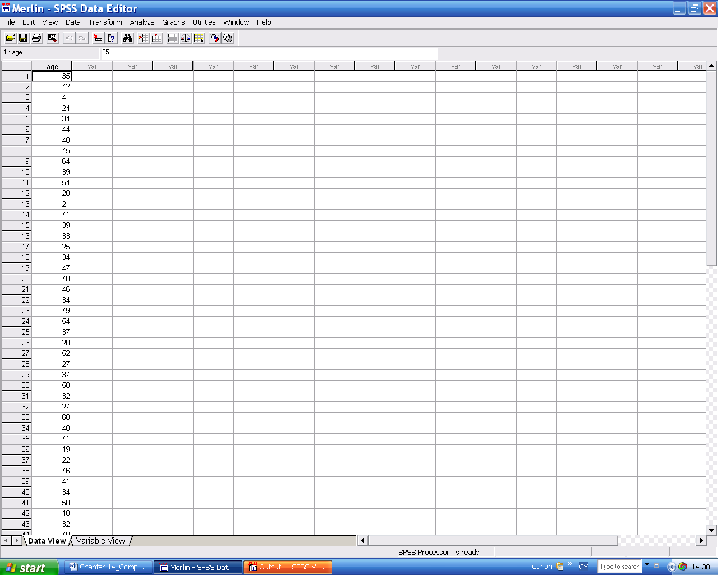
In Variable View row 1 name the variable Age. Label it Age of Employee and, if necessary, change the decimal places to 0.

In Data view type all the ages in column1 under Age working systematically through them down the columns above from 35 to 34, 44 to 39, etc. all in one column. Check that the final row number is 60.
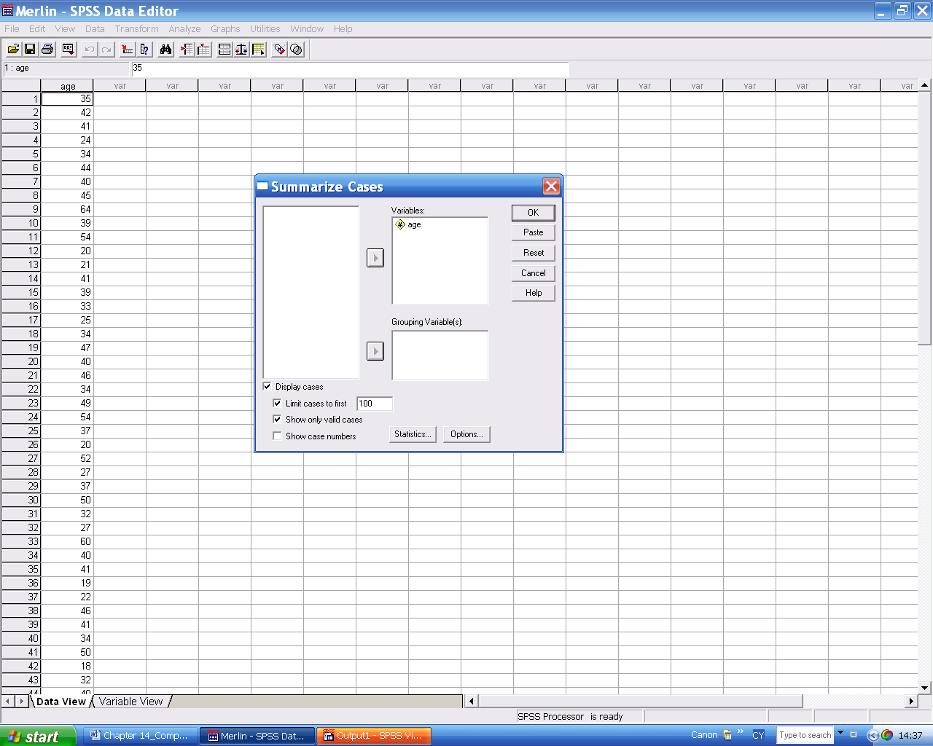

14.2.1.3 Checking your input
By printing the data into the SPSS Viewer you can check it at this stage and also have a record of it for printing out at the end of the session.
Analyse / Reports / Case Summaries Select Age and then click on the arrow to move it over to the active Variables box.
Any analysis is performed on the variables in this right hand box and not on the others which remain unselected in the original list.
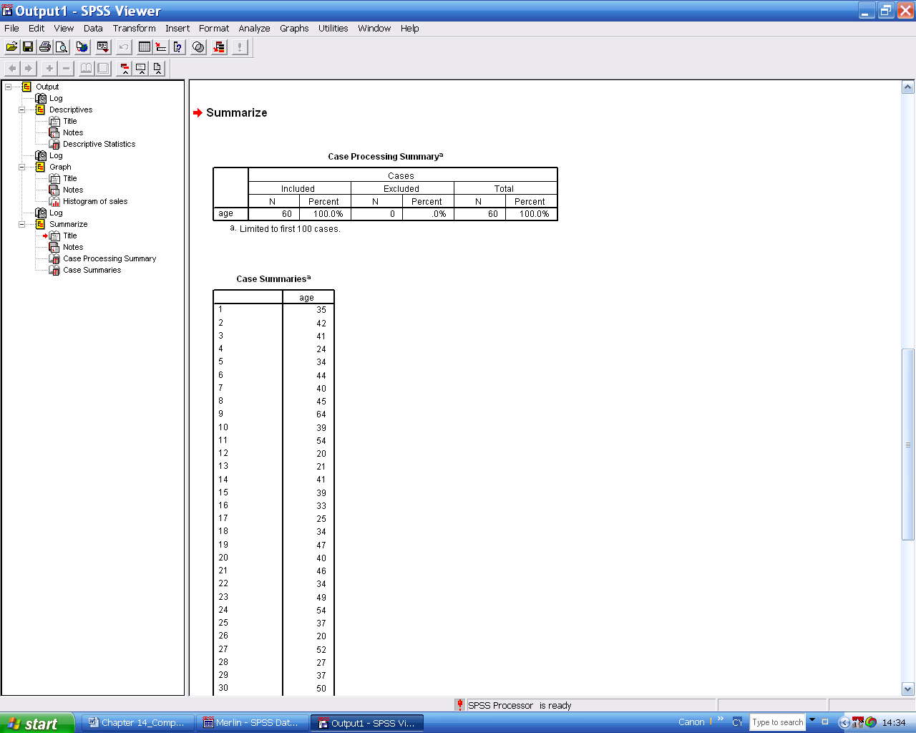
On pressing OK the data is printed into the SPSS Viewer window. Check the values with those above. If any is incorrect, just overtype the correct version into the data editor.

14.2.1.4 Saving your data as a file
If you are happy with the data save it to a disk, CD or onto your hard disk.
With the data window on top File / Save as Merlin1 and Save. Your data has now been saved as an SPSS data file 'Merlin1.sav' onto your preferred type of storage.

14.2.1.5 Producing a Histogram
We shall first produce the default histogram and then another more refined version.
Graphs / Histogram Select AGE as your variable and then OK.
The default histogram appears as a chart in the SPSS Viewer which can be printed out, saved as a separate file or exported into a Word file. It has no title and the default bar width is not a sensible one. We shall improve on this.
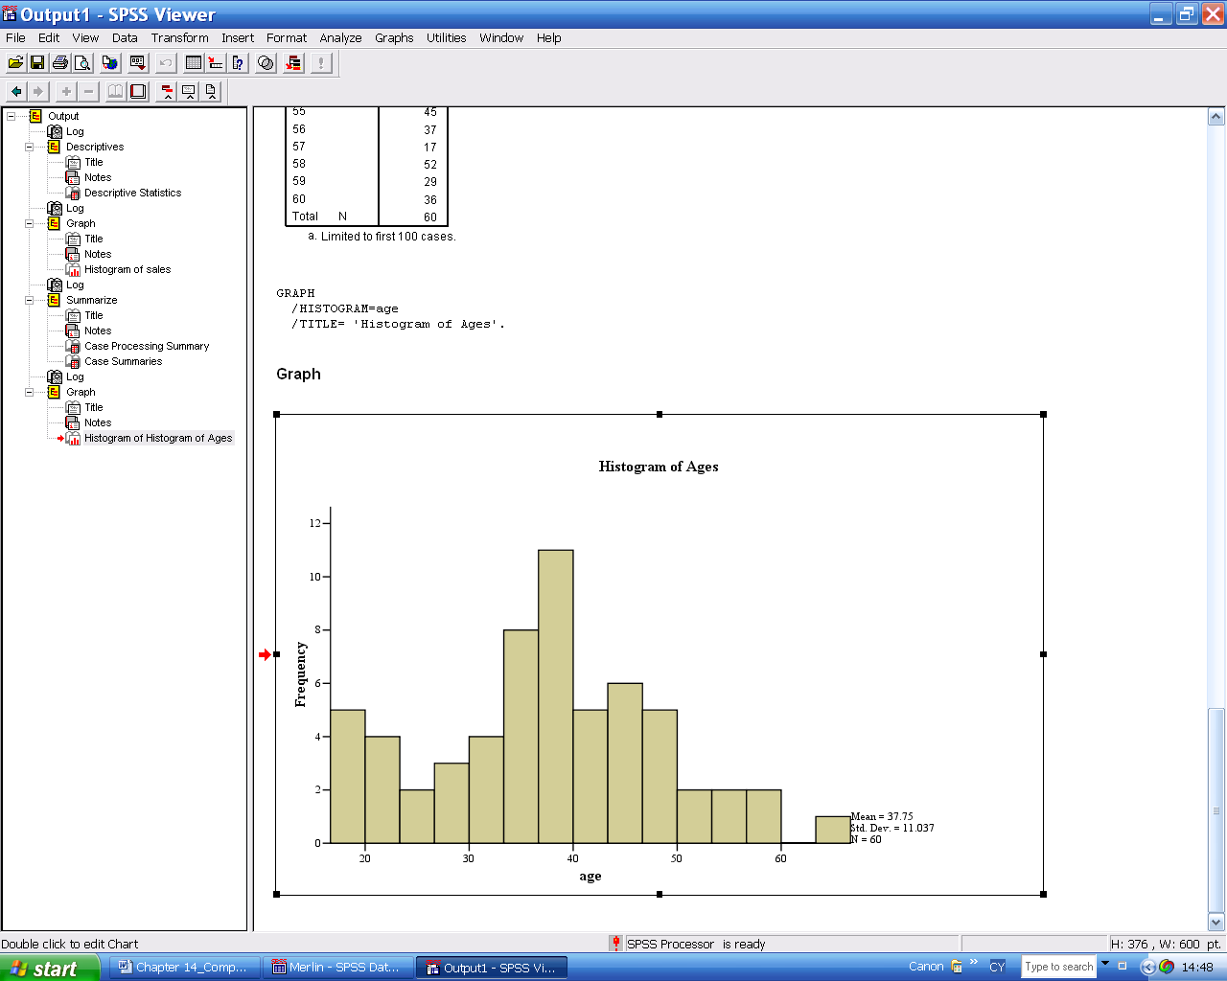

Graphs / Histogram Select AGE, then Titles and type in something like Histogram of Ages, and Continue then OK.
Improve on the default bar width: From the toolbar, with the histogram selected: Edit / SPSS Chart Object / Open / Edit / Properties / Histogram options / Bin sizes / Custom interval width 5 / Apply / Close / X (on the toolbar)/Scale / Range Custom / Minimum 10 / Maximum 70 / Major increments 5 / Apply / Close
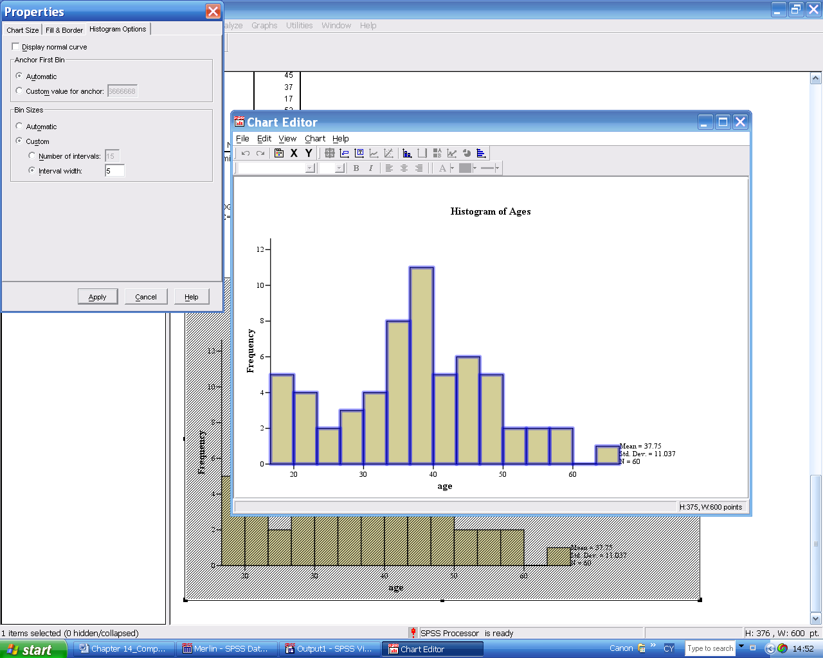
(Alternatively the Chart Editor can be opened by double clicking on the histogram in the SPSS Viewer.)
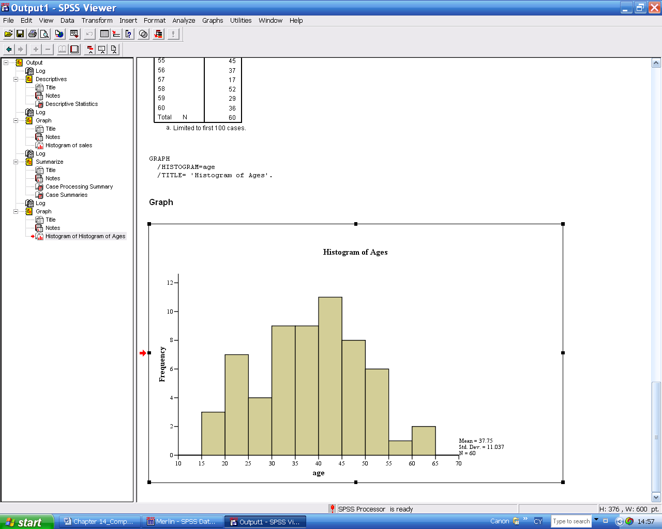
Your graph has a title and the scale on the horizontal axis is more reasonable. Don't worry about the mean and standard deviation; we shall be considering those in Chapter 3. We shall edit this histogram further as the next task.

14.2.1.6 Editing a Graph Further
Double click anywhere within the graph to open up the Chart Editor with its tool bar. Pointing with the mouse at any of the icons tells you its specific purpose. Single clicking on any element within the chart window selects it, double clicking opens the Properties dialogue box. Colour and pattern can be applied to the histogram bars using Fill and Border. Try changing colours and patterns. Text and fonts can be altered using Text.

SPSS does not offer the options of producing frequency or cumulative frequency polygons.

14.2.1.7 Producing a Stem-and-leaf plot and a Boxplot
Analyse / Descriptive Statistics / Explore Move AGE into the Dependent List, Display Plots rather than Both.
Among other output you will find a stem-and-leaf plot with stem width of 10 and each case represented by one leaf and a Boxplot. You can see from both that the data distribution is symmetrical, that the lowest value is 17 and the highest 64 and, from the boxplot, that the middle half of the data ranges from about 31 to about 46. Make sure you can interpret both these graphs.

14.2.1.8 Include a second variable
Next split the employees into two separate groups, male and female, by coding the data.
Click the Goto Data grid button. Click on column 2 in Data View and then type 1 in the first 40 cells of column 2 and 2 in the remainder. In Variable View name this new variable SEX, label it Sex of Employee and change the decimal places to 0. Code the variable label as 1 for Male and 2 for Female.

14.2.1.9 Select subgroups of data
Data / Select cases / If condition is satisfied / If Sex = 1 / Continue / OK
For the males only, repeat tasks 2.1.5 and 2.1.6.
Data / Select cases / All cases
Data / Select cases / If condition is satisfied / If Sex = 2 / Continue / OK
For the females only, repeat tasks 2.1.5 and 2.1.6.
Data / Select cases / All cases

14.2.10. Produce a Barchart
Graphs / Bar / Simple /Define / Category axis SEX Give your barchart a suitable title.

14.2.1.11 Print out the Session contents
When you have completed your tutorial you probably have some errors in your session window. These can be deleted by selecting each of the unwanted sections in turn by clicking on them and deleting them with the Delete key. When you are happy with the remaining material print it out, making sure that your cursor is in the Viewer window, then:

File / Print / OK

14.2.1.12 Saving data and session output (if required)
Data / Select cases / All cases
With the cursor in the data sheet:
File / Save as Merlin2.sav to save the data as an SPSS file.
With the cursor in the SPSS Viewer:
File / Save window as Merlin1.spo to save your output window if you wish.

