14.4 Introduction to Minitab
Minitab is a powerful tool originally developed at The Pennsylvania State University as a teaching aid for introductory statistics courses. It is now one of the most widely accepted statistical analysis packages for college instruction and is also an established research tool. It is becoming more sophisticated with each version and now includes many forms of multivariate analysis.
Minitab offers the facilities common to all Windows applications. The version used here is 14.0. It is upgraded regularly so that one problem is keeping up with the literature. It offers an excellent series of tutorials which should be worked through. It also includes a comprehensive 'Help' facility at any stage.
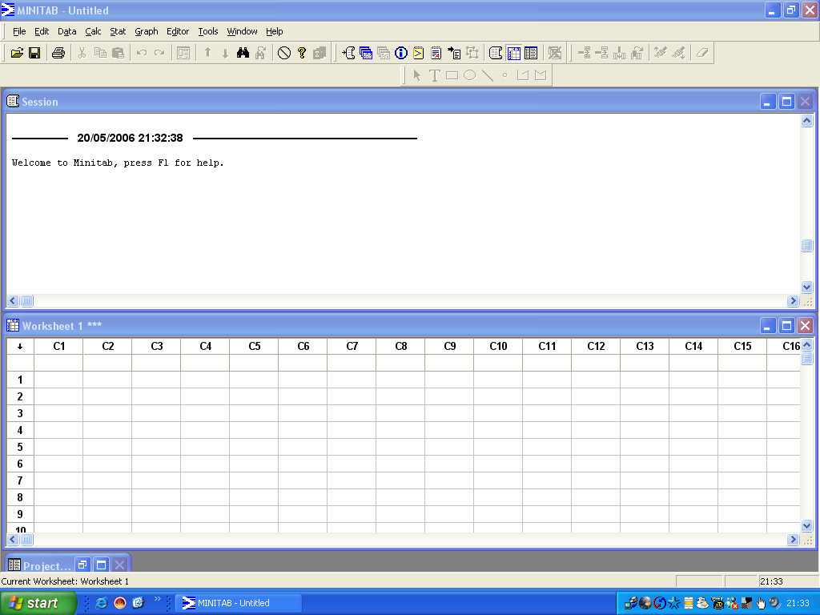
On initially entering Minitab a split window is automatically set up.
The lower half, the Worksheet, is for entering data. If you enter data from an existing file the heading changes to the name of that file. The Session window keeps a listing of all your commands and output. Each of these windows can be edited, saved, pasted to another Windows application and/or printed out in the usual manner.

Numerical data only are typed into the grid with each column containing the measurements on one particular variable and each row containing the measurements for a particular case. The variables are named (limited to eight characters) in the cells between the column numbers and row 1 of the data cells.
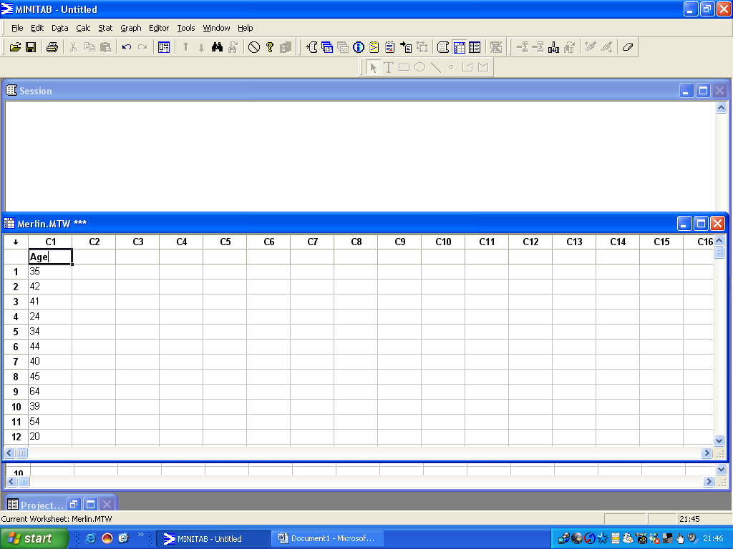
The output in the Session window can be edited before being saved, printed out or copied and pasted to another application such as Word.

14.5 Minitab Worksheets
Throughout this tutorial selections from menus, dialogue boxes or buttons are shown in bold italics separated by the slash sign /; VARIABLES in capitals; and characters you need to type in bold. As your experience increases the degree of detail in the instruction decreases.
The assumption is that you have not used Minitab previously and that you are familiar with Windows.
Minitab is not fussy about capitals but is very fussy about having only numbers in its worksheet. It remembers that letters have been typed into the grid even after they have been deleted so take care! In the Data menu there is ‘Change Data Type’ which can be used to rectify this problem.
(The full output from all the sheets, including the graphics, is included in the Instructor’s material on the Internet.)

