14.1 Introduction to SPSS
SPSS, the Statistical Package for the Social Sciences, was originally developed in the USA to enable data from surveys and experiments to be analysed ‘fully and flexibly’. It includes a wide range of procedures for both simple and highly complex methods of analysis which allows for very sophisticated analysis. Its weaknesses are mainly in the output from the simpler forms of analysis may not be immediately interpretable, although this is improving with each new version.
SPSS offers the facilities common to all Windows applications. It is supplied with an excellent Tutorial which you should either work through or refer to as needed.

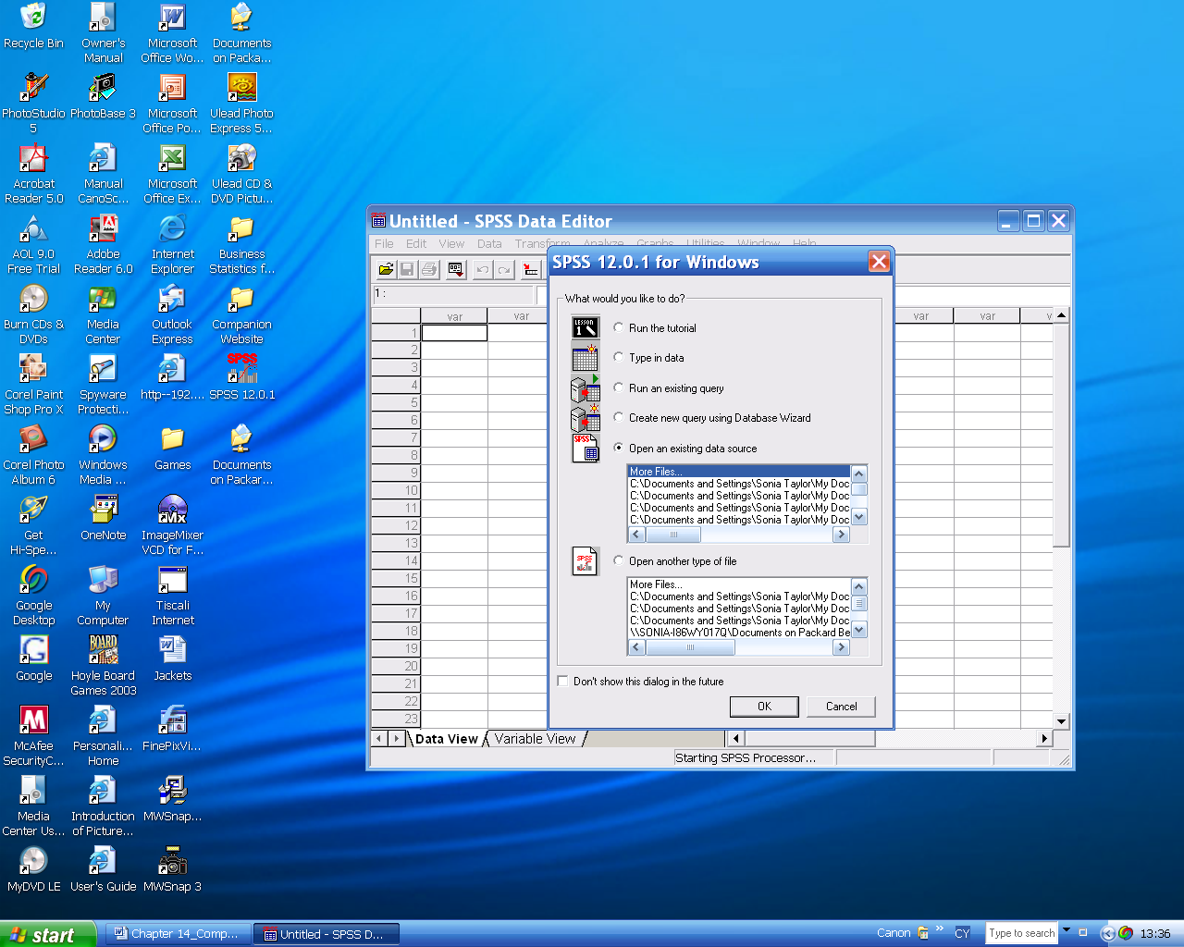
On initially entering SPSS you are offered some choices. If you wish to use a file which you previously created you can select it from 'Open an existing data source'. If you wish to create new file then select 'Type in data'. If you don't wish to use this box you can cancel it and select 'Don't show this dialogue in the future.

Whatever you choose the ‘SPSS Data Editor’ opens automatically. This has two windows: the Variable view for entering the names and descriptions of the variables and the Data view is used for entering their data values. A pair of tabs on the lower right hand side of the window indicate which view is which.
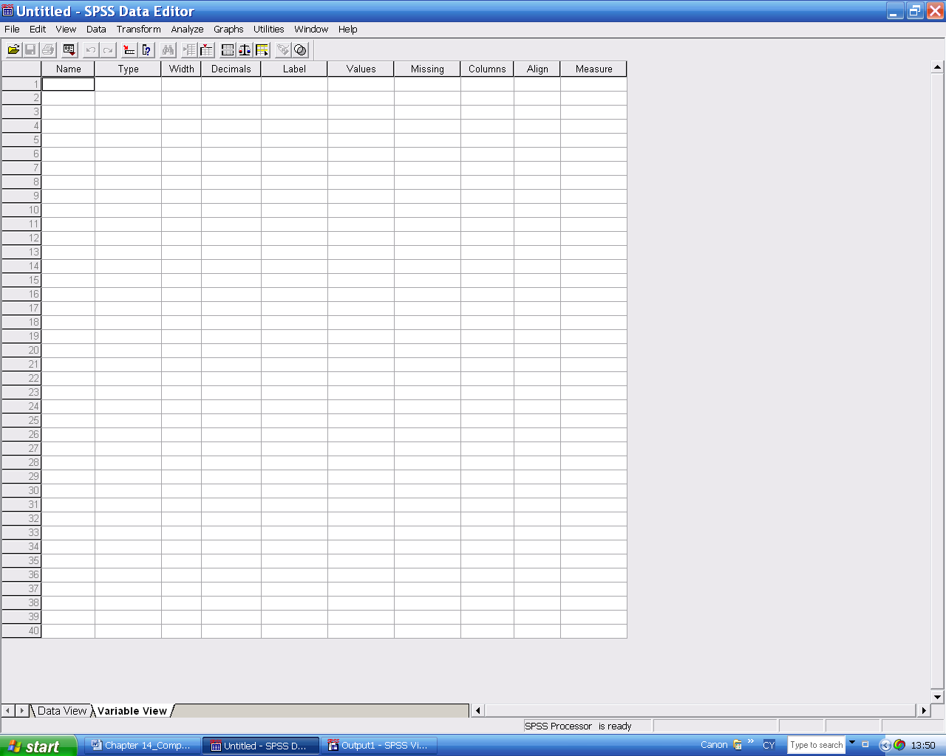
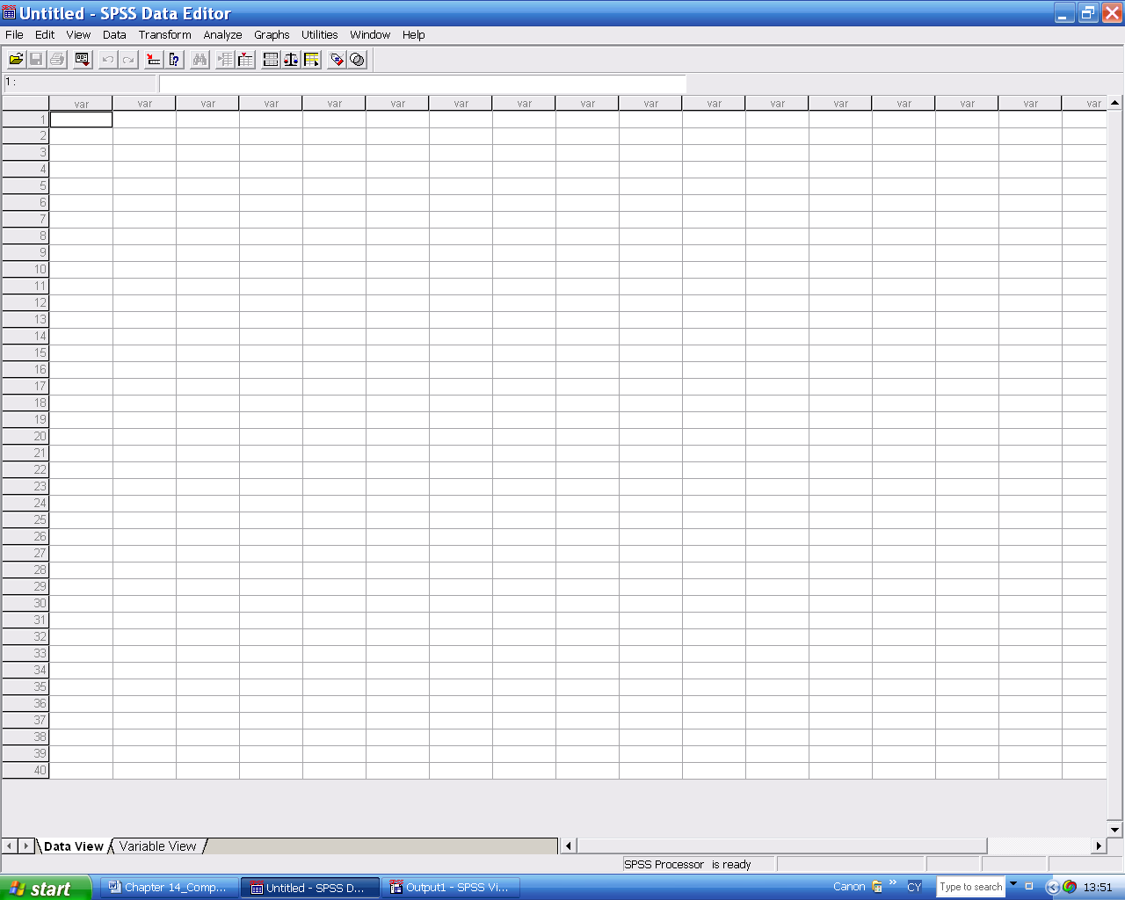

If you enter data from an existing file the heading changes to the name of that file.
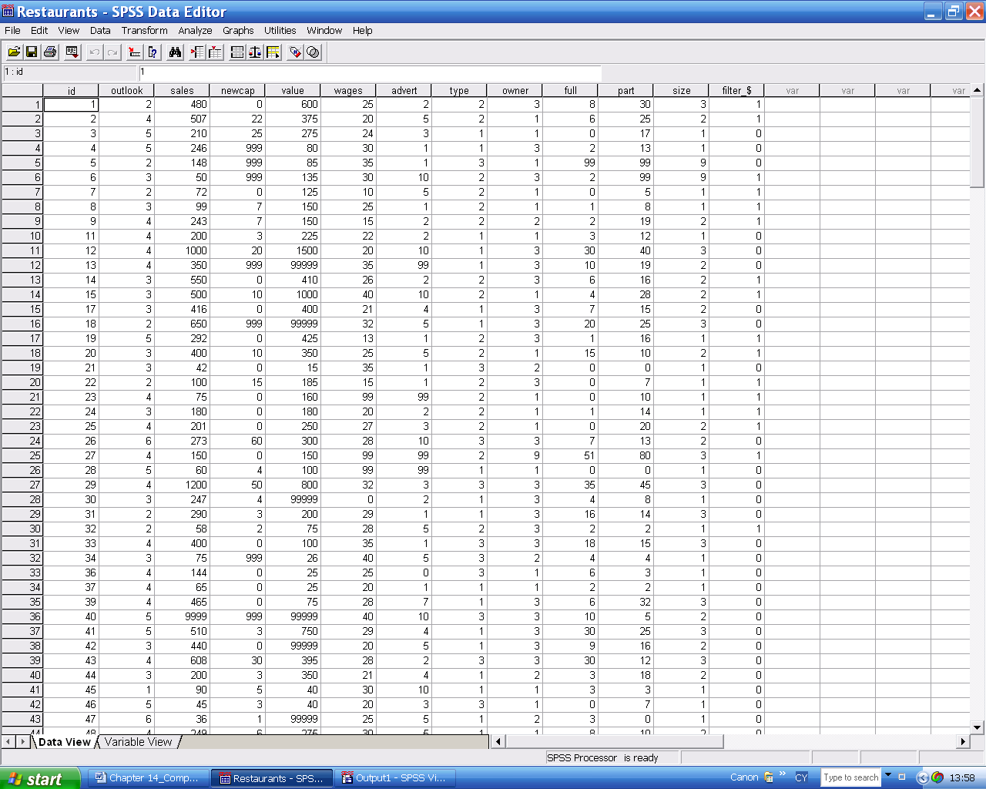
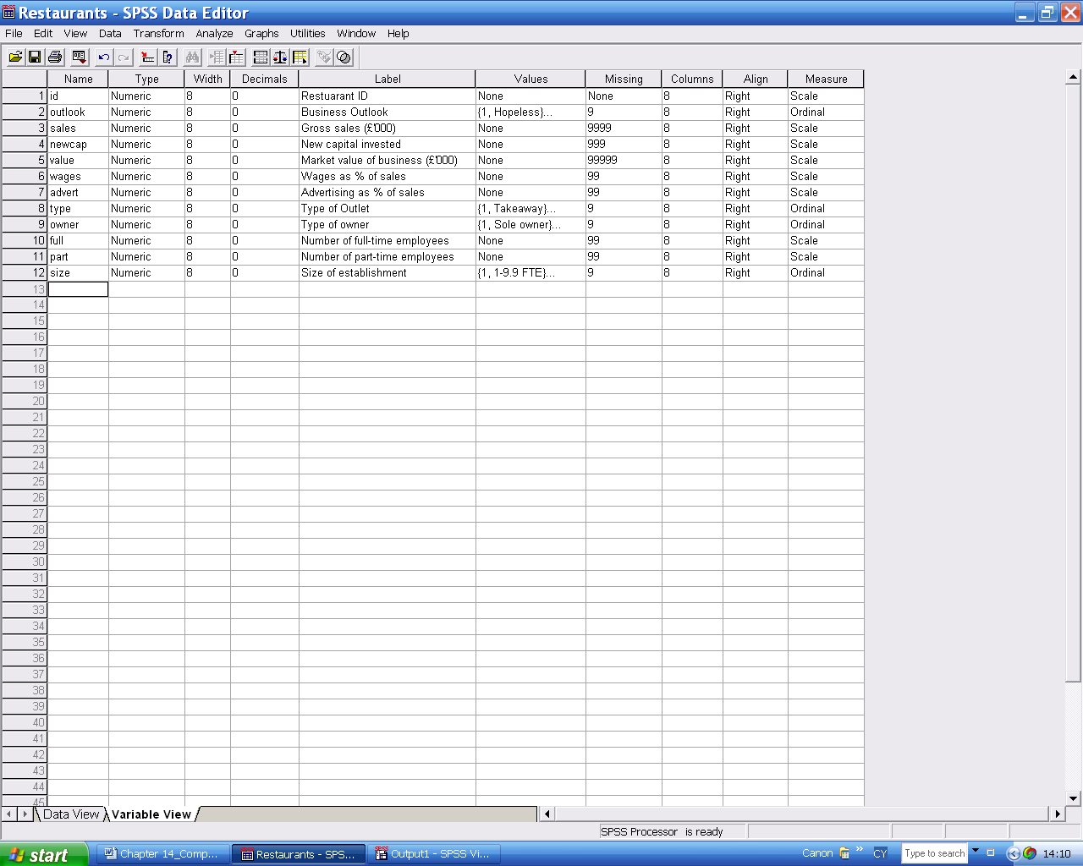

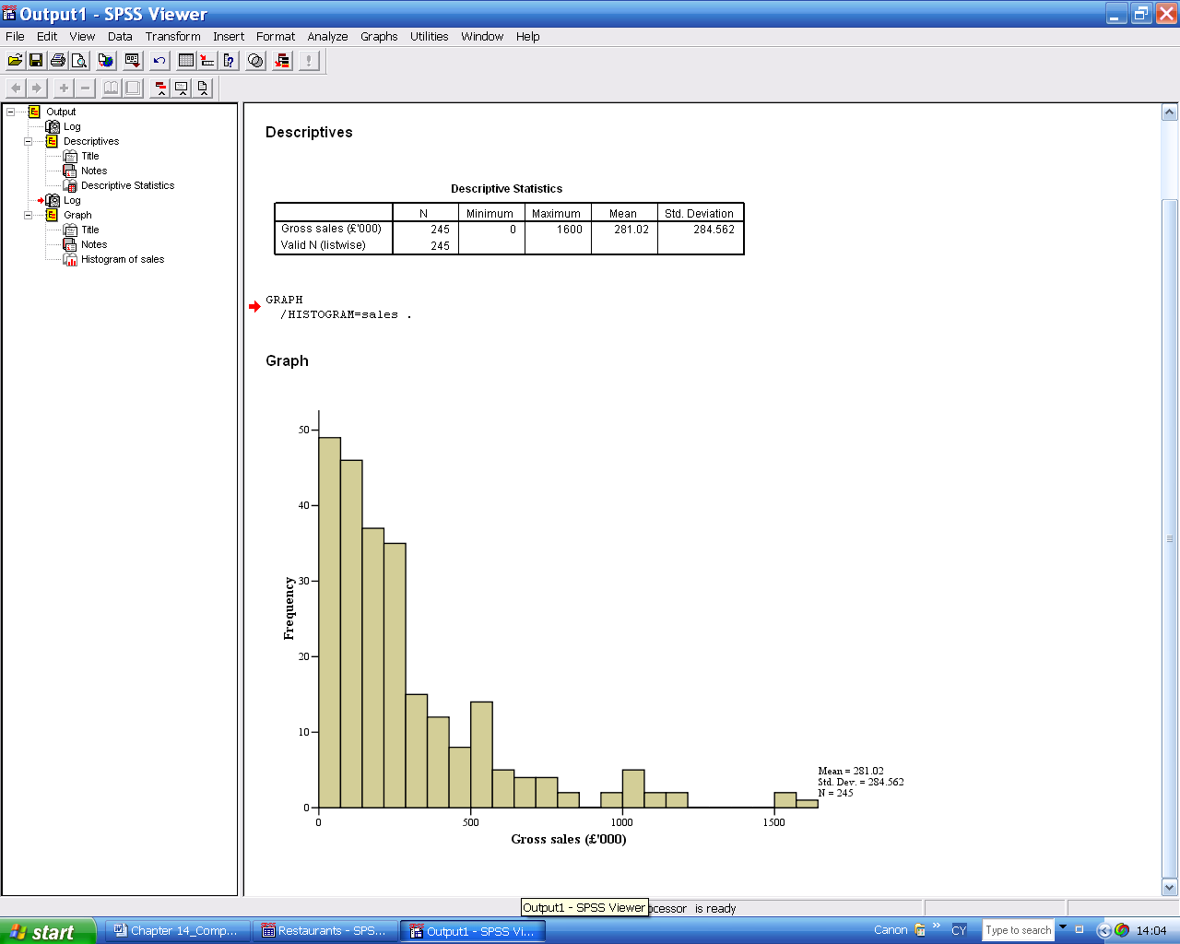

As soon as you do any work the ‘SPSS Viewer’ window opens to keeps a listing of all your commands and output including the charts.
Each of these windows can be edited, saved, pasted to another Windows application and printed.

Numerical data is entered into the grid in Data View in the usual manner with each column containing the measurements on one particular variable and each row containing the measurements for a particular case. The characteristics of each variable are described in the Variable View grid. The variable name is limited to eight letters but its label, which is what appears on graphs and tables can be any length.
The output which appears in the Viewer is in the form of ‘Objects’ which can be edited in SPSS, saved, deleted, printed out, exported to other applications. The amount of output is rather copious so it is a good idea to delete regularly any which is not needed, especially before copying and pasting into a word processor for assignments, projects, and so on.

14.2 SPSS Worksheets
Note: The commands in these worksheets are from SPSS Version 12.0.1.
Throughout this tutorial selections from menus, dialogue boxes or buttons are shown in bold italics separated by the slash sign /; VARIABLES in capitals; and characters you need to type in bold.
The assumption is that you have not used SPSS previously even though you are probably familiar with Windows.
Numerical answers to all the questions in these worksheets are to be found in Section 14.3. (The full output from all the worksheets, including the graphics, is included in the lecturers' material on the Companion website.)

