**Understanding Developmental Psychology**

**Student Guide**

1. **Get the best out of this book**
2. **How to be a brilliant student: advice on study skills**

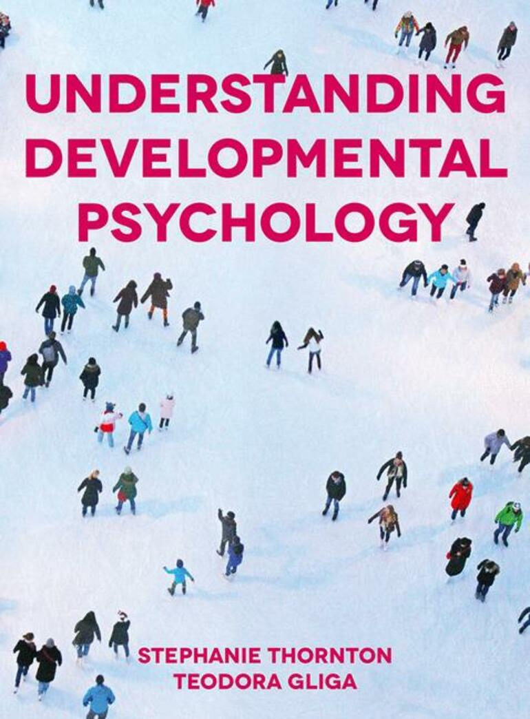

**Get the best out of this book**

What’s the best way to read a textbook? That depends on how the book has been structured.

At the end of each chapter you will find a revision summary. These summaries are a précis of the whole chapter, listing all the key points.

Throughout each chapter there are ‘student activities’, designed to put what you are learning to work, and stretch your thoughts and understanding

* Understanding Developmental Psychology has been written so that you can read it in any order you like. Each section of the book has been written to stand alone, so that you can dip into it, looking up the topics that interest you without needing to read the whole book to understand the material. If there’s more information which you might find useful somewhere else in the book, the index will help you track it down
* But you can also, of course, read the book from cover to cover, which will give you a coherent overview of Developmental Psychology as a whole
* You can use the revision summary as an ‘aide memoire’, to remind yourself of what you have read in the chapter.
* But you may find it useful to read the revision summary before you read the chapter. Read in advance, the revision summary will give you a ‘map’ which can structure your reading – and can serve as the basis for taking notes from the book or in lectures, or for making plans for essays or seminar papers.

**How to be a brilliant student: advice on study skills**

Becoming a student, writing essays and presenting seminars at University can be a daunting business. This section of the website covers frequently asked questions and aims to enhance your study skills.

**What’s the best way to take notes in lectures and seminars?**

All too often, the notes we take in a lecture or seminar seem to make perfect sense at the time – but are utterly incomprehensible a week or so later. Key tips for better note taking are:

* Do some reading around the topic beforehand, and get a rough idea what the important points or issues are – and build your notes around that (You can use the revision summaries at the end of each chapter of the book to provide this sort of ‘advance map.

Rewrite your notes soon after the lecture, restructuring them to reflect the key points better

Rewrite your notes again once you’ve done more reading and developed a better understanding

* Nowadays, you are often provided with the lecture material and may annotate in that text. Lecturers vary in how condensed the information they put on slides is so make sure to make notes where the text is not sufficiently clear. Sometimes it is easier to record the lecture and go over it and the slides, at a later date.

**How much do I need to know about a topic?**

This is a ‘billion-dollar’ question. There is so very much research on every topic in Psychology that no-one can read it all – not even your professor! Luckily, this doesn’t really matter. Only a small proportion of research is actually seminal (that is to say, ground-breaking or crucial). Quite a lot does no more than provide ‘interesting twiddles’ on the mainstream.

What matters is that you gain a critical understanding of the core issues for a given topic, and a familiarity with the key research addressing those issues. It’s the job of a textbook to tell you what the core issues are in any topic, and to summarise the key research – and *Understanding Developmental Psychology* will give you an authoritative guide.

Just between you and me, if you can thoroughly understand all the issues discussed in this book and can master the research it describes, you’ll know enough to pass most undergraduate exams, and more importantly, you’ll know enough to have an educated opinion. But, where something sparks your interest, you should try to read some of the key research papers indicated in the book, to get a more detailed view and to get a more ‘hands on’ feel for how research is done.

How much should you read beyond what it says in the textbook? That depends:

* On the guidance given by your particular lecturer and the reading lists he or she provides. Extend your reading to match the requirements of the particular course you’re taking
* On your own enthusiasm for a given topic: read what sparks your curiosity rather than just for exams

But however enthusiastic you are, however ambitious the reading list on your course, you’re going to have to be selective in what you read – because no-one can read it all.

The art of selectivity is to:

* Pick the research papers or books the textbook or your lecturer indicate to be the most important or the most interesting
* Don’t waste time reading papers which just repeat what you’ve already read (you can tell that from the abstract and skimming the introduction)
* Look for detailed reviews of the topic in prestigious journals such as Child

Development or the Annual Review of Psychology - and look for meta-analyses which cover many studies of the issue in hand

* And for the special essay: Do a psycinfo search on the topic: look for recurrent themes and controversies in the titles of articles – then read the abstracts of those articles to refine your search for what’s worth reading.

**What is a ‘critical understanding’?**

*“This essay is completely uncritical”* - most students will hear these dispiriting words at some time or another. But what does it mean? What, exactly, is a ‘critical’ understanding? And how am I to get one?

Google ‘critical understanding’ and you will be bombarded with websites offering incomprehensible polysyllabic definitions / anecdotes from past centuries / diatribes of despair about the lack of critical thinking in society today. It’ll make your brain hurt, and you’ll be none the wiser (unless you’re very different from me).

In my view, the key thing about a ‘critical understanding’ is that it is an intellectually defensible opinion that shows a clear grasp on the issues.

**Getting a grip on the key issues in the topic**

The crucial thing here is really understanding what the problem is.

* What puzzle is research trying to solve?
* Why does this problem matter?
* What differences of opinion are there between researchers – and why do different researchers think differently?
* What are the implications of their different theories?

**Developing your own critical opinion**

* The crucial thing here is deciding which theory or explanation you think is right – and why
* It’s NOT just a matter of opinion, where anyone’s opinion is as good as any other! That is not a critical opinion – that’s a prejudice
* What you need to do is to act like a detective
* Start with a clear understanding of the problem and an open mind
* What evidence would support one theory better than another?
* Is there any crucial evidence which rules out one theory and supports another?
* How good is that evidence – how reliable? In other words, how sound are the methods which produced it?
* Imagine you had to defend your conclusion to a court – have you got enough evidence, and is it convincing?
* Have the courage to say – ‘we don’t know the answer, we haven’t got the right evidence’ if that’s the case

Remember: there is no absolute truth, and there are no definite facts (see Chapter 1, pages 24 to 20).

* All there is – for any scientist – is a theory which you can defend as being better than alternative theories in the light of the evidence we presently have.
* Accept that, act on it and you’ll develop a critical understanding.

**What makes a good essay?**

An essay is a complex exercise. To write a good essay you must not only demonstrate a good critical grasp on the issues and research, but also deliver a well-structured piece of writing that communicates clearly.

A good essay has a definite beginning, middle and an end – and it should stick to the point and avoid waffle (you’d be surprised how often students overlook these simple facts!)

* The opening paragraph of a good essay lays out a clear agenda: it spells out the question to be answered – the issue or controversy to be covered, so that the reader has a clear and focused idea of what the essay is supposed to be about. There’s no waffle
* The body of the essay then presents and critically evaluates the research addressing that issue; this should be organised in a way that follows a logical order, for example first discussing evidence for and then evidence against a particular idea
* So that the last paragraph can sum up the conclusions emerging from that critical analysis

A first class essay (grade A, 70% plus) shows an intelligent and incisive grasp on the issues and sets up a clear agenda for the discussion to follow. It then demonstrates a comprehensive and critical understanding of the relevant research, using this research to directly address the question set up in the introduction in a focused way. The conclusion follows directly from this discussion – emerging from the critical evaluation of the relevant research and issues.

A good second class essay (2:1, grade B, 60-69%) must also show a good grasp on the issues, set up a clear agenda for the essay, provide a critical review of the relevant research and reach a conclusion which follows from that review. The difference between this B grade essay and an A grade one is a matter of degree: the first class essay has a deeper insight into the issues, a more critical grasp (you explicitly say why a piece of evidence is more or less conclusive) of the research and its strengths and weaknesses and presents a more incisive analysis and a better defended and sharper conclusion. The A grade essay is more of an argument and less of a summary of research than the B grade. The A grade essay has an intelligent critical opinion and an authority of its own – it often makes suggestions for future research that could further clarify the issues discussed– whereas the B grade essay is more conventional, sticking more closely to describing and supporting conventional opinions.

A weaker second class essay (2:2, grade C, 50-59%) may or may not be well written, but its ideas are more muddled than those in a B grade essay. The issues are presented in rather a woolly way, there’s no clear agenda in the introduction. There may be errors of understanding. The research review is less comprehensive, less critical and less focused – typically, there is much in the essay that has no relevance at all. Since the discussion is not well structured, the conclusion often is not justified – and may not have much to do with either the introduction or the discussion in the body of the essay.

The key difference between this C grade essay and either an A or a B is that, where the A and the B both address the issues and the research in a focused and insightful way (with a greater or lesser success), the C grade essay typically simply lists or summarises everything the writer can remember about some key word in the title – and then presents a conclusion which has not been critically justified in the discussion.

You’d be surprised how many students don’t read the title of the essay carefully before setting out to answer the question - a sure recipe for a C grade or worse.

A third class essay (grade D, 40-49%) shows even less grasp on the issues and even less critical skill than the C grade essay. There are more mistakes, and more muddles. Like the C grade essay, a D grade essay basically tries to summarise all the writer can recall about the topic in question without analysing the issues in an intelligent way – and so does not provide a focused argument and cannot hope to come to a defensible conclusion.

**Hypothetical essay outlines across the grades**

The question: How would you test the IQ of a dolphin?

**Grade A**

Reflects insightfully on the question: for example, since IQ is defined as what IQ tests measure and dolphins can’t take those tests, trying to measure dolphin IQ is not straightforward. The starting point must surely be a better conception of what intelligence is, before one can begin thinking whether this concept can be applied to dolphins, or how it could be measured in a dolphin? The essay then focuses on a discussion of theories about the nature of intelligence / the origin of individual differences in ability, before discussing how any of these concepts might apply to dolphins or how such individual differences between dolphins might be measured.

**Grade B**

Accurately summarises the history of IQ testing, showing a clear understanding of that history; points out that dolphins can’t take human IQ tests; uses the principles of IQ test design to invent new tests appropriate for aquatic mammals which might effectively measure dolphin IQ.

**Grade C**

A less accurate and insightful summary of the history of IQ testing than a B grade, and an attempt to construct a dolphin IQ test which shows less grasp on psychometric methods.

**Grade D**

A poor summary of IQ testing and showing a poor grasp on psychometric principles. Little insight into the key issues.

Quite apart from the intelligence of your understanding, writing is a skill in its own right. There are many websites which offer good advice on essay writing for example:

* <http://www2.actden.com/Writ_den/tips/essay/index.htm>
* <http://www.studentnow.com/features/essayswritingtips3.html>
* <https://www.theguardian.com/education/2017/mar/07/how-to-write-an-essay>

**How do I prepare a seminar paper to lead a discussion?**

Seminar presentations usually contribute less to your final course grade than essays or exams (though it’s worth checking) – but somehow, they can be more stressful.

Many students are very anxious about public speaking – and about exposing their talent (or confusion) to their peers. Comfort yourself: everyone in your group is in the same boat – and no matter how confident they seem, will almost certainly be feeling the same fear. And then there’s the tutor, who has to do this kind of thing at every class - and who certainly understands the pressures.

What is the point of a seminar presentation? Of course, it’s like an essay in that it’s a test of your knowledge and critical skills. But whereas in an essay the primary aim is to produce your own critical conclusion, in a seminar presentation the primary aim is to stimulate and lead a group discussion.

As in writing an essay, your seminar paper needs to have a clear agenda and to present a focused and critical overview of the relevant research.

The aim is to give your listeners enough information so that they can understand the issues and take part in a discussion (just in case there are others in the group who haven’t done any preparation, which happens too often…).

But where a good essay works its way toward a focused conclusion, a good seminar presentation throws the floor open for an interesting discussion and exchange of ideas.

Have a clear idea what debate you want to follow from your paper, and write the seminar paper to set that up.

Presentation style matters.

* Mumbling in a monotone will send everyone to sleep!
* So will talking for too long
* Giving out handouts which summarise your main points and pose the question for discussion is helpful

**How can I make the best of the internet for my studies?**

Thirty years ago, all the material a student studied came from a library and was published either in a book or in an academic journal. Books and academic journals are written by experts, and they are checked by other experts before they are published, so that you have some sort of guarantee that the contents are reliable and intelligent.

Material on the internet is very different. Some sites are as carefully vetted as books and journals, and as reliable – but many are not. You need to be a great deal more cautious and critical when taking material from the internet than when taking it from a book or academic journal in your University library.

It is not always clear just how reputable a website is. Google any topic and you’ll get hundreds, perhaps thousands, maybe millions of ‘hits’ - and what comes top isn’t the site with the most reliable information – it’s just the site with the most ‘hits’: which may be reliable, or may be rubbish.

Use the internet! Not to do so would be as absurd as a scholar 1000 years ago refusing to use a library! The internet is simply the best library in the world: It contains (or shortly will contain) everything. It’s the most amazing resource we’ve ever had – a source of tutorials on skills, of information at your fingertips richer than any previous generation could have imagined. But to use this resource you will need a cunning and a caution which no library user 1000 years ago even imagined. You will need far more critical skill than our ancestors did. They approached a library in awe and respect. You must approach the library of the internet with intelligent scepticism.

**Tips for making the most of the internet:**

* Ask: who endorses this site? A respectable institution such as a University or a reputable publisher? An unknown individual or agency? The best sources to look at are peer reviewed articles from prominent research journals or institutions – more and more of which are available online
* What’s the calibre of argument: something defendable as a critical opinion? Or not?
* If it’s not from an obviously trustworthy source – be suspicious. If it’s not from a trustworthy source and the argument doesn’t make sense, doesn’t amount to a critical opinion – be more than suspicious - be very, very sceptical.
* But keep an open mind! Gallileo wasn’t exactly in the mainstream with his ideas – and nor was Darwin. But their ideas stood up to critical appraisal and won the day (eventually)
* If you come across an interesting idea from an unknown source – cross-check it with more reputable sources – for example, by looking for research endorsing those ideas in respectable academic journals – perhaps through a psycinfo search?

There are many very reputable and very useful websites on the internet, for example:

* Psycinfo where you can search for research articles on every subject, across a very wide range of books and journals, and download the abstract (summary) of the article – or, in some cases, the whole article.
* You can pay to use psycinfo as a private individual (about $12 for 24 hours’ use for a websearch; or $15 to download a full article), or your library or department may provide all this free.
* Many academic journals are now available on the internet – and many offer complete articles free. Google Scholar offers direct links to open access versions of many research articles.
* The British Psychological Society provides a regular and very readable summary of interesting new research. You can subscribe (free) and have this sent to your email, or read the blog – go to the BPS website to sign up
* Many universities also provide very reputable websites where they list their faculty and the faculty describe their research