**Syringe drivers**

**The Answers**

#### Exercise 1

Using the information given, consider the preparation of the syringe driver (1 hour Graseby) and answer the following:

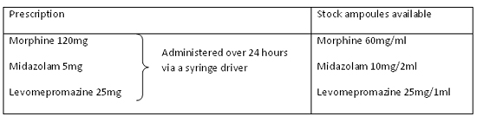

**1.** How many millilitres of each of the drug ampoules would you draw up?

* Morphine 2ml, Midazolam 1ml, Levomepromazine 1ml

**2.** What syringe size would you use?

* 10ml syringe

**3.** What volume would you make the syringe up to?

* Make volume to length 48mm

**4.** What rate would you set the syringe driver for?

* 2mm/hr

**5.** If you set the driver running at 11:20hours what time is it due to be renewed?

* 11:20hrs the following day

#### Exercise 2

Using the information given, consider the preparation of the syringe driver (1 hour Graseby) and answer the following:

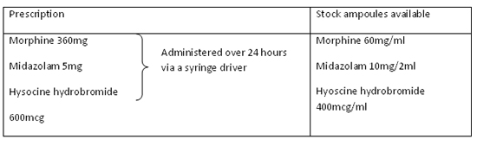

**1.** How many millilitres of each of the drug ampoules would you draw up?

* Morphine 6ml, midazolam 1ml, hyoscine hydrobromide 1.5ml

**2.** What syringe size would you use?

* 20ml syringe

**3.** What volume would you make the syringe up to?

* Make volume to length 48mm

**4.** What rate would you set the syringe driver for?

* 2mm/hr

**5.** If you set the driver running at 11:20hours what time is it due to be renewed?

* 11:20hrs the following day

#### Exercise 3

Using the information given, consider the preparation of the syringe driver (24 hour Graseby) and answer the following:

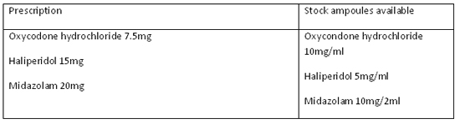

**1.** How many millilitres of each of the drug ampoules would you draw up?

* Oxycodone hydrochloride 0.75ml, Haliperidol 3ml, Midazolam 4ml

**2.** What syringe size would you use?

* 20ml syringe

**3.** What volume would you make the syringe up to?

* Make volume to length 48mm

**4.** What rate would you set the syringe driver for?

* 48mm/24hours

**5.** If you set the driver running at 11:20hours what time is it due to be renewed?

* 11:20hrs the following day

**Exercise 4**

Using the information given, consider the preparation of the syringe driver (24 hour Graseby) and answer the following:

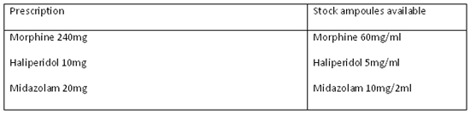

**1.** How many millilitres of each of the drug ampoules would you draw up?

* Morphine 4ml, Haliperidol 2ml, Midazolam 4ml

**2.** What syringe size would you use?

* 20ml syringe

**3.** What volume would you make the syringe up to?

* Make volume to length 48mm

**4.** What rate would you set the syringe driver for?

* 48mm/24hours

**5.** If you set the driver running at 11:20hours what time is it due to be renewed?

* 11:20hrs the following day

#### Exercise 5

Using the information given, consider the preparation of the syringe driver (1 hour Graseby) and answer the following:

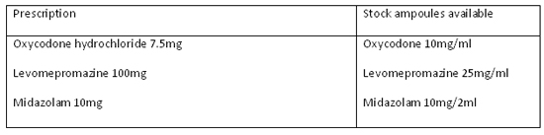

**1.** How many millilitres of each of the drug ampoules would you draw up?

* Oxycodone Hydrochloride 0.75ml, Levomepromazine 4ml, Midazolam 2ml

**2.** What syringe size would you use?

* 10ml syringe or 20ml

**3.** What volume would you make the syringe up to?

* Make volume to length 48mm

**4.** What rate would you set the syringe driver for?

* 2mm/hour

**5.** If you set the driver running at 14:10hours what time is it due to be renewed?

* 14:10hrs the following day