Confidence with numbers

**Learning outcomes**

**This chapter offers you opportunities to:**

* build your confidence in using numbers
* identify the kinds of number-related activities you are most likely to need at university
* recognise and understand the technical terms used in number-related study
* understand how to use fractions and percentages
* calculate three kinds of averages (modes, medians and means) and five-number spreads
* round numbers up or down
* understand the basics of interpreting data in graphs, tables and charts.

Most subjects at university involve using numbers – it isn’t only science and maths subjects that require you to analyse and present data, and to perform numerical operations.

Many students feel uncertain about their abilities in working with numbers. They may struggle to remember what they learned at school about ‘percentages’ and ‘averages’, or feel perplexed about terms such as ‘mode’, ‘median’, or ‘quartile’. If you don’t feel

confident with numbers, it may be tempting to skim quickly over texts that contain figures, data or mathematical terms, hoping that you can avoid thinking about them.

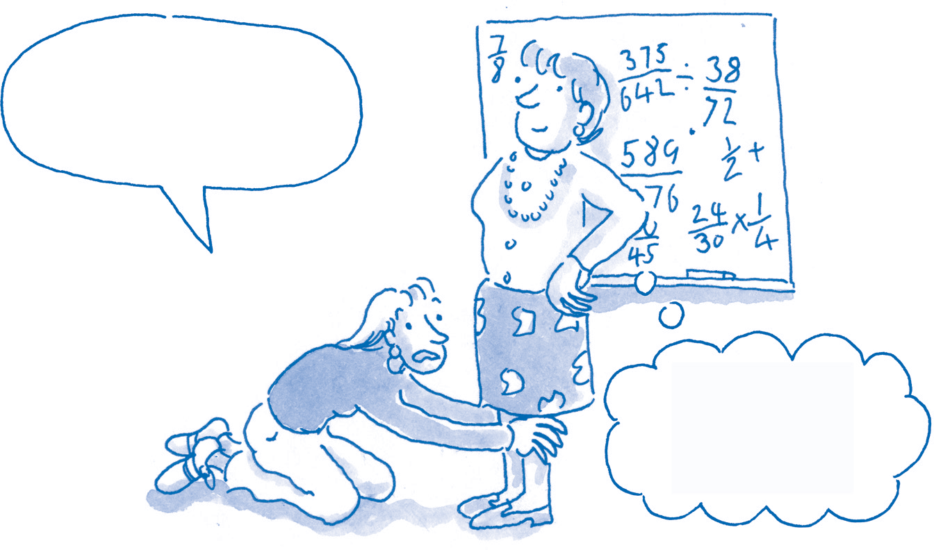

**I’ll leap through fire, walk on burning coals, clean dishes for a year – but please don’t make me do fractions!**

**But surely everyone loves fractions?**

Gaps in basic numerical skills can make study seem unnecessarily daunting. If numbers worry you, then it may be reassuring to know:

* You are not alone!
* For most subjects, even a little knowledge about using numbers goes a long way.
* Often universities recognise that students may have difficulties with number skills and provide

additional support.

* The topics in this chapter cover the basic number skills required for most study

programmes.

# What do I need to know?

## What kind of number work is necessary?

The amount, level and type of numerical work all vary with the study programme, course or unit. Simply through practice during your programme you will probably become used to working with numbers as required.

***What do I need to be able to do?***

of the following. Tick those that apply.

■

statements: ‘75% of students from the University of Aremia are employed part-time’; ‘Almost 40% of students at Exford work part-time in bar work or sales.’

Note here that the accompanying words help to define the context and the meaning of the numbers. Your presentation needs to show this combination – the right numbers and the right words to explain them.



## Subjects that require specialist skills

Find out whether you will need to do each

Some subjects require specific statistical methods or other specialist knowledge: if so, these are usually taught as part of the programme. If you find that you are struggling, ask your tutors for additional support or set up a student group to practise the numerical work together.

***Areas I want to improve***

■

Building confidence with

numbers

■

Managing distrust of numbers

■

*pages*

3–4

5–6

Make sense of numerical information in

texts, charts, graphs and tables.

Recognise what is significant, relevant,

valid or misleading about number-

■

Collect information for projects, reports

and other assignments.

■

Calculate averages and percentages.

■

Use fractions.

■

Identify numerical trends.

■

Present findings from experiments,

surveys, questionnaires or research

■

based information.

## How do numbers add value?

15



Working with fractions

■

Understanding percentages

■

Converting fractions to

percentages

■

Rounding up and down

■

Understanding averages

■

Calculating averages: means

■

Calculating averages: medians

■

8–9

10

11

12

13

14

projects.

■

Use specialist statistical software.

■

Attend training or workshops for any of

the above provided by your college.

When you are making an argument, you can generally make a better case if you can present numerical data that support what you are saying. A numerical table, for example, may sum up a great deal of information concisely and clearly, saving you thousands of words. The numbers you present must be *accurate* and *well selected*, and it should be clear why you have included them.

Calculating averages: modes

16

■

Making five-number summaries

17

■

Using graphs, tables and charts 19–24

■

Collecting and presenting data

■

Analysing numbers critically

*My priority areas are:*

..................................................................

For example, ‘Many students have jobs’ is vague – it could be interpreted in different ways. Compare this vague statement with two precise numerical

..................................................................

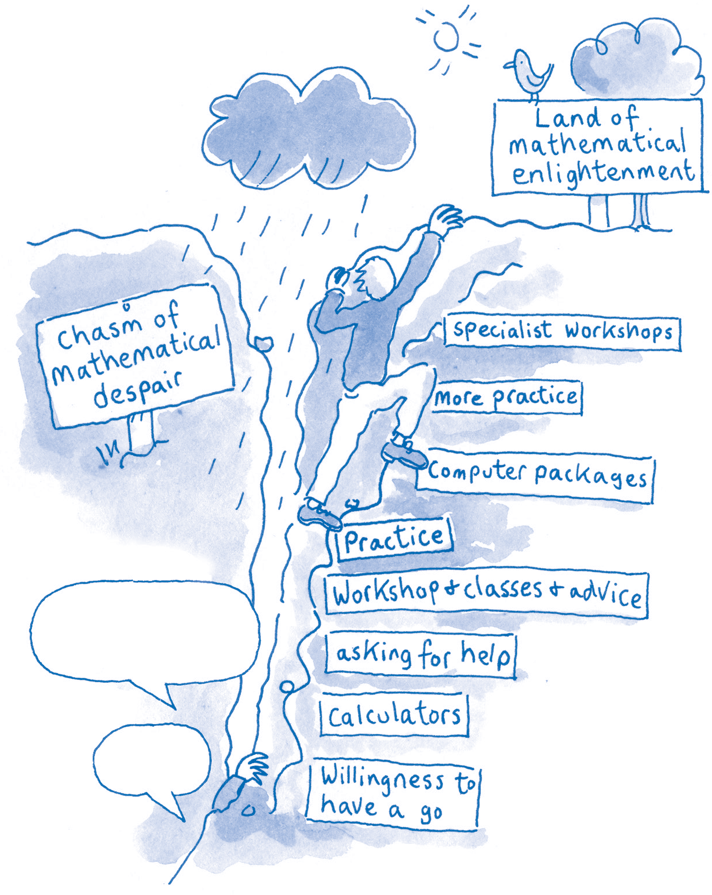

**1 I don’t understand numbers at all**

■

# Build your confidence with numbers

The first obstacle many students face is anxiety. If you feel you ‘can’t do maths’:

* + Stay calm.
  + Work through the steps systematically.
  + Don’t rush.
  + Recognise your weak spots.
  + Practise – then practise some more.

## Overcoming your barriers

If you lack confidence in using numbers:

* + Look at the barriers outlined below and on page 4. Tick any that

apply to you.

* + Think about how you could overcome each barrier.

A lot of basic number work is actually quite easy if you just follow a set of steps in sequence. Easy-to-use tools can also help. Maths may seem mysterious, but if you learn the steps and follow them exactly, you will

get the right answer. The more you understand what you are doing, however, the more confident you will feel and the likelier you will be to spot an answer that doesn’t look right.

**I can’t get this to add up!**

**Help!**

subtracting, multiplying or dividing. The secret is to check back carefully over your maths, just as you proof-read written work.

Don’t over-complicate your thinking. Most maths

that you will need will build on a few simple basics such as adding, subtracting, multiplying or dividing. It is highly likely that you can do such calculations, even if you do occasionally make mistakes.

**2 I make too many little mistakes** ■

* + It is easy to make minor errors – don’t let this discourage you.
  + Many mistakes happen simply by missing a step from the correct sequence, or in basic adding,
* The more you practise, the more you will notice the kinds of mistakes you are most likely to

make. You can then check for those in particular.

* If you are better with words than numbers, write out instructions in a way that makes sense to

you.

* Set out the sequence of ‘how to do it’ for each operation. Using a layout that you can easily

follow:

* write only one step per line
* leave space between steps
* highlight key points in colour.

**3 I can’t track numbers** ■

* + If you find it hard to track down columns of figures, check whether it is easier if you work on

graph paper.

* + If you still switch columns, colour adjoining columns or rows differently – this will help lead

your eye down each column.

* + Using a calculator or ‘speaking calculator’ may help.

**4 I quickly forget how to do maths** ■

* + As stress makes memory worse, focus on what you *can* do.
  + Write down formulae for the mathematical operations you need, such as calculating a

percentage (see page 11).

* + Put these formulae where you can find them easily when you need them – in your diary,

perhaps, or in a labelled file on your computer.

* + Use the formulae from time to time: this will jog your memory.
  + To help you recall the operations you need most often, devise personal memory joggers

**5 I’m no good at basics such as multiplication and division**

■

If you don’t often use these, it is easy to forget how to do them. This chapter explains the common operations that many students need.

**6 I can’t do things you’re supposed to know, like calculating averages and**

**percentages** ■

**7 I don’t know the technical terms** ■

Don’t be daunted by technical terms in maths. The basic processes are not complicated – you can pick them up through instruction and practice. (See page 23.)

**8 I don’t trust numbers and statistics, so I don’t want to work with**

**them** ■

Knowing how to interpret data helps you know when to trust numbers. It also enables you to identify flaws in other people’s arguments, and to detect occasions when figures are being cleverly manipulated. (See pages 5–6.)

**9 I don’t know how to interpret**

**information in graphs and charts** ■

* + Multiplication just means adding the same number over and over. ‘17 × 20’ means adding

17 repeatedly: 17 + 17 + 17 + 17 … .

* + Often there are several different ways to get the right answer: find out which way works best for

you. In the example above, you could just write the number 17 twenty times in a long list, and then add up the list.

* + Simple calculators make multiplication and division easy, and your computer will usually

provide a calculator in its accessories.

* + - *Multiplication* Enter the first number, then a multiplication sign (×) or an asterisk (*), then

the second number, and press ‘Enter’ or the ‘equals’ sign (=).

* + - *Division* Enter the amount you want to

divide up, then the diagonal line (/), then the

number you want to divide by, and ‘Enter’ or the ‘equals’ sign (=).

* + You could refer to a visual table or learn multiplication tables for

speed.

Graphs and charts are important not only in presenting your own work but also in

understanding what you read. Practice will help. (See pages 19–22.)

**10 I need to collect and present numerical data, but I don’t know**

**where to start** ■

The key to collecting and presenting data is to focus on the purpose of your research. What are you trying to find out? What data do you need to find the answer?



* What do you think are your main barriers in working with numbers?
* What would help you overcome these?
* What will you do to overcome these?

**Reflection: Working with numbers**

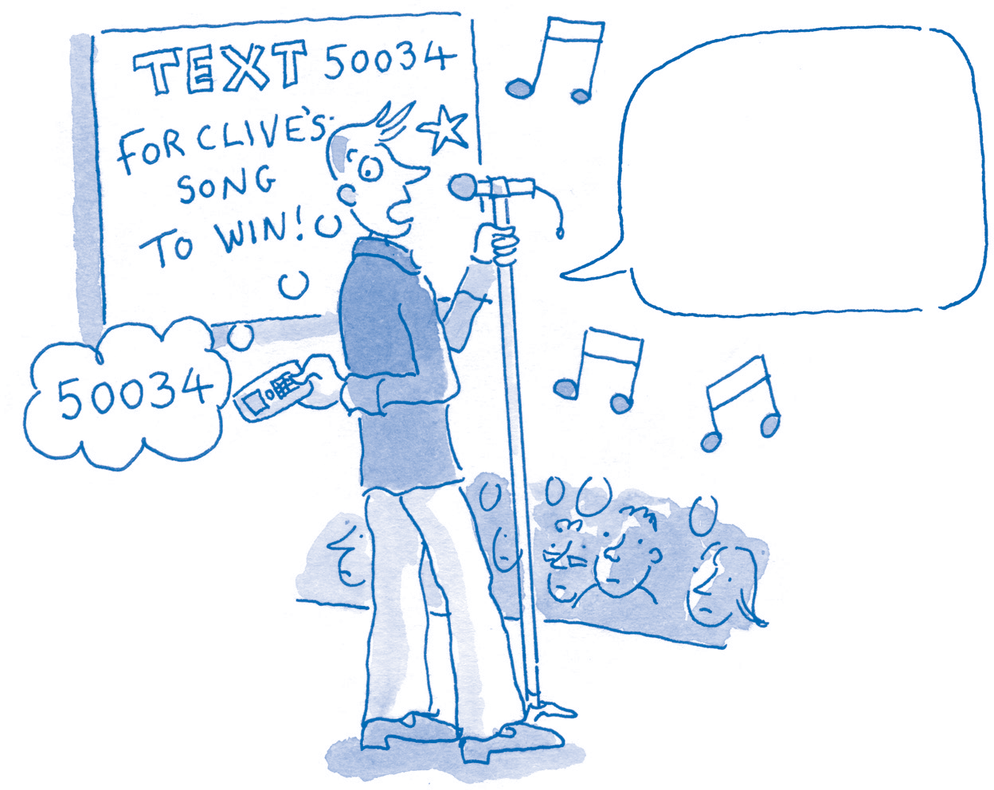

# Can you trust numbers?

## How useful are numbers?

Many people have strong opinions about numbers, especially statistics. It is easy to assume either that numbers ‘prove’ a case or that all statistics

are ‘lies’. In reality, numbers simply provide information, and the *value* of that information depends on what else you know about it and whether it suits your purpose.

## What are ‘statistics’?

‘Statistics’ has two meanings:

* the methods and techniques for measuring, organising, interpreting

and describing numerical information (data)

* specific sets of data produced to measure a given subject.

## Populations and samples

The total number of instances of something – all the plants in a meadow, for example – is the *population*. It is seldom possible to measure every individual in the population, so instead you can measure just some of the individuals – a *sample*.

If the sample is typical of the population, statements that are true for the sample are also true for the population as a whole: such a

sample is said to be *representative*. If the sample is untypical of the population as a whole, however, it is said to be *unrepresentative*, or *biased*. If the samples are representative, you can use them to draw inferences about the whole population – these are known as *inferential statistics*.

Good measurements must be accurate: they should measure in full what they say they measure and should not be measuring anything else.

Measurements gathered for one purpose cannot necessarily be applied in other situations – you must judge whether or not data tells you what you need to know.

**Chiropody’s the job for me! If only folks washed their feet, how wondrous life would be …**

## The relevance of the numbers

Whether or not data are relevant depends on what is being asked of them. When considering a specific set of data, ask yourself:

Chapter **9**

* Does it provide useful insights? Does it indicate oddities I need to investigate further?
* Does it help me spot any trends?
* Does it affect how I should think about a subject?

## Know the context

To interpret data, you need to know about the context in which they were collected. Suppose someone won a TV songwriting competition by gaining 56% of the phoned-in votes. Would a music producer be wise to invest in this artiste? The producer would need to know more. How many people watched the show? What proportion of them phoned in? Were they representative?

Perhaps:

* the winner was supported by people who phoned in more than once
* the winner was popular with phone voters but not with people who buy recorded music
* the phone lines were not working properly.

# Questioning numbers and statistics

## Do numbers provide proof?

Numbers may appear to be convincing, but they may not be as reliable as they seem. When using any set of data, be objective and critical. Consider:

* + Do these data measure what they purport to measure?
  + Are they likely to be accurate?
  + Could they contain errors or misprints?
  + How were they collected? Might this have led to mistakes or inaccuracies?
  + Who wanted them collected? Why?
  + When were they collected? Are they up to date? If not, does that matter?
  + Are they representative? Or do they refer only to particular sets of people or particular

circumstances?

* + Do they cover exactly what you are looking for? Do they throw useful light on the issue you are

investigating?

Chapter **9**

## Are the data based on estimates?

Some data are based not on actual counting but on *estimates*. For example, a newspaper report of the size of a crowd at a public demonstration may be no more than an ‘informed’ guess. The estimates made by the organisers and by the police may differ – and neither may be correct.

## Are the data likely to change?

Estimates may change rapidly or over time.

For example, the first estimate of casualties immediately following a disaster may differ from estimates made later as more accurate information becomes available. Data about the overall

impact of the disaster may change as long-term consequences, such as environmental effects, gradually become apparent.

## Are the data still up to date?

Check whether there is a later or an earlier set of data that is more accurate or with which you can compare the current data. For example, if a

shop claims that it won a ‘Customer Satisfaction’

survey ten years ago, you would probably wonder whether current customers are satisfied.

Remember, too, that it takes time to collect, analyse and publish data: some are out of date even before they are published.

## What was actually measured?

Historical data need to be treated with caution. During some historical periods, whole sections of populations were simply ignored when making counts. For example, the number of casualties typically cited for the Great Earthquake of San Francisco in 1906 omits the Chinese casualties, even though the Chinese population at the time was significant. For much of history, only the views of people regarded as ‘important’ were counted: we cannot know what ‘most people’ thought if they were not allowed to vote or to register their opinions.

## What kind of ‘sample’ was used?

We are often presented with claims about the average number of televisions in each home, how the average voter will vote in the next election, or what proportion of pets prefer a particular food. Such figures do not measure every home, every voter or every pet – that would take too long

and be too expensive. Instead, a sample is taken, much smaller than the whole population, and is treated as if it were representative of the whole.

For the result to be reliable, the sample must be big enough to be a fair representation of the population – if not, claims about proportions or rising or falling trends will be unreliable.

## What kind of ‘averaging’ was used?

Different kinds of average may throw a different light on an issue. Which sort is being used? Is it appropriate? (See pages 13–16.)

A fraction is part of a whole. We acknowledge this in everyday speech:

***Written fractions***

The lower number or *denominator*, such as the 4 in 3/4, represents the total number of equal parts into which the whole unit is divided.

The top number or *numerator*, such as the 3 in 3/4, represents the proportion of the equal parts into which the whole is divided.

* ‘Buy this at a fraction of the cost …’
* ‘If you had the right tools, you’d get that done in a fraction of the time.’

In maths, a *fraction* represents one of a number of equal parts of a complete unit. Thus a fraction

could be a part of a price, a time, a width, a group (‘set’), or any other unit.

## The language of fractions

The language of fractions is straightforward. For example, if you cut a cake into 8 equal slices, each slice would be one *eighth*. If instead you divided

it into 6 equal parts, each part would be a *sixth*. If you shared it out in 20 equal slices, then each piece would be a *twentieth* of the whole cake. If

you then ate 3 of those 20 equal pieces, you would have eaten *three-twentieths*. If you gave a friend 2 of 5 equal slices of the cake, you would have given *two-fifths*.

## Fractions of a set

The set of stars below consists of 28 items. They are divided into 7 equal parts, or fractions: each line represents 1/7 of the total. The shaded area covers 3 of those 7 parts, or 3/7.

**One-tenth (1/10) of the cake**

***Example: fractions of 28***

A set of 28 items divided into 7 equal parts consists of 7 groups, each of 4 items. With the items laid out as below, you can see the relationship between the total set and the set divided into sevenths.

**1** ★ ★ ★ ★

**2** ★ ★ ★ ★

**3** ★ ★ ★ ★

**4** ★ ★ ★ ★

**5** ★ ★ ★ ★

**6** ★ ★ ★ ★

**7** ★ ★ ★ ★

* As you can see, 1/7 of 28 items is 4 items.
* 3/7 of 28 items is 3 x 4 items = 12 items. To check this, count the items.

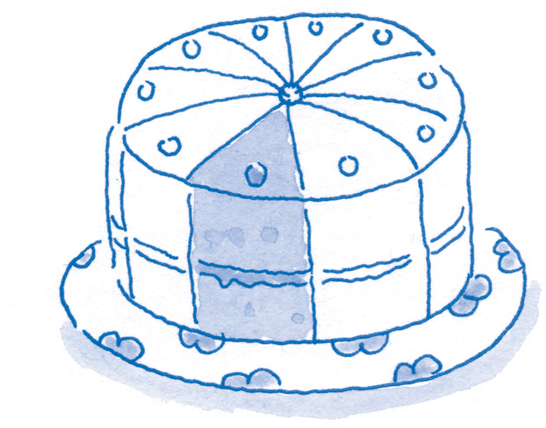

**Three-tenths (3/10) of the cake**

## Proper and improper fractions

In a *proper fraction*, the top number is smaller than the bottom number (e.g. 3/4). In an *improper*

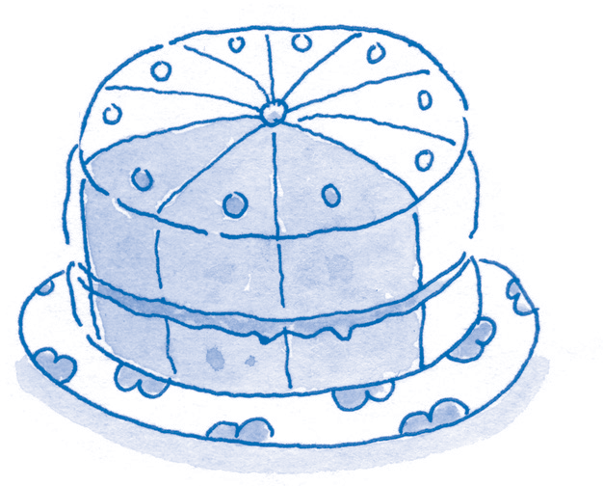

*fraction*, the top number is bigger than the bottom number (e.g. 4/3): the fraction is greater than 1. A *mixed number* combines a whole number and a proper fraction (e.g. 11/3).

|  |  |  |  |  |  |  |
| --- | --- | --- | --- | --- | --- | --- |
| **1** ★★★★  ★★★★  ★★★★  ★★★★  ★★★★  ★★★★ | 1/2 ★★★★  ★★★★  ★★★★ | 1/3 ★★★★  ★★★★ | 1/4 ★★★  ★★★ | 1/6 ★★★★ | 1/8 ★★★ | 1/12 ★★ |
| 1/12 ★★ |
| 1/8 ★★★ |
| 1/6 ★★★★ | 1/12 ★★ |
| 1/4 ★★★  ★★★ | 1/8 ★★★ | 1/12 ★★ |
| 1/3 ★★★★  ★★★★ | 1/6 ★★★★ | 1/12 ★★ |
| 1/8 ★★★ |
| 1/12 ★★ |
| 1/2 ★★★★  ★★★★  ★★★★ | 1/4 ★★★  ★★★ | 1/6 ★★★★ | 1/8 ★★★ | 1/12 ★★ |
| 1/12 ★★ |
| 1/8 ★★★ |
| 1/3 ★★★★  ★★★★ | 1/6 ★★★★ | 1/12 ★★ |
| 1/4 ★★★  ★★★ | 1/8 ★★★ | 1/12 ★★ |
| 1/6 ★★★★ | 1/12 ★★ |
| 1/8 ★★★ |
| 1/12 ★★ |
| **1 × 24** | **2 × 12** | **3 × 8** | **4 × 6** | **6 × 4** | **8 × 3** | **12 × 2** |

## Comparing equivalent fractions

The chart above shows equivalent fractions. By tracking across, you can count, for example, how many one-twelfths are equivalent to two-thirds.

Chapter **9**

* The height of each column is divided so that you can compare fractions visually.
* The items in each column add up to the same total number (24), so you can also count out the

relative proportions.

## Comparing fractions

When fractions have the same bottom number (denominator), it is easy to compare them. For example, with 3/12 and 5/12 you can tell that 5 portions are more than 3 portions of the same size.

When the bottom numbers differ, however, comparison is more difficult. Which is bigger, 1/4 or 2/9? You need a new denominator that can be divided both by 4 and by 9. The easiest way is to multiply these two different denominators together to find a *common denominator*. In the

case of 1/4 or 2/9 a common denominator is found

from 4 x 9 = 36. Each of the two fractions can then be expressed as a number of 1/36ths.

You then need to work out the equivalent number of 1/36ths for each fraction. To maintain

the proportion, multiply the top number (the numerator) by the same number as the bottom number (the denominator) in that fraction:

* For 1/4: To get 36 at the bottom, you multiply 4 by 9, so multiply the top,1, by 9 also. The result is 9/36 (that is: 1/4 = 9/36).
* For 2/9: To get 36 at the bottom, you multiply 9 by 4, so multiply the top, 2, by 4 also. The result is 8/36 (that is: 2/9 = 8/36).

The question, ‘Which is bigger, 1/4 or 2/9?’, can now be answered by substituting the converted

fractions. ‘Which is bigger, 1/4 (9/36) or 2/9 (8/36)?’ It is

now clear that 1/4 (9/36) is bigger.

***Adding and subtracting fractions***

Once you have converted numbers so that they have a common denominator, you can also add and subtract fractions easily. You simply add or subtract the top numbers:

9/36 + 8/36 = 17/36

5/36 + 11/36 = 16/36

9/36 – 8/36 = 1/36

30/36 – 10/36 = 20/3

## Uses of fractions

We use fractions in everyday life:

* to share any item in equal parts
* to share out profit in proportion to the level of investment
* to work out a sale price when items are reduced by a fraction, such as ‘1/3 off’.

## Calculating the fraction of a quantity

We can also calculate actual numbers and total amounts when we are given fractions. For example, if we know that in a survey of 800 people, three-quarters were women, we can work out how many women were questioned.

In 800 participants, 3/4 were women.

1. Divide the total number (800) by the bottom number (the denominator) in the fraction (the 4 in 3/4): 800/4 = 200.

(That is: 800 = 4/4, so 1/4 = 200.)

|  |  |
| --- | --- |
| ***Activity*** | **Using fractions** |
| 1. In each case, which fraction is larger?   **a** 1/5 or 1/6 **c** 4/7 or 5/9  **b** 2/3 or 7/11 **d** 4/5 or 5/6   1. Add each of the following fractions:   **a** 1/3 and 1/2 **d** 1/4 and 2/3  **b** 1/6 and 1/8 **e** 2/7 and 3/5  **c** 1/2 and 5/6 **f** 1/9 and 3/4   1. Calculate each of the following:   **a** 2/3 of £750 **d** 2/9 of 81  **b** 3/4 of 160 **e** 3/5 of 620  **c** 5/6 of 72 **f** 2/7 of 91   1. Calculate the total, given that:   **a** 1/2 = 100 **e** 3/4 = 120  **b** 1/4 = 100 **f** 1/7 = 10  **c** 1/3 = 50 **g** 2/7 = 10  **d** 2/3 = 50 **h** 4/5 = 20   1. Multiply:   **a** 1/2 × 1/2 **d** 1/3 × 1/3  **b** 1/2 × 1/4 **e** 1/3 × 1/2  **c** 1/4 × 1/4 **f** 2/3 × 1/2  *Answers are given on page 411.* | |

1. Multiply the result by the top number (the numerator in the fraction (the 3 in 3/4): 200 x 3 = 600.

(That is: 200 = 1/4, so 3/4 = 600.)

### Example 1

To calculate 3/4 of a sample of 200:

1. Divide 200 (the total) by 4: 200/4 = 50.
2. Multiply the 50 by 3: 50 × 3 = 150.

### Example 2

A shop is offering an item for 1/3 off its usual price of £120. This means that the item would cost you 2/3 of £120. To calculate this:

1. Divide £120 by 3 (bottom number):

£120/3 = £40.

1. Multiply £40 by 2 (top number):

£40 x 2 = £80.

The reduction (1/3) is £40; and the cost (2/3) is

£80.

## Multiplying fractions

When you multiply fractions of a whole number you are multiplying a *part* by a *part*, so the result is even smaller. For example:

* a half of a half (1/2 × 1/2) is a quarter (1/4)
* a half of an eighth (1/2 × 1/8) is a sixteenth (1/16).

## Top-heavy fractions

Sometimes you see a fraction in which the top number is bigger than the bottom number. This simply means that the fraction amounts to more than one whole item or set. For example, 7/6 is the same as 6/6 + 1/6 or 11/6.

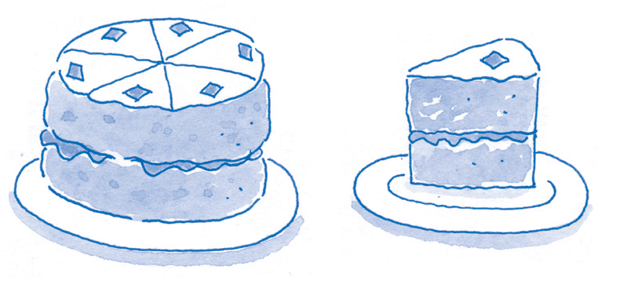

***What is a percentage?***

A percentage (%) is a way of stating any fraction as a proportion of 100.

## A proportion of the ‘whole’

The whole of anything – the full amount of an item or a group of items – is 100%.

If you divide this total amount, 100%, into smaller parts, each part will be a proportion of the whole 100%. All the pieces together add up to 100%.

### Example

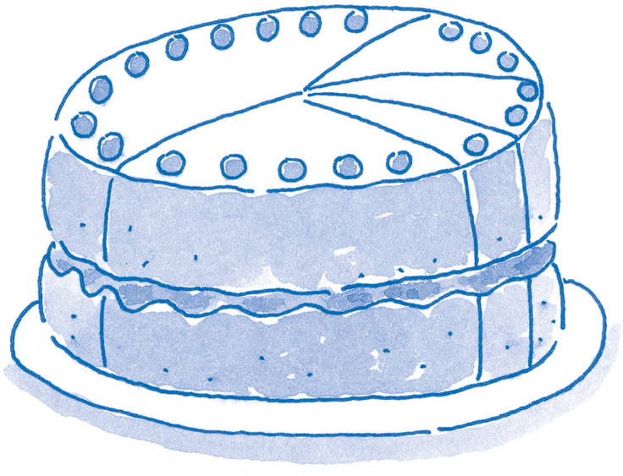

**45%**

**15%**

**10%**

**5%**

**25%**

Consider this cake, which has slices of different sizes. The five slices of the cake add up to 100%.

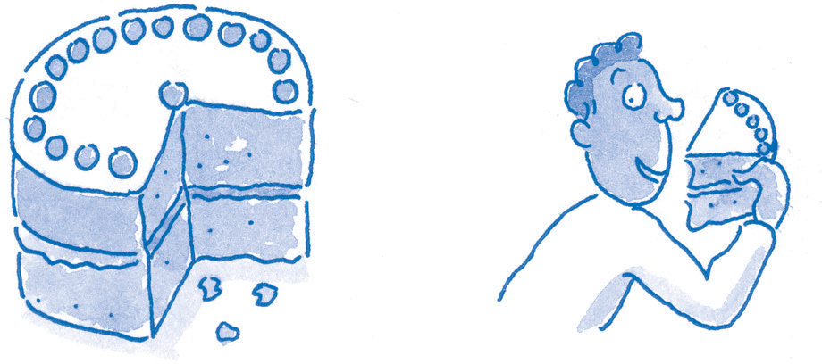If some of the cake is eaten, the remainder can be expressed as a percentage of the original whole cake.

## Percentages written as fractions

Percentages can be written as fractions, in which the bottom number is always 100:

1/100 = 1% (1 per cent)

23/100 = 23% (23 per cent)

59/100 = 59% (59 per cent)

## Why use percentages?

If proportions are stated relative to a standard number, 100, it becomes easy to make direct comparisons. For example, suppose you want to compare how effective two sports clubs are in attracting student members. If there are 17

students in a total of 34 members in Club A, and 13 out of 52 in Club B, it is hard to make direct comparisons between the clubs. If the figures are both converted into percentages, however, they can be compared easily on this single scale: 17/34 = 50%; 13/52 = 25%.

## Reliability

The reliability of percentages depends on the sample size.

## Percentages: ‘more than one cake’

Imagine two cakes of equal size. The ‘whole amount’ of cake, 100%, is *two* cakes. Now suppose that 75% of one cake and 25% of the other

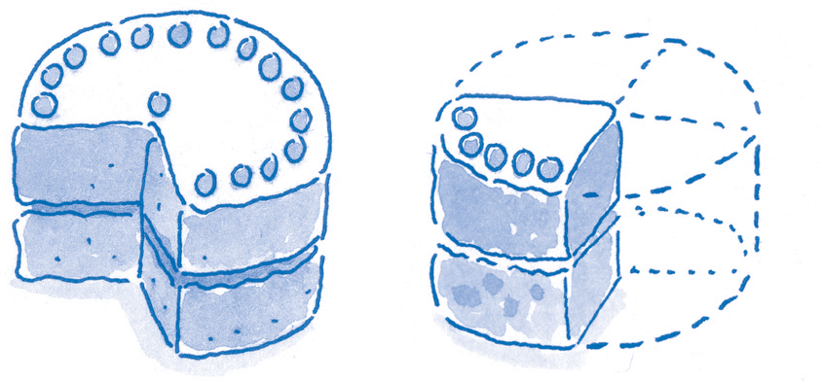cake are eaten. Although the amount eaten is equivalent to 100% of *one* cake, it is only 50% of the ‘whole amount’ of cake – *two* cakes.

**75% remaining 25% gone**

**25% of Cake 1 eaten**

**= 12.5% of the whole amount (two cakes)**

**75% of Cake 2 eaten**

**= 37.5% of the whole amount (two cakes)**

**Total amount eaten = 12.5% + 37.5% = 50% of the whole amount (two cakes)**

A fraction is a part of a whole, such as a half or third. When it isn’t easy to see how fractions or proportions of different items compare, then it is worth converting fractions into percentages.

***Easy conversions from fractions and percentages***

On page 10, the proportion of students in the membership of one club was shown to be 17/34 or 50%. This fraction is easy to convert to a percentage if you recognise that 17 is half of 34 – ‘half’ is always 50%. Other useful conversions are listed below.

One-half One-quarter

Three-quarters One-third Two-thirds One-fifth

Two-fifths Three-fifths Four-fifths One-sixth Two-sixths One-eighth Two-eighths Three-eighths Four-eighths One-tenth

One-twentieth

One-fiftieth

= 1/2

= 1/4

= 3/4

= 1/3

= 2/3

= 1/5

= 2/5

= 3/5

= 4/5

= 1/6

= 2/6

= 1/8

= 2/8

= 3/8

= 4/8

= 1/10

= 1/20

= 1/50

= 2 x 33%

= 2 x 20%

= 3 x 20%

= 4 x 20%

= 50%

= 25%

= 75%

= 33%

= 66%

= 20%

= 40%

= 60%

= 80%

= 1/3

= 1/4

= 16.7%

= 33.3%

= 12.5%

= 25%

= 3 x 12.5% = 37.5%

= 1/2

One-hundredth = 1/100

= 50%

= 10%

= 5%

= 2%

= 1%

It is worth playing with these basic fractions and percentages, and looking for relationships between them. For example, to find three- fiftieths, multiply one-fiftieth (2%) by 3 to give 6%.

***Converting fractions to percentages***

1. Divide the part by the whole.
2. Multiply the result by a 100.

**Example**

17/34 = 0.5 (17 = ‘the part’; 34 = ‘the whole’)

0.5 x 100% = 50%

If you didn’t recognise 17/34 as 50%, don’t worry – you can use the formula above to convert any fraction into a percentage. Using a calculator, key in the operation, in order, as in this example:

1 7 / 3 4 1 0 0 =

**×**

Chapter **9**

|  |  |
| --- | --- |
| ***Activity*** | **Calculating percentages from fractions 1** |
| Turn the following fractions into percentages. For this activity, ignore any numbers that follow the decimal point on your calculator. Example: 27/134 x 100 = 20.149. Just write 20. | |

Look for proportions that help you calculate a percentage quickly in your head. For example, ‘24 out of 96’ is the same proportion as ‘1 in 4’ (4 x 24

|  |  |
| --- | --- |
| ***Activity*** | **Calculating percentages from fractions 2** |
| 1. In a sample, 6 of 11 plants are deciduous. What percentage is deciduous, and what percentage is not? 2. In one school, 41 out of 230 children have reading difficulties. What percentage have reading difficulties? What proportion do not? 3. Out of a population of 234,560 people, 23,456 people went to see a film. What percentage of the population saw the film? What percentage did not? 4. 873 of 9,786 participants took part in the competition online, 2,314 by texting, and the rest by phone-in. What percentage participated by each method? | |

= 96) or 25%. If you know your ‘tables’, you will find it easier to recognise proportions.

Strings of digits can be hard to read and to work with. ‘Rounding’ makes them easier to manage.

## Whole numbers

A whole number is one with no fractions or decimal points attached to it, such as 75 or 921.

## Numbers followed by decimal points

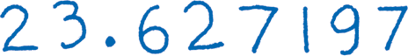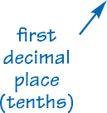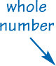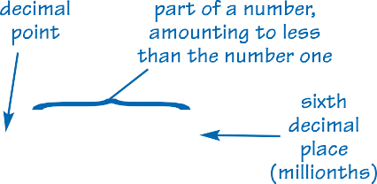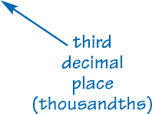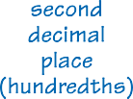

The digits that follow a decimal point represent only a *part* of a whole number. However many digits follow the decimal point, they represent less than the number 1.

When you convert a fraction into a decimal, there may be more digits after the decimal point than are useful. This is where ‘rounding’ helps.

Chapter **9**

## Rounding money

You may be used to ‘rounding up’ or ‘rounding down’ when using money, rounding to the nearest pound, dollar, Euro, or other unit of currency.

For example, if you owed a friend 4 Euros and 75 cents, you might ‘round up’ and repay 5 Euros, telling your friend to keep the change. Similarly, if you owed 4 Euros and 10 cents, your friend might ‘round down’ and accept just 4 Euros.

## Rounding numbers

### Example: rounding down 986.748

Rounding numbers follows the same principle as rounding money. To round 986.748 to just its first decimal place:

* The digit in the first decimal place is 7.
* If the digit immediately to the right of the 7 (in the first decimal place) is *4 or less, round down* –

remove everything following that decimal place. Here the digit in the next decimal place is a 4, so round *down*, removing the 4 and the 8, and leaving 986.7.

### Example: rounding up 986.752

* The digit in the first decimal place is again 7.
* If the digit in the next decimal place is *5 or more, round up* – increase by 1 the number in

the decimal place you want. Here the digit in the next decimal place is 5, so you round *up*, removing the 5 and the 2, changing the 7 to 8,

and leaving 986.8.

You can round up or down to whole numbers, or to one or more decimal places.

### More examples

*To round 756.483921 to the nearest whole number* Everything before the decimal point is the whole number: 756.

*To round 756.483921 to two decimal places*

The digit immediately to the right of the second decimal place is 3. For ‘4 or less, round down’. As 3 is less than 4, round down: 756.48.

*To round 756.486111 to 2 decimal places*

The digit immediately to the right of the second decimal place is 6. For ‘5 or more, round up’. As 6 is more than 5, round up: the 8 in the second decimal place increases to 9, giving 756.49.

|  |  |
| --- | --- |
| ***Activity*** | **Rounding numbers** |
| Round these numbers to one decimal place.  **a** 41.34675 **d** 99.88 **g** 66.55  **b** 912.172 **e** 1.714 **h** 6.10987  **c** 22.222 **f** 10.08 | |

## Discussing a set of numbers

Many kinds of research involve collecting data by counting. For example, you might want to know:

* how many people take holidays abroad, and where they go
* how many plants and animals there are on a piece of seashore
* how many children are immunised in different communities, and against which diseases
* how much students earn.

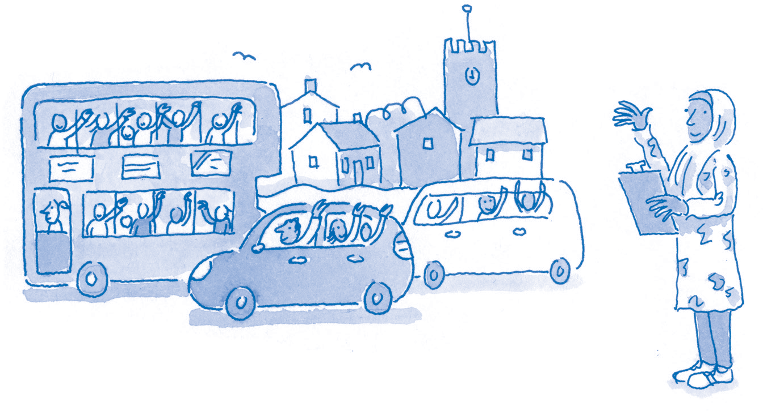For instance, suppose you were investigating road safety and you were measuring the traffic through a village. You might count how many people there are in each vehicle that passes through the village in a given period of the day. You might collect a set of numbers such as this:

3, 2, 5, 41, 1, 76, 1, 97, 3, 1

It would be hard to discuss this list in your report because the number of people per vehicle varies between 1 and 97. It would be even harder to make comparisons, for example with the figures at a different time of day or in another village.

## Averages

One way to deal with this is to use a single number that in some way *summarises* or *represents* the set of numbers. It needs in some way to be typical of the set. It needs to be an *average* number.

* An average would help us work more efficiently with large sets of numbers.
* It would help us spot patterns and trends.
* It would help us compare numbers more easily.

## Choosing the average number

In choosing one number to represent a set, we need to decide which would be the best number to use. The lowest one? The highest? The one in the middle? The one that appears most often?

In discussing students’ income, for example, we might choose as an average:

* the *median* – the amount that falls mid-way between £0.00 and the income of the highest

earner, *or*

* the *mean* – the amount that each student would receive if their total earnings were equally

divided between all of them (as if sharing out a pool of money equally between members), *or*

* the *mode* – the amount that students earn most frequently.

## Calculating averages

The three averages are not all the same. For instance, for the list of numbers already given –

3, 2, 5, 41, 1, 76, 1, 97, 3, 1

– the mean is 23, the median is 3, and the mode is 1. All three averages might be useful in different contexts.

The following pages look at how to calculate these three commonly used representative averages.

## What is the mean?

Most people, when they refer to an ‘average number’, are talking about the ‘mean’ number. This is the method you would use to find out how to distribute money, objects, time or other items into equal shares or amounts.

***Calculating the mean***

Calculating a mean is relatively simple, especially with a calculator. You just:

1. Add up all the numbers in the set in order to find the grand total, or ‘sum’, of the numbers.
2. Divide the sum by the number of items in the set: that gives you the mean average.

### Example 1

Consider the set of numbers given on page 13:

3, 2, 5, 41, 1, 76, 1, 97, 3, 1

To find the mean for this set:

1. Add the 10 numbers together:

3 + 2 + 5 + 41 + 1 + 76 + 1 + 97 + 3 + 1 = 230

1. Divide the total passengers (230) by the number of vehicles (10):

Mean = 230/10 = 23

‘23’ might seem a strange number to consider as ‘representative’ – most vehicles carried far fewer passengers, and 7 of the 10 vehicles each carried only 1–5 passengers. Nevertheless, this

figure could still provide a point of reference when comparing overall information about volume

of movement from one place to another, or at different times.

### Example 2

This set of numbers records the number of US dollars held by each of 6 tourists:

$34, $31, $200, $11, $19, $88

To find the mean for this set:

1. Add the 6 numbers together to get the total number of US dollars held by the 6 tourists altogether:

$34 + $31 + $200 + $11 + $19 + $88 = $383

1. Divide the total dollars ($383) by the number of tourists (6):

Mean = $383/6 = $63.8

If the tourists shared their money equally between them, they would each have $63.8.

|  |  |
| --- | --- |
| ***Activity*** | **Calculating the mean** |
| Calculate the mean number, or average, for each of the following sets of numbers.  **a** 1, 2, 3, 5, 6, 7, 8, 9, 11, 15, 17  **b** 234, 19, 1, 66, 2002, 7  **c** 7, 7, 6, 8, 9, 8, 11, 7, 6, 11, 2, 14, 5  **d** 11, 22, 33, 44, 55, 66, 77, 88, 99, 111  **e** 7, 14, 19, 8, 6, 11, 21, 32, 8, 19, 21, 5  **f** 23, 36, 42, 56, 57, 58, 59, 59, 59, 69, 69 | |

## What is the median?

The *median* is the mid-way point in a set of numbers that have been put in order of increasing size.

***Calculating the median***

1. Lay out the numbers in the set in order, from smallest to largest.
2. The median is the middle value. The way of calculating this place depends on whether there is an odd or an even number of items in the set.

*Odd number of items* Find the middle item in the ordered list: this value is the median.

*Even number of items* Find the middle two items in the ordered list. Add them together and divide by 2: this value is the median.

### Example 1: odd number of items

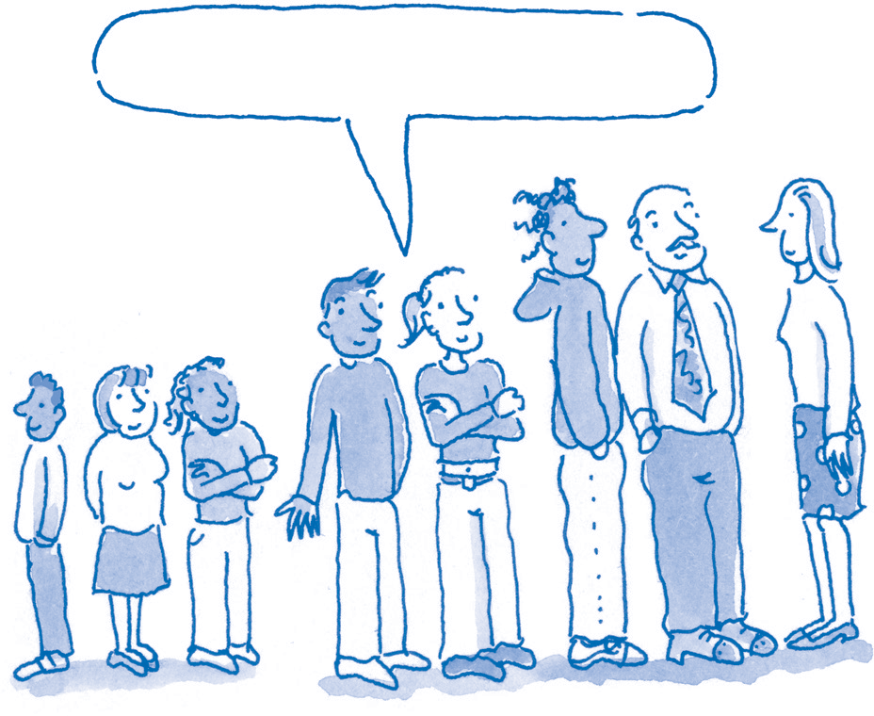

**We represent the median height.**

Here is a set of exam scores:

23, 36, 42, 56, 57, 58, 59, 59, 59, 69, 99

There are 11 scores in the set, and they have been laid out in order from lowest to highest. The

median is the number that falls in the middle. For 11 numbers, the middle is the 6th place. The 6th value, the median, is 58.

### Example 2: even number of items

Here is another set of exam scores:

36, 42, 56, 57, 58, 60, 61, 69, 69, 70

Here there are 10 scores in the set, and again they have been laid out in order from lowest to highest. For 10 numbers, there is no single middle value.

* The two middle numbers (5th and 6th places) are 58 and 60.
* 58 + 60 = 118.
* The median is 118/2 = 59 (59 is the mean of the two middle values).

Chapter **9**

|  |  |
| --- | --- |
| ***Activity*** | **Calculating the mean** |
| Calculate the median for each of the following sets of numbers.  **a** 1, 2, 3, 5, 6, 7, 8, 9, 11, 15, 17  **b** 234, 19, 1, 66, 2002, 7  **c** 7, 7, 6, 8, 9, 8, 11, 7, 6, 11, 2, 14, 5  **d** 11, 22, 33, 44, 55, 66, 77, 88, 99, 111  **e** 7, 14, 19, 8, 6, 11, 21, 32, 8, 19, 21, 5  **f** 23, 36, 42, 56, 57, 58, 59, 59, 59, 69, 69 | |

## When is the median useful?

The median is especially useful for small sets of numbers, as in the examples above. Other

averages are often affected by extreme differences between the numbers, known as ‘extreme values’, such as the 99 in example 1. The median is less affected by extreme values, so it may be more representative of the set of numbers as a whole.

## What is the mode?

The *mode* is the number in a set that appears the most frequently.

### Example

Look again at this list of exam scores, sorted into ascending order:

23, 36, 42, 56, 57, 58, 59, 59, 59, 69, 99

The number that appears most frequently in this set is 59: this is the mode. In this set, 59 is the exam score that occurs most often.

## When is the mode useful?

The mode is especially useful when you have a large set of data in which there is only a small range of values. For example, national data on family size would be a large data set, with perhaps millions of numbers, yet the *range* of values would be quite narrow – the number of children per

family is likely to be between 0 and around 12 at most. If, in practice, most families had 3 children, it might well make better sense to use this value – the most frequently occurring number of children in a family – rather than to use a mean or a median, which would probably be a fraction such as ‘2.12’ children. The mode can be valuable when making comparisons within large populations, as when carrying out research regionally or nationally into the effects of family size on health or income.

**Comparing means, medians and modes**

However, using the mode can make it harder to see trends. For example, if there were a new trend in which increasing numbers of families

had 3 or more children, this trend would not be apparent if one knew only that 3 children was the most common number in a family. In contrast, the mean, a more precise decimal number, might

show a rise in average family size, such as from 2.8 to 3.3.

23, 36, 42, 56, 57, 58, 59, 59, 59, 69, 99

* + In this set, the mode – the number that occurs most frequently – is 59.
  + The median – the number that falls in the middle place – is 58 (calculated on page 15).
  + The mean – calculated by adding all of the items in the set (617) and dividing the sum by the

number of items in the set (11) – is 56.

These are all accurate statistics, but they do not match. This is one reason why ‘statistics’

sometimes seem to ‘lie’. As arguments are often based on comparisons of averages, it is important to know:

* + What was included in the data set? (For example, were all the exam scores included, or

were any omitted?)

* + Which method of calculating the average was used? Is this kind of average suitable?
* Would a different method of calculating the average give a different outcome? (It might,

depending on the numbers involved.)

* When averages are compared in an article or report, were these averages calculated using the

same method, whether mean, mode or median? (Each average might be higher or lower, depending on the method used.)

|  |  |
| --- | --- |
| ***Activity*** | **Calculating averages** |
| Find the mean, median and mode for the following numbers. Consider how extreme values (unusually small or large numbers) affect each average.  **a** 1, 1, 1, 3, 3, 4, 7, 7, 10  **b** 28, 14, 21, 28, 26, 62  **c** 19, 170, 17, 19, 19, 16, 20 | |

## What is a five-number summary?

The numbers in a set may be similar and closely related, or they may be varied with features such as very high or low scores – *extreme values* – which are quite unlike the other numbers in the set. The variety of numbers and the way in which they are clustered or spread in a set is called the *distribution*.

If you know just an average number for a set and nothing else, you cannot tell anything about the distribution of numbers in the set, and whether it is in any way unusual. Are the data reliable, or might they be distorted or unrepresentative in some way? Can they be used as they are or do they need further investigation?

### The effect of extreme values

Suppose, for instance, that in a group of 12 students (a small sample), 11 students received exam marks of 64% and 1 student received just 3%. You might expect the average mark for the whole group to be 64% – after all, that is what all but one of the students received. If the average used was the *mode*, it would be 64%. If the average used was the *mean*, however, it would be around 59%.

The single mark of 3% in this set is an ‘extreme value’: it skews the results for the set as a whole. When data sets are small, or when means are used, extreme values can be quite misleading. In larger samples, extreme values have less impact.

## The five numbers

Extreme values are just one of the possible sources of distortion when one chooses a particular number to represent the whole group. To address such problems, statisticians have found that in describing a set it is helpful to state not just one number but five numbers.

First the numbers in the set are put in sequence, from the smallest to largest. Then five numbers can be recorded:

1. *Minimum number* The first in the sequence.
2. *Maximum number* The last in the sequence.
3. *Median* The mid-point of the sequence.
4. *Lower quartile* (*LQ*) The value one-quarter of the way along the sequence.
5. *Upper quartile* (*HQ*) The value three-quarters of the way along the sequence.

## Summaries and averages

The table below shows a five-number summary. Consider this information compared with that provided by averages. It may help to note that:

Chapter **9**

* The mean for the marks, by calculation, is 47.29%. The mode is 70%.
* The mean is brought down by the 2 extreme values, 2% and 3%. It would otherwise have

been 51.36% (1130/22).

* Without the 2 lowest and 2 highest scores, the mean is 49.5% (990/20).

|  |  |  |  |  |
| --- | --- | --- | --- | --- |
| ***Example: a five-number summary***  Below is a set of class exam scores for 24 students. These are placed in order, from lowest to highest, and the number of their place in the sequence is written below for ease of reference. The positions of the lower and upper quartiles must be calculated (as for medians: page 15).  **Mark (%) 2 3 40 41 42 43 44 45 46 47 48 49 50 51 52 53 54 55 56 57 58 59 70 70**  Place 1 2 3 4 5 6 7 8 9 10 11 12 13 14 15 16 17 18 19 20 21 22 23 24 | | | | |
| **Minimum** | **Lower quartile** (**LQ**) | **Median** | **Upper quartile** | **Maximum** |
| 1st place | The value mid-way | The average of | (**UQ**) | 24th place |
| = **2** | between the 5th and | the 12th and 13th | The value mid- | = **70** |
|  | 6th places | places | way between the |  |
|  | = **42.5** | = **49.5** | 18th and 19th |  |
|  |  |  | places = **55.5** |  |

## Examples of five-number summaries

### Class A

For Class A, a set of 11 exam scores is:

23, 36, 42, 56, 57, 58, 59, 59, 59, 69, 99

The five-number summary for this set would be:

1. Minimum number 23
2. Lower quartile: LQ (3rd score) 42
3. Median number 58
4. Upper quartile: UQ (9th score) 59
5. Maximum number 99

### Class B

For Class B, a set of 16 exam scores is: 7, 27, 27, 27, 55, 55, 64, 65,

66, 66, 67, 68, 69, 70, 71, 78

The five-number summary for the set would be:

1. Minimum number 7
2. Lower quartile: LQ (4th score) 27

Chapter **9**

1. Median number (mean of 65 and 66) 65.5
2. Upper quartile: UQ (12th score) 68
3. Maximum number 78

## Using the five-number summary

Consider Class B. If the only fact you knew about the scores for this class was that the *mode* (the most common score) was 27, you would gain a quite mistaken impression of the group’s performance.

Even without a list of all the class scores, however, the five-number summary would give you a much more accurate picture. Looking at these five numbers only, you could see that the scores in the class were widely distributed, from 7 to 78, and that at least half the group must have scored 65.5% or higher.

Similarly, if you knew only that the mean was 55%, you would be unable to appreciate how well some students had done while others had struggled. The five-number summary makes the distribution clear.

The five-number summary thus gives a better ‘feel’ for the whole set of numbers. When you have large sets of numbers, such a summary can be very useful.

## Presenting five-number summaries

Five-number summaries can be used to compare two or more sets of data. The numbers can be presented in table form so that the equivalent numbers can be compared easily. For example, the two exam scores for Classes A and B would be presented as below.

**Table to compare exam scores for Class A and Class B, using a five-number summary**

|  |  |  |
| --- | --- | --- |
| **Scores Class A Class B** | | |
| Minimum number | 23 | 7 |
| Lower quartile (LQ) | 42 | 27 |
| Median number | 58 | 65.5 |
| Upper quartile (UQ) | 59 | 68 |
| Maximum number | 99 | 78 |

|  |  |
| --- | --- |
| ***Activity*** | **Five-number summaries** |
| Draw up five-number summaries for the following sets of numbers, as in the examples above.  **a** Set of class scores: 10, 31, 39, 45, 46, 47,  48, 55, 56, 57, 58, 59, 61, 63, 64, 65, 66,  67, 68, 69, 71   1. Number of pets per household: 0, 0, 0, 0, 0,   0, 0, 0, 1, 1, 1, 1, 1, 1, 1, 2, 2, 2, 2, 2, 2, 2,  3, 3, 4, 4, 5, 17   1. Life expectancy for males in sample families (in years): 32, 39, 41, 56, 58, 64, 65, 67, 69,   70, 71, 71, 73, 73, 73, 73, 74, 77, 77, 78,  81, 84, 89, 92 | |

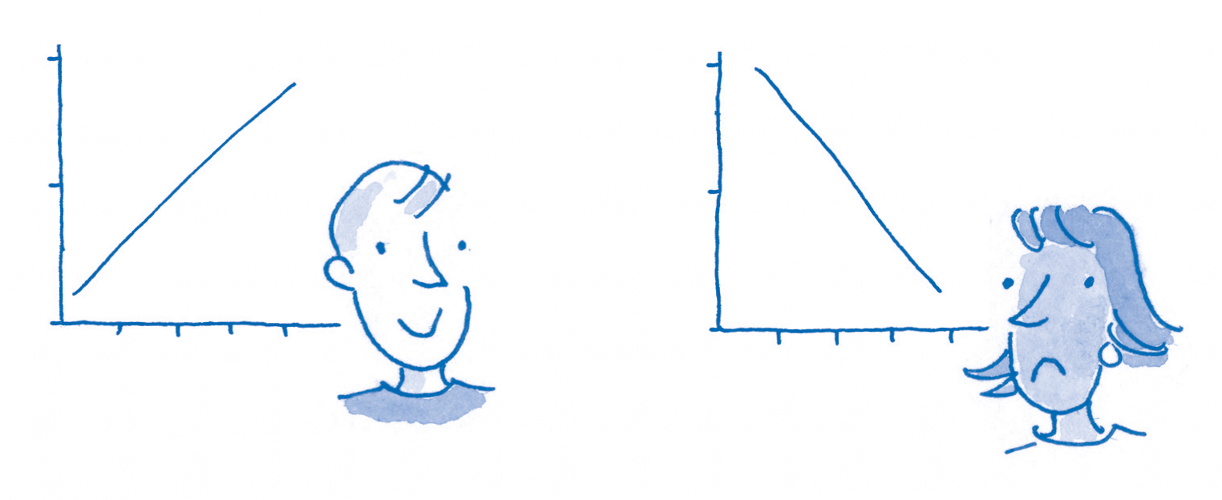

# Using tables, charts and graphs

Tables, charts and **10**

graphs provide

a kind of visual

shorthand – they **5**

condense complex

information and present it clearly.

**0**

**My money – income**

**Jan Feb Mar Apr**

**10**

**My money – income**

**5**

**0**

**Jan Feb Mar Apr**

## Why use tables, graphs and charts?

* Good tables and charts present information in clear, orderly, systematic ways.
* You can ‘see’ key information more quickly than when you read it as text.
* You can see relationships, detect patterns and trends, and draw comparisons easily.
* You may find visual information easier to interpret.
* You may see aspects to tables and charts that their authors did not see – that is, you may bring

an additional interpretation.

## Read the labels

Headings and labels help you to interpret the data appropriately.

* 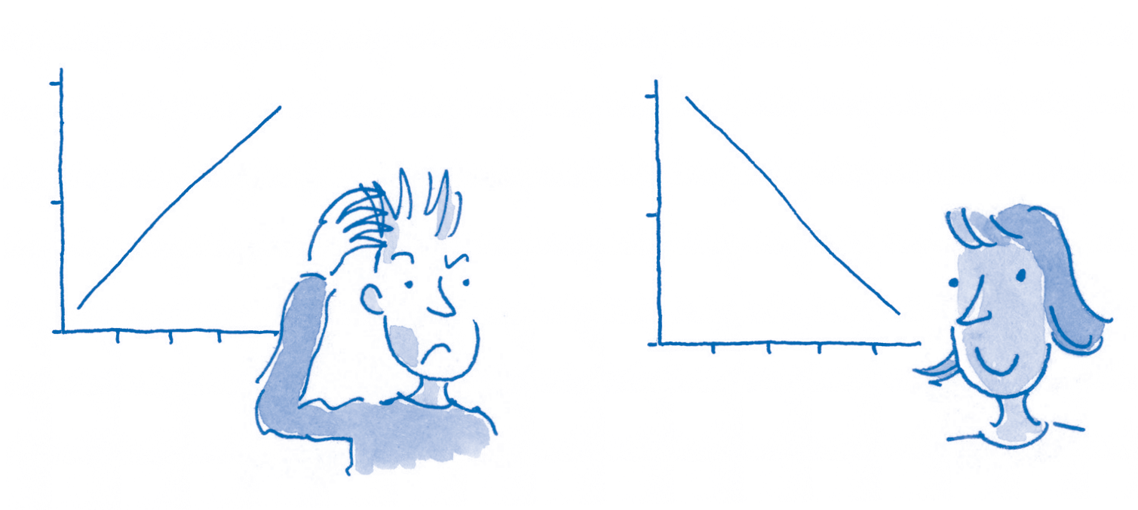*Headings* Read the main headings
* *Key* If colour, shading or symbols are used, look for the key that explains how to interpret these.

This is usually a box above, below or to the side of the table, and tells you the meaning of each colour, shading type or symbol.

## Take time; be systematic

Each table presents information differently, so take time to understand what the table is showing you.

* Familiarise yourself with the style, symbols, and measurements.
* Note dates and the source of information.
* Work your way systematically along each row, column, line, and so on.
* Keep checking back to the key and the measurements.
* Work out amounts. Look at any ‘totals’ that are presented – what do these tell you?

carefully. Note each **10**

word or phrase, and

be sure you know exactly what the

graph or table is **5**

meant to represent.

* + *Labels* Read the

labels on rows and **0**

columns, axes and lines. These should tell you precisely what each represents.

**My money – debts**

**Jan Feb Mar**

**10**

**My money – debts**

**5**

**0**

**Jan Feb Mar Apr**

**Just one word can change the meaning of the graph**

## Why use graphs?

Graphs are useful in indicating trends, including how one aspect, or *variable*, changes in relation to another. For example, a graph might show:

* how income rises or falls over time, or in relation to a factor such as world oil prices
* how sales vary relative to cost
* how an insect population increases or decreases with seasonal temperature or rainfall.

### Heading

*This should state exactly what the*

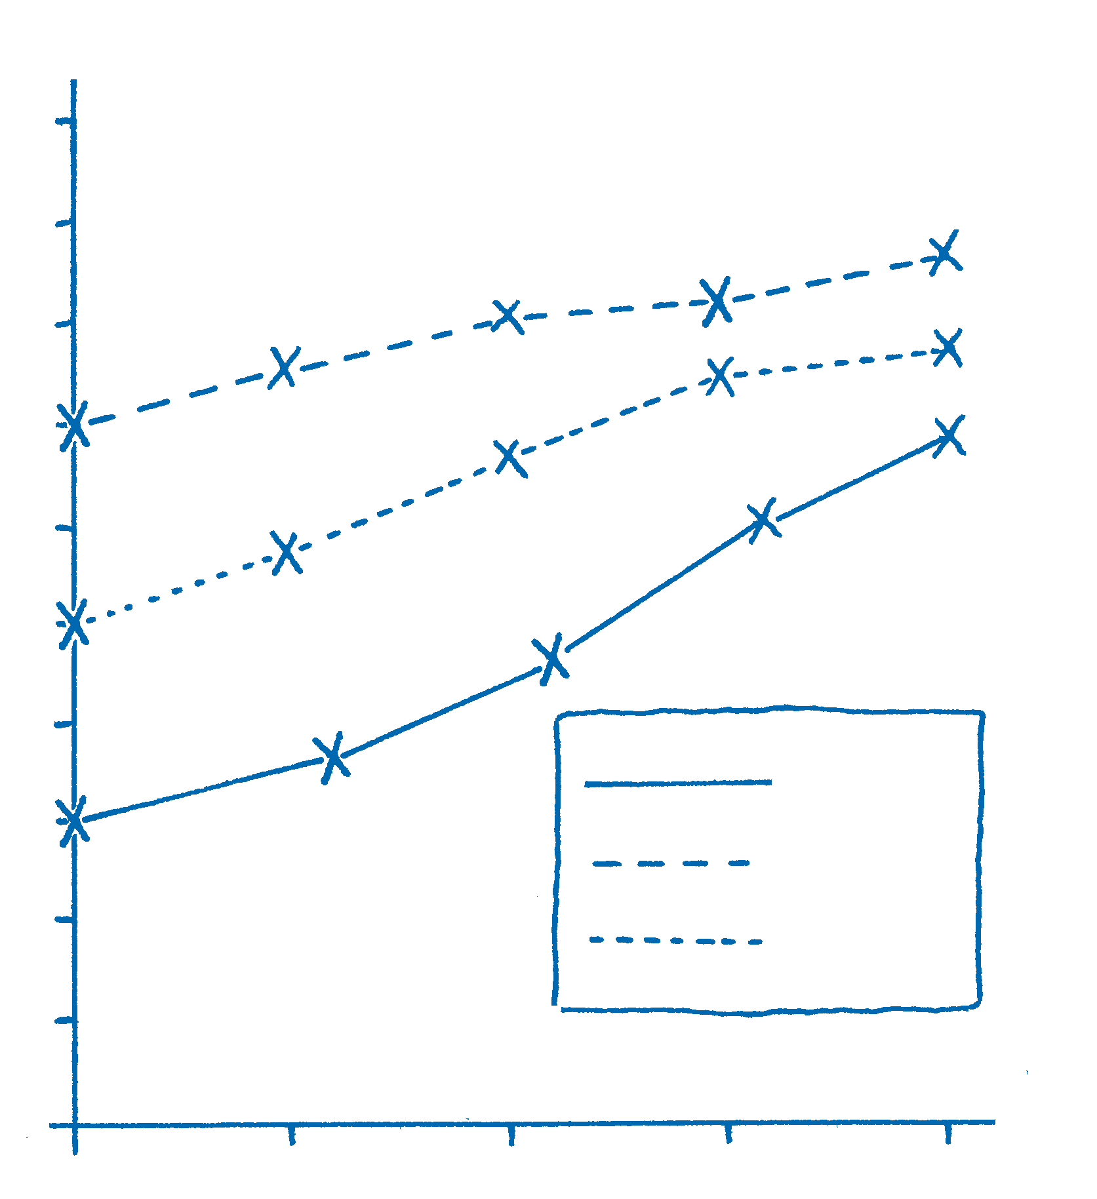

## Drawing graphs

A graph has two axes, horizontal and vertical. Each axis is divided into equal measures and labelled to specify the scale and unit of measurement being used, such as ‘Weight in grams’, ‘Volume in litres’, ‘Income in £1000s’, or ‘Temperature in degrees Celsius’.

## Reading graphs

Read all the textual information, such as headings, labels, and units of measurement.

Follow one line on the graph. Track it in relation to measurements on the

horizontal and vertical axes.

*graph is meant to show, including dates.*

### Axis label

*Each axis should be labelled to state exactly what it represents.*

### Vertical axis

*This is divided into equal measures.*

**Average earnings in Aremia, Jan.–Dec. 2012**

**Average income ($1000s)**

**50**

**45**

**40**

**35**

**30**

**25**

**20**

From these measurements, note the changes as you move along a line.

Are there any sharp rises or falls? What do these suggest?

## This graph

This graph indicates that in Aremia in 2012 women’s average income was lower than men’s average income, but that women’s income was rising more quickly.

*(Here the axis scale* **15**

*marks intervals of*

*$5000.)* **10**

**5**

### Horizontal axis 0

**Women**

**Men Whole**



1. What was the average salary for Aremian men in October?
2. In which quarter did Aremian women’s earnings rise above

$20,000?

*Answers are given on page 413.*

**Interpreting graphs**

***Activity***

*This is divided into equal measures. (Here the axis scale marks intervals of 3 months.)*

**Jan Apr Jul Oct Dec**

Source: Aremia Official Statistics, 2013

### Source and date

*The date and source of the information should be stated.*

### Labels or key

*Lines are labelled or a key is used to indicate what each line represents.*

The table below provides raw data for two student groups, A and B, with names, courses and test scores for 24 students. Examine the data to see what it tells you. For example, at first view, which course seems most popular? Which group does best in the test? Are these interpretations reliable?

|  |  |  |  |  |  |  |  |  |  |  |
| --- | --- | --- | --- | --- | --- | --- | --- | --- | --- | --- |
| ***Data set: 24 students’ test scores, by sub***  **Test scores for Group A** | | | | | ***ject and group (Aremia University, 2013)***  **Test scores for Group B** | | | | |  |
|  | **Student** | **Course Test** | **score** | **M/F** |  | **Student** | **Course** | **Test score** | **M/F** |  |
|  | Belinda | Geology | 67 | F |  | Assunta | Politics | 60 | F |  |
|  | Darren | Oriental Studies | 41 | M |  | Chiara | Social Work | 57 | F |  |
|  | Dilshad | History | 54 | F |  | Diane | Maths | 55 | F |  |
|  | Elizabeth | Maths | 64 | F |  | Horace | Psychology | 68 | M |  |
|  | Femi | English | 61 | M |  | Joachim | Film | 23 | M |  |
|  | Francis | Oriental Studies | 60 | M |  | Joseph | Nursing | 69 | M |  |
|  | Geraint | Psychology | 65 | M |  | Kiran | Arabic | 53 | M |  |
|  | Omar | Geology | 67 | M |  | Natasha | Film | 49 | F |  |
|  | Patrick | Geology | 72 | M |  | Niall | French | 44 | M |  |
|  | Rosa | Geology | 71 | F |  | Otto | Physics | 62 | M |  |
|  | Sunjit | Geology | 54 | M |  | Soraya | Film | 57 | F |  |
|  | Thandi | Geology | 58 | F |  | Zoe | Fine Art | 31 | F |  |

A set of only 24 students is unlikely to be representative of a large university population. You probably noticed that the most popular course overall is Geology, selected by 6 of the 24 students (25% or a 1/4 of students). Unless this is a specialist university, it is unlikely that a quarter of the students all study one subject.

If we looked only at the data for Group B, it would seem that Film was the most popular course and as if nobody studied Geology. Each group shows considerable variation in subject choice. With only one or two students taking each subject, in most cases, the sample size is too small for us to make generalisations about subject popularity.

This data on programme choices is unstable – if we were to add data about additional groups, it is likely that the proportions who had chosen each subject would change.

The mean test score overall for each group would allow one comparison between the groups. The total number of marks for Group A is 734 and in

that group there are 12 students, so the mean score is 734/12 = 61 marks. The total marks for Group B is 628: the mean score is 628/12 = 52 marks.

This is a big difference between the two groups. To interpret this data, you would need to know more. For example:

Chapter **9**

* How were these two groups selected?
* How do marks for these groups compare with those for the university overall?
* Does the high number of geologists in Group A distort the data?
* Are there other particular differences between the two groups, such as the proportions of

men and women or the proportion in part-time employment? Do these differences affect group marks?

You would also want to know what was being tested. For example, if the test were in geology, we would expect the geologists’ scores to be higher!

## Showing relationships

Tables, graphs and charts can be used to present two or more sets of information in a way that makes it easier to see how one set of information relates to the other, to find patterns and trends, and to draw comparisons.

## Bar charts

Bar charts contain less detail than tables, but summarise data in a way that makes it easier to read.

For example, the chart below presents the average marks for two student groups, A and B (page 21), and for their university as a whole. It breaks the data down to show the mean figures for whole sets, and also separately for men and women.

Note that the marks are shown from 50 upwards.

## Pie charts

Pie charts are useful in indicating the *relative proportions* of the various components that make up a whole. They cannot provide statistical precision, however.

Consider the information about recruitment to two groups on different programmes (page 21). The pie charts below compare the data for the 24 students with data for the university as a whole.

**Distribution of students by subject, 2012–13**

**Mean test marks by group 2012–13**

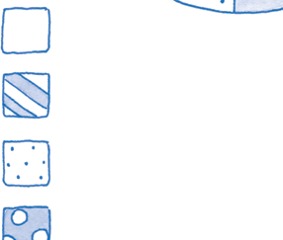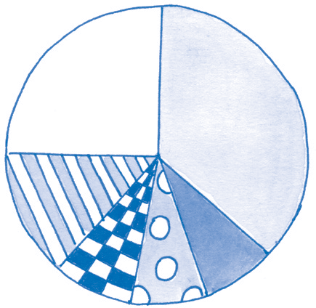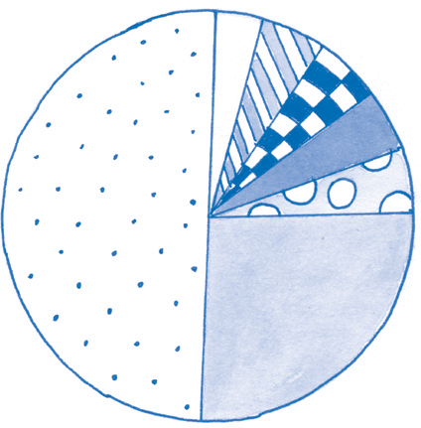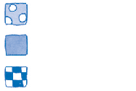

Chapter **9**

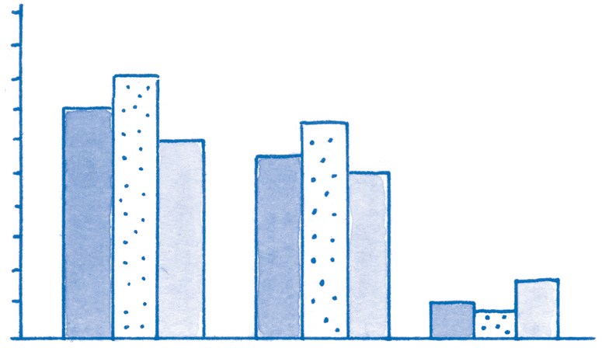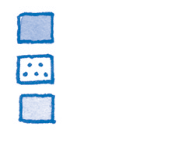

*Source: Aremia Assessment Report, July 2013*

*Source: Aremia Official Statistics, 2013*

|  |  |
| --- | --- |
| ***Activity*** | **Interpreting bar charts** |
| From the bar chart above, is Group A or Group B more representative of the university as a whole?  How do mean average scores for these groups compare with those for the university overall? | |

|  |  |
| --- | --- |
| ***Activity*** | **Interpreting pie charts** |
| Examine the two pie charts. In what ways were the 24 students representative or unrepresentative of the whole university? | |

***Average*** A number that is in some way ‘typical’ of a group of numbers, and that can be used to ‘represent’ them. What is meant by ‘typical’ depends on the context, and three kinds of average are commonly used: ***mean***, ***mode*** and ***median***. (See below and pages 13–6.)

***Data*** ‘Data’ is the plural of the Latin word *datum* (meaning ‘something given’). Data are facts, observations and measurements; collectively data provide information. Numerical data are collected by sorting, measuring and counting. For example, measurements of people’s heights and weights, or of sales or industrial production, or even of conditions on Mars, all provide numerical data.

***Data set*** A complete collection of information on a particular topic. For example, all the data collected in a survey of transport in London, Zagreb or Jakarta would together provide the data set for that survey.

***Denominator*** The bottom number in a fraction (see pages 7–8).

***Elements*** The basic categories of data used for collection, counting and analysis, such as ‘Income’, ‘Pieces of broken pottery’,

‘Respondents to the survey about font styles’.

***Extreme values*** Numbers that are much lower or much higher than the rest of the set. For instance, in the set 16, 55, 56, 56, 56, 57, 59,

61, 61, 63, 64, 68, 88, the numbers 16 and 88 would be ‘extreme values’.

***Mean*** The middle point of a sequence. This is the usual meaning of the word ‘average’ in

everyday conversation. (Calculation of the mean is explained on page 14.)

***Median*** The middle number in a sequence: one way of expressing an average. (Calculation of the median is explained on page 15.)

***Mode*** The number in a set that occurs most often: one way of expressing an average. (Calculation of the mode is explained on page 16.)

***Numerator*** The top number in a fraction (see pages 7–8).

***Percentage*** The number of occurrences in each 100 instances. For example, suppose 25 out of every 50 people are able to swim. The same proportion can be given as 50 people in each group of 100 people: ‘50 per cent’ or ‘50%’.

(Calculation of percentages is explained on page 11.)

***Prime numbers*** Numbers that, without resulting in a fraction, can be divided *only* by themselves or by the number 1. For example, the number 7 can be divided only by 1 or by 7 – division by any other number gives a fraction. The same is true of 3, 5, 11, 13, 17, etc.

***Qualitative data*** Information that comprises subjective descriptions rather than objective measurements. For example, a survey of pets might record owners’ reasons for choosing a particular animal, and how they feel about their pet.

Chapter **9**

***Quantitative data*** Information that comprises objective measurements rather than subjective descriptions. For example, a survey of pets might count the number of each kind of animal, and the annual cost of keeping it.

***Raw data*** The basic information as collected, with no interpretation. (See page 21.)

***Rounding ‘up’ or ‘down’*** Replacing a number with a simpler number that is no longer as accurate but is easier to work with. (See page 12.)

***Statistics*** Sets of data, and techniques for working with them. (See page 223.)

***Variables*** The aspects of the elements (or countable items) that may differ from one item or group to another. For example, a shopping survey might consider the kinds of product bought, the quantity of each, the number of shopping trips each week, the amount spent, the age and gender of the shopper, and so on.

***Vulgar fraction*** Another name for a fraction (see page 7).

# Review

This chapter has provided information about, and practice in, several aspects of working with numbers. The areas covered – such as working with fractions, calculating averages, and interpreting graphs and charts – challenge many students at times, even when they are

good at other aspects of number work. Although the necessary mathematical operations are not particularly difficult to learn, they are easy to forget if you do not use them regularly.

Here are some key messages from the chapter:

* You can overcome obstacles and barriers to using numbers, even if you have found these

difficult in the past.

* Numbers must be *interpreted* – in themselves, they provide no authority.
* In using numbers to find answers or make interpretations, you can be much more

confident if you:

* + don’t rush at the task
  + take time to absorb what is required
  + work systematically through a sequence of steps or rules for working out the right

answer

* + check your answers repeatedly
  + practise often the numerical operations and

tasks that are relevant to your course.

* If you are providing data in charts, tables and graphs, present these clearly. Use precisely

worded headings and labels.

* Words can be just as important as the numbers themselves. Make sure you read the instructions,

labels, headings, explanations and any other verbal information carefully.

If specialist techniques or statistical software packages are required for your course, your university or college is likely to provide sessions that explain how to use these. To cope with these more specialist areas of your programme, however, you will probably need first to be able to understand and perform the basic numerical functions outlined in this chapter.