Northern Cities Vowel Shift
(To be used as a handout, overhead, or in a PPTX)

Language Change occurs across all linguistic features.
NCVS
Where the shift is happening What is changing

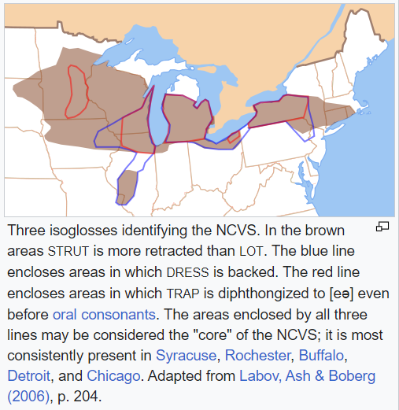
Word pronunciation is changing:

pot > pat sod > sad

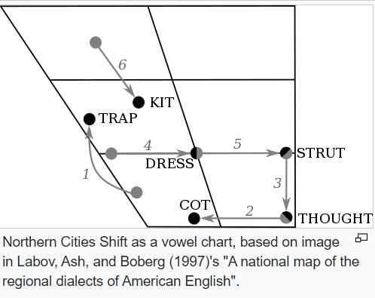

The Northern Cities Vowel Shift is a shift in the production of vowels in which one vowel moves to a new location—in this case upward—causing a chain reaction. The vowel that originally existed in that pronunciation space is then displaced, moving to the next closest spot, and the chain continues.
Different causes are speculated as to the origins of the shift, but once it begins, social factors such as identity allow the shift to continue.

