Evidence of Child Language Acquisition

The Wug tests

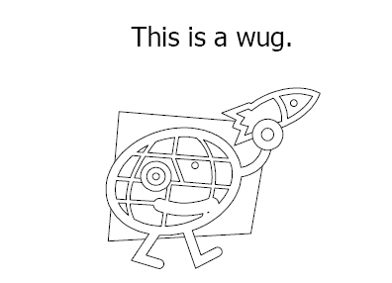

Berko, J. (1958). The child’s learning of English morphology. Word, 14(2-3), 150-177. doi:10.1080/00437956.1958.11659661.

