People in Action
Javier Leija

My name is Javier Leija. I grew up in the greater Houston area, in Baytown, TX, a city about 30 minutes east of Houston. I graduated from University of Houston – Clear Lake (UHCL) with a Bachelor of Science in Geography, where I first discovered GIS. I was initially interested in geography and using my degree to teach, but after taking my first GIS course, I was hooked ever since. After two semesters and three GIS courses under my belt, I began to apply for GIS internships, where I was able to demonstrate what I learned at UHCL within the professional world. I landed an internship with Setld, an organization which offers GIS data-driven products to energy organizations as solutions to growing geospatial needs. After completing the internship, I received an offer from NASA to work on research involving lava flow morphology and GIS. Currently, along with full time work as a GIS analyst for the City of Pearland, I’m also working on my master’s degree in GIS from Sam Houston State University.

- What does your organization/company do?
As a local government entity, City of Pearland is responsible for serving its residents. Among some of the services the city offers are informing residents of current ongoing projects, improve city infrastructure, enforce city ordinances, issue residential and commercial permits, police/fire/emergency services, and water billing, to name a few. Our mission states: “To deliver unparalleled city services and responsibly manage our resources holistically to contribute to a safe and desirable Pearland community. We will be a high-performance organization focused on continuous improvement and innovation, aspiring to build an engaging, sustainable, and inclusive community of choice.”
- What sort of clients does your organization/company have?
Our clients are residents of Pearland, potential residents, and anyone visiting our city. The city government is there to serve its constituents; any city project is designed to improve the lives of residents in one way or another. Other clients include third party companies to improve road infrastructure, develop new software applications to facilitate tasks within the organization, provide waste management services to residents, asset management (inventory), etc.
- Can you tell the readers a bit about your job. What is your current role and responsibilities?
I’m currently a GIS Analyst for the City of Pearland. My role within the organization is to 1.) Design web applications, dashboards, and maps that help support local government functions, 2.) Assist the GIS Manager and GIS Specialists with any projects or requests, 3.) Create custom analog or digital maps upon request for city departments such as planning, zoning, traffic, engineering, etc.
- What do you use GIS/geospatial technologies for in your organization?
Some of the uses of GIS in the organization can include anything ranging from simple feature creation to more advanced applications such as 3D modeling of city infrastructure or indoor mapping. We use GIS software to create feature classes, update/manage data, update our vector-tile basemaps, symbolize, publish PDF maps, store our data in SDE environment. Online cloud software is used to work with published projects from software on our desktop, and we can use what is on the online environment to create targeted maps, apps, and dashboards to provide city officials with solutions to problems. This is not an exhaustive list, there are many more GIS services we will offer in the future as our GIS department continues to grow.
- What GIS software/s do you use?
ArcGIS Pro is where most of our work is done; we still use ArcMap in unique cases where Pro does not produce desired results/outputs. To publish online we use ArcGIS Online, and here is where we configure services for internal, organization-wide use in maps, surveys, and applications. The most popular online applications we use to configure the services we offer are Survey123, ArcGIS Dashboards, Experience Builder, and WebAppBuilder. For any data or service that requires to be locked down due to privacy or security reasons, they are published to our ArcGIS Portal, which houses all of our secure data on a private server. Field data collection takes place in ArcGIS Collector/ArcGIS Field Maps. We use DJI software for remote sensing using a Phantom 4K drone and Pix4D to visualize our remote sensing results.
- How many people in your organization directly utilize geospatial technologies?
There are currently four people in the IT department, a GIS Analyst (myself), two GIS Specialists, and a GIS Manager, who work with GIS every day. We oversee editing, updating, and maintenance of GIS data, as well as the publishing of services for official city use in the form of maps, apps, and surveys. However, all departments can access and use GIS directly, an example being using the popular online interactive map to locate a parcel, pinpoint a street intersection, determine what day trash services collects waste for a neighborhood, or download data from our open data library for their personal projects.
- What brought you into GIS in your field? How did your GIS career begin?
My intro to GIS began with my undergraduate studies, in an intro to GIS course. I had a great GIS professor who loved what he did and cared about the discipline. Because of his leadership and enthusiasm, I was hooked to GIS, and have not put it down since. After my first semester with three GIS courses under my belt, I decided to begin to apply to internships. Any internship I could find online which involved GIS, I applied to. My first professional experience came working 30 hours a week at an organization called Setld, which provided GIS data driven data products to oil and gas organizations. At this internship, coupled with my self-driven learning outside of work, I learned about professional cartographic principles such as labeling, color schemes, symbology, scales for layers, scales for labels, georeferencing, and applying projections and coordinate systems. My GIS skills improved dramatically by working here.
- Can you give an example of a typical project that your organization would do that involves GIS?
The Right of Way Department in Public Works requested to research the possibility of creating an ArcGIS Dashboard to monitor work performed within Pearland city limits by third party companies. Before, the department had no way of tracking work done by third party companies and would run into reporting issues when asked the current status of third party projects by city council or the city manager. The project involved creating a point feature class in ArcGIS Pro called “ROW_third_party,” symbolizing based on type of work which included twelve different types, and publishing the feature class as a web layer to ArcGIS Online (AGOL) with editor tracking enabled (to be able to see who created each feature). The web layer was then brought into an AGOL map. The final map was used to drive the dashboard, which also provides a third-party analysis based on different fields from the layer. Internal users have the option to download the data displayed on the dashboard and use it to report to upper-level management.

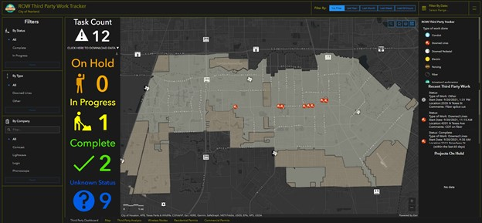
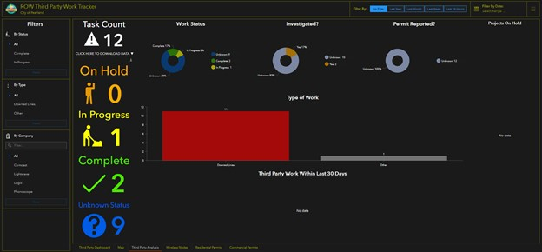
Public Works (Right of Way, Streets and Drainage, Traffic) is the department we work with the most, seen the benefits of GIS and have begun to implement it in any way they can, but we also help other departments like Engineering, Planning, Addressing, to name a few. We want to move towards supporting all departments with GIS solutions. We have recently worked with the Fire Department to create a Fire Dashboard to help visualize and notice patterns in fire calls, which is not possible with traditional table/Excel reporting. Here the user can query/filter based on conditions they want to see. An example show below is a fire marshal wants to know how many calls emergency services calls (EMS) Fire Station 2 received for the month of January 2021. Using the interactive dashboard elements, the user can filter down to meet the conditions for his analysis and download the data.

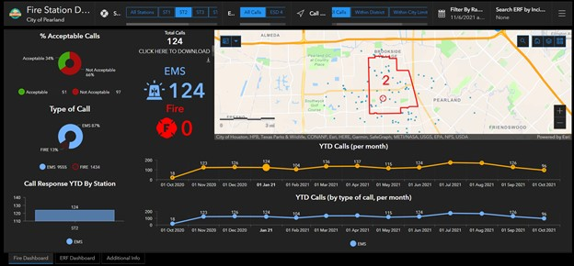
- Can you think of a project in your organization where geospatial technology/spatial analysis was the game changer? Why?
Our most important service we offer is the Emergency Operations Dashboard. This dashboard is crucial to city operations when there is a natural disaster approaching or an active city-wide emergency. This dashboard provides city officials a live view of where incidents are occurring throughout the city during an emergency, even when power is out. Instead of having to wait for someone out in the field to report an incident, wait for him to type out an email and have to decipher the email, or wait for a phone call, instead the field worker can instantly report an incident with key attributes which will help drive the objective of the dashboard, which is to view active incidents (downed power lines, debris, damaged roads, etc.), and determine where there are potentially frozen, flooded, or impassable streets. Along with live incident reporting, we can monitor storm conditions, such as rainfall and windspeed throughout the entirety of the storm. The dashboard also enables us to be able to actively check out every incident after the emergency is over, and clear out any potential debris, perform repairs, and conduct damage assessment. Without GIS, it would be an impossible task to visualize so much data in a quick and effective manner.

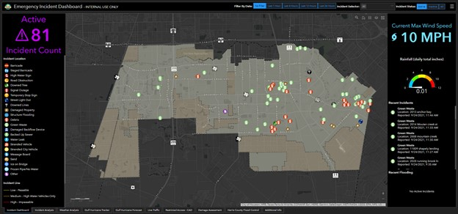
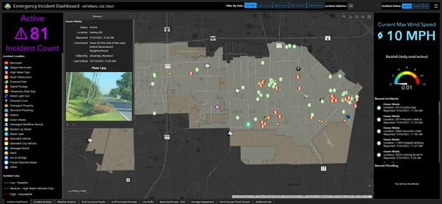
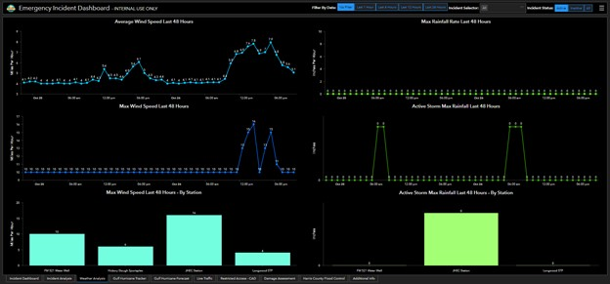
- What value does GIS add to your organization? How does it impact your business?
Right now, we are still using GIS to locate assets, taking inventory of the current infrastructure the city has. This is a lengthy process and may not be done until next year. Concurrently, the city is implementing a city-wide asset management program to help maintain inventory of city assets. This new program will have the capability of integrating with our current GIS, and once the new program is implemented, we will replace any feature classes we have of inventory with the new data from asset management. This will help put off the burden on us of having to maintain/update city inventory and focus more on the user visualization/analysis of the city assets. However, that is not to say that the current systems we have in place will be rendered obsolete. Not everything we store is our database are assets, and we can also use current maps, apps, and dashboards that use city assets layers we maintain as templates for use with the new asset management software.
- If you had to give any advice to an incoming freshman, what would it be?
To an incoming freshman who is interested in GIS, I would suggest: 1.) Begin to establish professional connections with your professors and classmates. Your colleagues and peers may have information on an open GIS position and can recommend you, as well as be a valuable reference in an application. 2.) You’re never done learning about GIS, especially after graduation. The field is ever-changing, and jobs expect you to take online training, take certification exams, and attend conferences outside of your normal hours to continue learning. 3.) Fill electives with any classes related to GIS, AutoCAD, 3D/BIM, programming, SQL, and web application development. The field continues to involve more coding, database administration, 3D, and design of applications, something traditional GIS courses don’t teach. Or, if you are interested in environmental GIS, take weather/climate, environmental, geology, and more geography courses. It will also help you in deciding if you would like to specialize into a specific topic within GIS.
- What would be your advice to someone who is interested in pursuing a career in GIS?
Do not be afraid to reach out to GIS users if you have any questions about GIS. It’s a growing, but close community. I have not been afraid to ask other GIS professionals for advice, problem solving, or career opportunities, and it is through this dialogue that I am now a GIS professional. Also, prepare yourself to be asked to perform analysis or tasks that you did not learn about while a student. Research, online searches, and community wiki pages are your best friend.
- What according to you in your educational background prepared you for a career in GIS?
At University of Houston – Clear Lake, the curriculum was based on social science research, which stressed the importance of understanding computer information systems, statistics, and geography, along with core GIS classes. I learned about database management, data types (nominal, ordinal, interval, ratio), and spatial analysis, all important aspects of core GIS standards and GIS theory. I continue my education at Sam Houston State University, currently enrolled as a graduate student in a master’s degree in Geographic Information Systems, where there is a stronger focus on the following GIS concepts but not limited to: understanding GIS data structure, cartographic design, ethics in GIS, and digital image classification techniques.
- What according to you is the role of GIS in the digital transformation of your organizational business?
Because of everything being online, and with the help of our open data being available to anyone who wants it, our GIS department is now moving from a traditional map producing role into one which supports decision making on infrastructure, projects, and asset management. We still provide maps for specific requests, but our focus is no longer on map production, as data is openly available for either public users or internal users, and making a map is easier than ever in ArcGIS Pro with lessons on how to do so online. The online transformation has freed us to transition into a more “productive” GIS department.
- How does your company/organization use GIS for business analytics, customer, and employee experience?
We provide few GIS-business analytics. Anything which could be considered business related involves first locating current city assets. It is the responsibility of the department we are working with end to quantify the asset/permit/work order to a dollar figure amount. The department may assist in determining costs by providing a way of quantifying the asset based on an attribute (example: asphalt road = x amount of dollars per mile). An example is helping Public Works locate where sidewalk repairs are needed based on the priority of work, which is determined with an ArcGIS Survey. Once we helped them determine where sidewalks repairs are needed throughout the city and with what priority, it is their job to place a cost value to the repair. Once they have quantified that value (based on equipment, manpower needed, and materials), we will be able to extend the analysis further to costs/risks/rewards of sidewalk maintenance.
There are few GIS services we offer to the public. A major one is our open data, where anyone can download data we offer as public data as a CSV file, shapefile, KML file, GeoJSON, or a file geodatabase. Another major application is the Interactive Map. This is used to view data such as parcels, plats, zoning, utilities, FEMA floodzone layers, etc. We also offer applications as public apps, paying special attention to address information to make sure no individual address is available for view, because of privacy concerns.
Employees who have an ArcGIS online account will be able to view any of the layers, maps, dashboards, applications, and surveys shared to the ArcGIS Online organization. Users who need to update layers in ArcGIS Collector will have access to those maps, granted by myself or one of the other GIS team members. There is also an “Employee Home” tab on our ArcGIS Online organization homepage where employees can view any application we have determined as employee use.
- Would you like to add anything?
I would like to thank Dr. Mukherjee for the opportunity to contribute to the textbook. Any way I can give back to the GIS community is welcomed, and if this helps someone decide to enter the GIS professional world, it is even more rewarding.

