Narrative Bias

Narrative bias is when the narrator of a story shares their own perspective on other characters or events rather than providing an objective view. This can influence the readers’ view as we only hear one perspective.

Imagine two friends had an argument, but only one of them wrote about it. If we read their writing, we would only have one perspective so would be more likely to side with them. You might have learned something similar in history lessons when you explore historical sources that are written by a country that has fought with another.

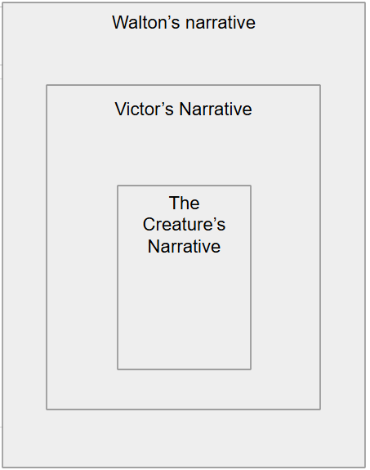
In Frankenstein, we are presented with the Creature’s narrative, told by Victor, captured in words written by Walton. This means the text is a wonderful way to explore narrative bias.

Discuss the following statements and finish the sentences to explore narrative bias.

Walton believes that Victor is…

This means he is likely to think that what Victor says is …

Victor believes that the Creature is…

This means that he is more like to describe him as…

The Creature’s story is being told by Victor…

Because of this, his story may not be told entirely faithfully because…

