How Healthy Is Your Pond?
Just like a frog in boiling water, your inner circle is like a pond whose health depends on the level of toxicity in the water. The more toxic traits are in your pond, the more polluted the water. The more polluted the water, the worse you feel. In this exercise, consider how many toxic and healthy traits exist in your most important relationships and draw a hash mark for each category. For a pond to be healthy, the healthy traits should outweigh the toxic ones. Table 6.3 shows an example.
Evaluating Toxic Traits in Relationships: Table 6.3
Relationship | Toxic Traits | Healthy Traits
Sibling | III | I
Next, if you have more toxic than healthy traits, put a snake in the pond

If you have more healthy than toxic traits in the pond, put a fish in the pond

For the example below, image 6.4 shows a snake in the pond
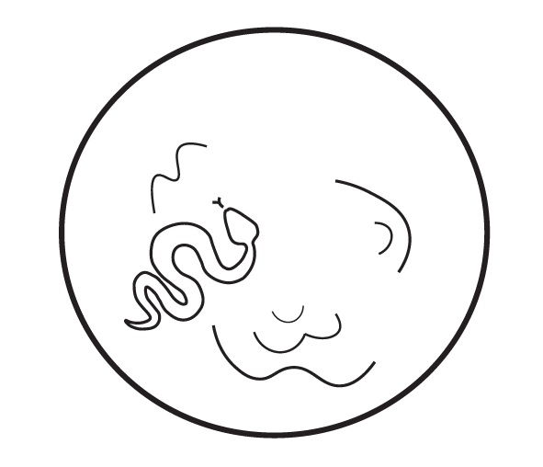

Using table 6.4, reflect on your intimate relationships and the traits therein. Using image 6.5, you can create your pond so that you have a visual representation of how healthy it is.
Traits in Intimate Relationships: Table 6.4
Relationship | Toxic Traits | Healthy Traits

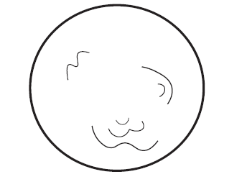
Finally, consider these closing questions as you reflect on your most important and intimate relationships:
Which relationships are you proudest of?

Do you have more snakes or fish in your pond?

Do you see any toxic traits that are patterns in your relationships?

What can you do to “detoxify” your pond?

What steps can you take to resuscitate a toxic relationship—or determine whether it needs to be let go?

What boundaries do you need to establish in your intimate relationships?

