Exercises and Reflection
Using image 8.3, on a scale from 1-10, rate your overall vocational satisfaction. There are several things to consider when you’re rating your overall satisfaction, including working conditions, colleagues, workload, autonomy, education and growth opportunities, variety of tasks, the fit between you and the work environment
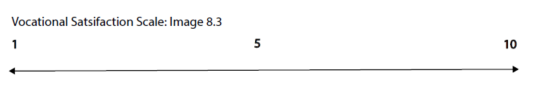 After you’ve determined your number, take a moment to define what that number means to you. How does the number reflect your satisfaction and dissatisfaction with your vocational life? (You can be both satisfied and dissatisfied with the same work-we are complex creatures.)

What values do you hold about your vocation and work?

How is your current job and/or vocation allowing you to live within your values? (remember your job and vocation can be different activities)

How is your current job and/or occupation not aligning with your values?

Now, on a scale from 1-10 rate how burnout may impact your vocational experience using image 8.4. Dimensions or constructs that are related to burnout include exhaustion, being overextended at work, cynicism, disengagement, and feeling ineffective. Signs that may indicate that you are not experiencing burnout can include feeling engaged in your work and having high levels of professional efficacy. (note these constructs are further defined by research from the Maslach Burnout Inventory (MBI))
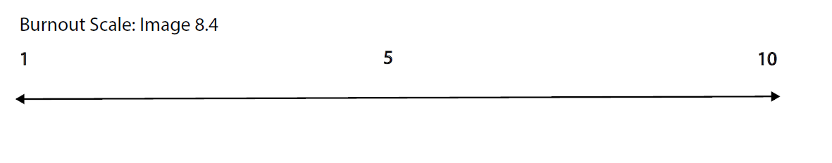 After you’ve determined your number, take a moment to define what that number means to you. How does the number reflect your level of burnout? Note that burnout is a serious condition, and I encourage you to seek mental health treatment if you believe that you are experiencing high and/or debilitating levels of it.
Additional Reflection Questions
- How can you make your job work for you?
  - Finding creative ways to engage in new/old projects that ignite creativity
- How can you reframe one of the issues that you are experiencing at work to look at it differently?
- If you are experiencing heightened levels of job fatigue or burnout, what is one boundary you need to engage in to decentralize your work life from the rest of your life?

If you were to redraw your vocational work life pie chart to reflect how you would want your life to look like, how would it look different?


What three steps will help recalibrate your pie chart from the first one to the one above?
1.
2.
3.

