FIGURE 8.1: Example of teaching French greetings and cultural etiquette
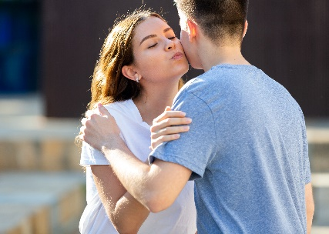
Greetings in France
- Greetings are important in France. Thus, it is necessary to greet others correctly to make a good impression.
- Handshakes are the norm in a business setting or with acquaintances. It is expected that you will shake hands with everyone present when arriving and leaving.
- Among friends and relatives, the most common greeting is the ‘la bise’ (kiss on both cheeks). The ‘la bise’ consists of placing one’s cheek against another’s, making a kiss noise, then repeating it on the opposite side. A ‘la bise’ is sometimes accompanied with an embrace.
- People generally kiss twice during a ‘la bise’; however, this varies depending on the region in France. In this instance, follow your French counterpart.
- One should remove their sunglasses and/or hat when doing a la bise.
- Respect is shown in verbal greetings by referring to the person as “Madame,” (‘Mrs’) “Monsieur”(‘Mr’) or “Mademoiselle”. Madame is only used to refer to a married woman, while Mademoiselle is reserved for unwed women.
- https://www.youtube.com/watch?v=d4V0aD2PF14

