Chapter One
Group Design Exercise: 3 x 3
Supplies: whiteboard, whiteboard markers, sticky note pads, and pens.

Prep: On a whiteboard, create three sections using two dividing dotted lines, and write the word “Teach” at the top of the left section.

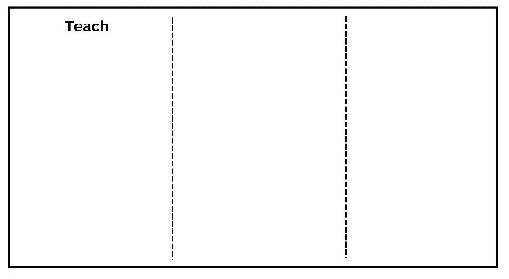

Break the large group into small groups of three to four people, providing groups with sticky note pads and pens.

Step 1: Invite the participants to contemplate things they know a lot about or love to do. Permit the group not to feel obligated to give a churchy answer, such as, "I know a lot about the naked prophet Isaiah." We all love Jesus here, but the point of the activity is to make new connections beyond our shared journey with Him.

For example, I dork out over Medieval European, Middle Eastern, and Western Asian history, or I know a great deal about the University of Alabama’s football legacy, being that my father graduated from the school and I didn't have a choice in who I was going to cheer for collegiately.

Step 2: Invite the participants to now consider if they were to take what they know a lot about or love to do and were allowed to teach a class on these things. Invite the participants to write down the topic they’d love to teach in a class on sticky notes, one topic per sticky, and up to three stickies.

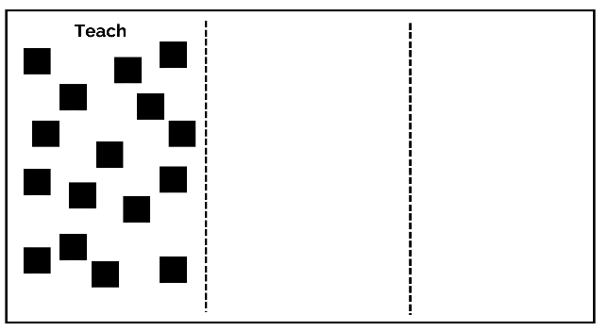

Step 3: After the three topics have been written onto their sticky notes, invite the participants to briefly share their ideas with their small group.
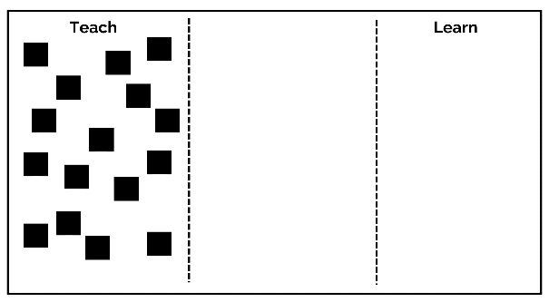

Step 4: Invite participants to place their stickies in the “Teach” section. Once all the stickies are set, briefly read them out loud to the entire group.

Step 5: Write the word “Learn” at the top of the right section, and invite the participants to contemplate now a topic, skill, or interest that they’d love to learn more about or learn to do. For example, I’d love to know more about the mysterious art of underwater basket weaving. Trust me; it’s a thing.

Step 6: Invite the participants to consider now if they were to take what they want to learn more about and were allowed to take a class on these things. Invite the participants to write down the topic they’d love to take a course on sticky notes, one topic per sticky, and up to three stickies.

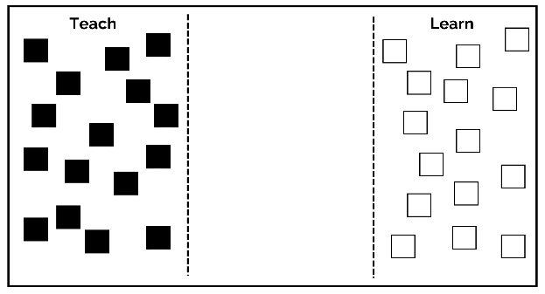

Step 7: After writing the three topics on their sticky notes, invite the participants to briefly share their ideas with their small group.

Step 8: Invite participants to place their stickies in the “Learn” section. Once all the stickies are set, briefly read them out loud to the entire group.

Step 9: Write the phrase “Points of Connection” at the bottom of the middle section, and invite the participants to help you bridge the points of connection between similar ideas shared, both in the “Learn” and “Teach” sections. Once the connection points are made, bring those stickies together, creating clusters of similar ideas. For example, someone might have expressed an interest in learning how to utilize their smartphone better, while someone else expressed the ability to teach a class on changing technology.
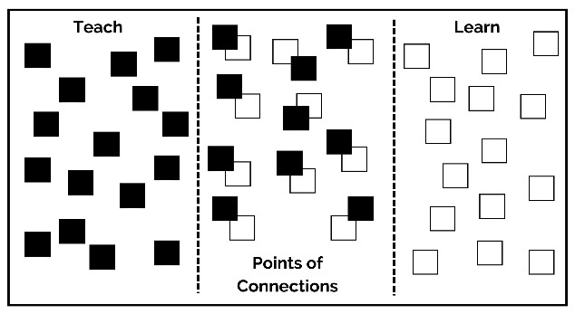

Step 10: Discuss the following with the group:
- What can we take away from this activity?
- What is one thing you have learned about the other members of our church?
- What does this activity teach us about our points of commonality beyond membership in this church?
- What action steps can we take as a result of this chapter and exercise?

Note: This exercise is a tremendous building block for creating shared interest groups and events within your church that has the capacity to foster new relationships, strengthen existing connections, nurture intergenerational connections, and so much more. Later in the book, we discuss how churches can learn to play together. The results from this activity have given you a blueprint for play moving forward.

