Chapter Two
Group Design Exercise: Empathy Map

Supplies: whiteboard, whiteboard markers, sticky note pads, and pens.

Prep: On a whiteboard, draw the provided quadrant with words and images.

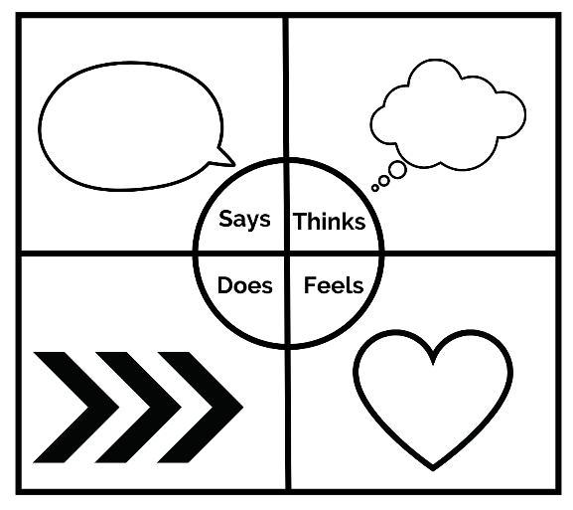

Provide each person with sticky note pads and pens.

Step 1: Invite the participants to contemplate how they respond to the unknown and uncertainty.

Step 2: Invite the participants to contemplate how they tend to respond verbally to the unknown. Ask them to write one way they verbally respond to the unknown per sticky note, inviting them to add their stickies to the “Says” section.

Step 3: Invite the participants to contemplate how they tend to think in response to uncertainty. Ask them to write one way they mentally respond to uncertainty per sticky note, inviting them to add their stickies to the “Thinks” section.

Step 4: Invite the participants to contemplate how they tend to act in response to the unknown. Ask them to write one way they act in response to the unknown per sticky note, inviting them to add their stickies to the “Does” section.

Step 5: Invite the participants to contemplate what they tend to feel emotionally in response to uncertainty. Ask them to write one way they emotionally respond to uncertainty per sticky note, inviting them to add their stickies to the “Feels” section.

Step 6: Review each quadrant independently, examining each response without commentary. Then discuss and sort the responses with the following:
- Commonalities
- Outliers
- Surprises

Step 7: Discuss the following with the group:
- What is one thing you have learned about other members of our church?
- How might you respond differently knowing now the diverse ways our members respond to the unknown?
- What is one takeaway from this exercise?
- What are some action steps we can take as a result of this chapter and exercise?

