Chapter Five
Group Design Exercise: Connecting the Dots

Supplies: 6 mm circle dot stickers (4 colors), ¾ inch circle dot stickers (4 colors), and star stickers (4 colors). Note that the colors need to match the other dot or star stickers.
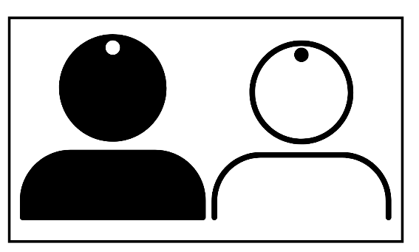
Prep: Count out the number of participants and then separate the 6mm dots, ¾ inch dots, and star stickers based on the following numbers:
- 60% of Color 1
- 25 % of Color 2
- 10 % of Color 3
- 5 % for Color 4

*It is critical to the activity that you follow these percentages of four different colors for both size dot stickers and star stickers.

For this activity, you will need ample space for people to move.

Step 1: Instruct the participants to remain silent throughout this activity, making no sounds and speaking no words.

Step 2: Let the participants know that you and an assistant will place a sticker on their foreheads, asking them not to touch or take off the sticker.

Step 3: Invite participants to form small groups without saying a word or making a sound. Do not say anything else. There are no instructions on the criteria for forming the groups.

Step 4: After the small groups have formed, ask them to look around at the people in their group and observe the other small groups.

Step 5: Invite the participants to break up and form another small group without saying a word or making a sound. Do not say anything else. There are no instructions on the criteria for forming the groups.

Step 6: After the small groups have formed, ask them to look around at the people in their group and observe the other small groups.

Step 7: Invite the participants to break up and form yet another small group without saying a word or making a sound. Do not say anything else. There are no instructions on the criteria for forming the groups.

Step 8: After the small groups have formed, ask them to look around at the people in their group and observe the other small groups.

Step 7: Invite the participants to break up and formulate yet another small group without saying a word or making a sound for the fourth and final time. Do not say anything else. There are no instructions on the criteria for forming the groups.

Step 8: After the small groups have formed, ask them to look around at the people in their group and observe the other small groups.

Step 9: Invite the participants to take their seats. Consider asking the following questions:
- What did you observe from this activity?
- For the folks who had a _____ (10% of Color 3) or ____ (5% of Color 4), how did this activity make you feel?
- For the folks who had a _____ (60% of Color 1) or ____ (25% of Color 2), how did this activity make you feel?
- Did anyone with a ____ (60% of Color 1) or ____ (25% of Color 2) attempt at any point to bring in someone with a _____ (10% of Color 3) or ____ (5% of Color 4) into your group?
- What’s fascinating is that I did not instruct anyone to group themselves by color, shape, or size of stickers, did I? Why do you think you gathered in groups based on dot color or dot size?
- Do you think participants rarely look beyond the sticker shape, color, or size?
- What does this activity teach us about bias?

Step 10: Discuss the following with the group:
- What can we take away from this activity?
- What action steps can we take resulting from this chapter and exercise?

