Chapter 7

Group Design Exercise: I See in You

Supplies: whiteboard, whiteboard markers, sticky note pads, index cards (six per person), and pens.

Prep: Break the large group into small groups of no more than three to four people, providing groups with sticky note pads, index cards (six per person), and pens.

During their small group time, on the whiteboard, draw the provided interlocking circles with words and images.

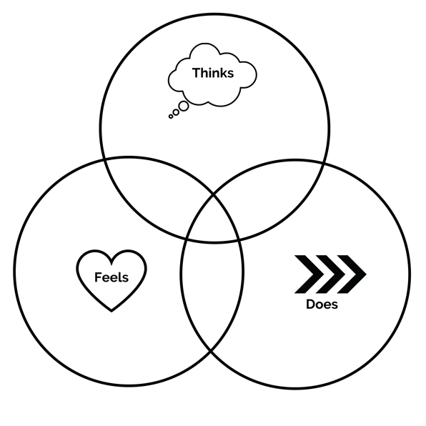

Step 1: Invite the participants to contemplate what they love most about this church, writing it down on one side of an index card. Give three minutes for this exercise.

Step 2: Invite the participants to contemplate a time when they felt that they were a part of something successful through the church, writing it down on the other side of an index card. Give three minutes for this exercise.

Step 3: Invite the participants to take 2 minutes to share what they wrote down from Steps 1 and 2, asking each person to listen intently while others are sharing, taking down notes on an index card.

Step 4: Explain to participants that in the next stage of this activity, you are going to be writing “I See in You” statements for each person in their small group. “I See in You” statements are words of encouragement of maybe something an individual does not see in themselves or words of affirmation for their known strengths, gifts, and talents.

You will begin with one member of the small group, giving other members a chance to write an “I See in You” statement, and then each sharing that statement aloud to the focused member.

Encourage the participants to write down the “I See in You” statement on an index card that they can share with the focused member.

Note to the group that this might feel awkward to have other people write statements of affirmation and speak them aloud, but encourage them to lean into the moment with vulnerability and openness.

Step 5: For the first focused member of the small group, give each person two minutes to reflect and write an “I See in You” statement, followed by sharing that statement.

Step 6: For the second focused member of the small group, give each person two minutes to reflect and write an “I See in You” statement, followed by sharing that statement.

Step 7: For the third focused member of the small group, give each person two minutes to reflect and write an “I See in You” statement, followed by sharing that statement.

Step 8: For the fourth focused member of the small group, give each person two minutes to reflect and write an “I See in You” statement, followed by sharing that statement.

Step 9: Discuss the following with the group, inviting individuals to also write one response per sticky note:
- What are you thinking right now? (Sticky note responses go in “Thinks” circle)
- What are you feeling right now? (Sticky note responses go in the “Feels” circle)
- What do you think we should do now? (Sticky note responses go in the “Does” circle)
- What is one takeaway from this exercise?
- What are some action steps we can take as a result of this chapter and exercise?

