Chapter 8
Group Design Exercise: Affinity Mapping

Supplies: whiteboard, whiteboard markers, sticky notes, blank paper, and pens.

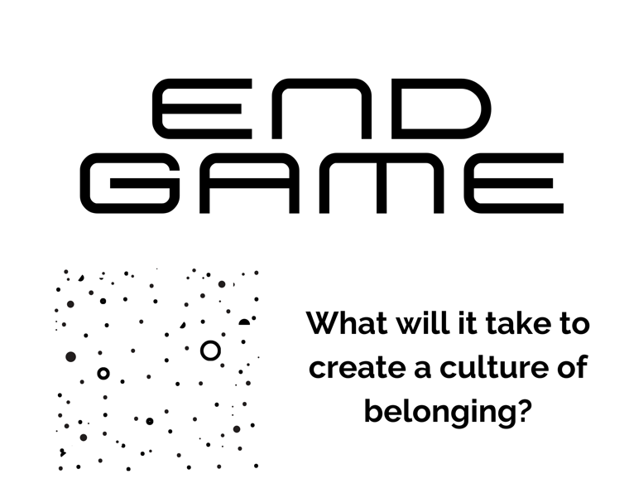

Prep: On a whiteboard, draw the provided words and images. Leave space all around the drawing for sticky notes.

Break the large group into small groups of no more than eight people, providing each group with sticky notes, blank paper, and pens.

Step 1: Invite the participants to contemplate what makes them personally feel a sense of belonging, writing down their thoughts on blank paper.

Step 2: Invite the participants to share their thoughts with their small group.

Step 3: Invite the small groups to identify some of the common traits and differences among the personal statements shared, writing each common and different trait down on an individual sticky note (one idea per sticky note).

Step 4: Invite each small group to briefly share their findings from Step 3, placing the sticky notes above the whiteboard drawing and pairing similar ideas. Label this section “Personal Sense of Belonging.”

Step 5: Invite the participants to contemplate what makes them personally feel isolated or rejected within a community, such as the church, writing down their thoughts on blank paper.

Step 6: Invite the participants to share their thoughts with their small group.

Step 7: Invite the small groups to identify some of the common traits and differences among the personal statements shared, writing each common and different trait down on an individual sticky note (one idea per sticky note).

Step 8: Invite each small group to briefly share their findings from Step 7, placing the sticky notes below the whiteboard drawing and pairing similar ideas. Label this section “Personal Sense of Isolation and Rejection.”

Step 9: Building off the assumption that there is room for improvement, invite the participants to contemplate what it would practically take to create a culture of belonging within this church, writing down their thoughts on blank paper.

Step 10: Invite the participants to share their thoughts with their small group.

Step 11: Invite the small groups to identify some of the common and outlier ideas shared, writing each common and outlier idea down on an individual sticky note (one idea per sticky note).

Step 12: Invite each small group to briefly share their findings from Step 11, placing the sticky notes right of the whiteboard drawing and pairing similar ideas. Label this section “Practical Ways to Create a Culture of Belonging.”

Step 13: Invite participants to briefly reflect on the “Practical Ways to Create a Culture of Belonging” section. Next, ask them to personally reflect on the viability and applicability of these ideas, considering what it would take to put them into action.

Step 14: Invite the participant to share their thoughts with their small groups.

Step 15: Invite the small groups to identify some of the key findings from their conversation, writing each idea down on an individual sticky note (one idea per sticky note).

Step 16: Invite each small group to briefly share their findings from Step 15, placing the sticky notes right of the whiteboard drawing and pairing similar ideas. Label this section “Next Steps of Creating a Culture of Belonging.”

Step 17: Invite the participants to reflect on this parting thought:
Belonging cues are behaviors that create safe connections in a group. They include, among others, proximity, eye contact, mimicry, turn-taking, attention, body language, vocal pitch, consistency of emphasis, and whether everyone talks to everyone else in the group. Like any language, belonging cues can’t be reduced to an isolated moment but rather consist of a steady pulse of interactions within a social relationship. - Daniel Coyle, The Culture Code

