Essentials of UK Politics and Government

Further Resources Booklet

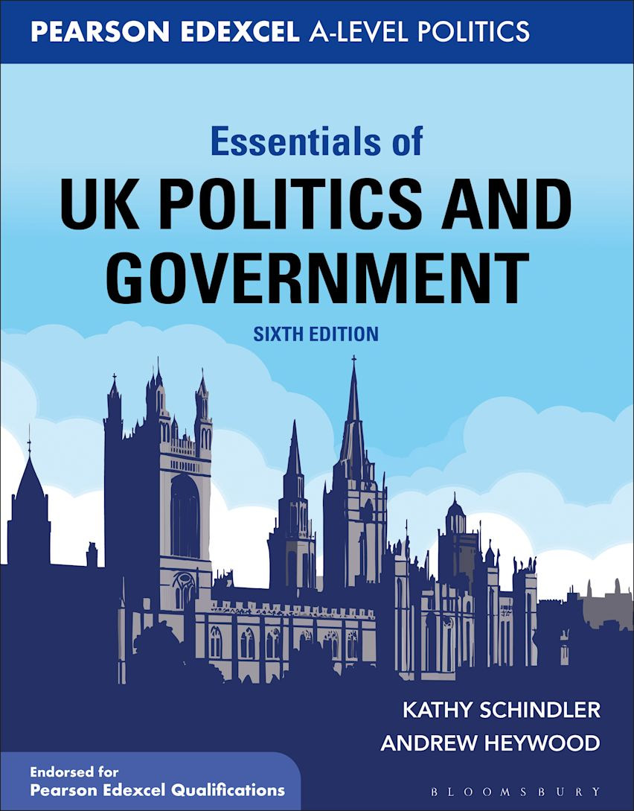

Chapter 1: Democracy and Participation: Suffrage
The Audit of political engagement
https://www.hansardsociety.org.uk/projects/audit-of-political-engagement

Membership of political parties
https://commonslibrary.parliament.uk/research-briefings/sn05125/

Electoral Turnout in 2019
https://commonslibrary.parliament.uk/insights/general-election-2019-turnout/

https://www.ipsos.com/ipsos-mori/en-uk/how-britain-voted-2019-election

Voter engagement in the UK https://publications.parliament.uk/pa/cm201415/cmselect/cmpolcon/232/232.pdf

Votes at 16
https://blogs.lse.ac.uk/politicsandpolicy/votes-at-16-new-evidence-from-scotland/

https://www.parliament.uk/business/publications/research/key-issues-parliament-2015/parliament-politics/votes-at-16/

Compulsory voting
https://commonslibrary.parliament.uk/research-briefings/sn00954/

Electoral Registration
https://www.theguardian.com/politics/2019/sep/27/more-than-9-million-eligible-voters-not-correctly-registered

Votes for prisoners
https://metro.co.uk/2017/06/08/votes-for-prisoners-the-rights-and-rules-for-convicts-explained-6686982/

https://www.theguardian.com/politics/2017/dec/07/council-of-europe-accepts-uk-compromise-on-prisoner-voting-rights

Chapter 2: Democracy and Participation: Pressure Groups and Rights
Democratic Audit
https://www.democraticaudit.com/2018/08/24/audit2018-how-democratic-is-the-interest-group-process-in-the-uk/

https://www.democraticaudit.com/2018/11/28/how-well-does-the-uks-democracy-protect-human-rights-and-civil-liberties/

The nature of protest politics
https://theconversation.com/decade-of-dissent-how-protest-is-shaking-the-uk-and-why-its-likely-to-continue-125843

UK Lobbying Register
https://www.lobbying-register.uk/about-.html

TUC
https://www.tuc.org.uk/

The CBI
https://www.cbi.org.uk/our-campaigns/#impact

Liberty
https://www.libertyhumanrights.org.uk/your-rights/

Howard League
https://howardleague.org/

CPS
https://www.libertyhumanrights.org.uk/your-rights/

Common Wealth
https://www.common-wealth.co.uk/about

Hanbury Strategy
https://www.hanburystrategy.com/

Extinction Rebellion
https://extinctionrebellion.uk/

Black Lives Matter
https://blacklivesmatter.com/

Chapter 3: Political Parties
The Conservative Party
https://www.conservatives.com/

The Labour Party
https://labour.org.uk/about/

The Liberal Democrats
https://www.libdems.org.uk/

One Nation Conservatism
https://www.theweek.co.uk/101705/what-is-one-nation-conservatism

Thatcherism
https://www.bbc.co.uk/news/uk-politics-22079683

The Third Way
http://news.bbc.co.uk/1/hi/458626.stm on the Third Way

Clause IV of The Labour Party

https://www.theguardian.com/politics/2015/aug/09/clause-iv-of-labour-party-constitution-what-is-all-the-fuss-about-reinstating-it

https://keirstarmer.com/plans/10-pledges/

Party Funding
https://www.electoralcommission.org.uk/who-we-are-and-what-we-do/financial-reporting

https://commonslibrary.parliament.uk/research-briefings/sn07152/

Parties and the Party System

https://www.parliament.uk/about/mps-and-lords/members/partysystem/

http://www.democraticaudit.com/2018/08/22/audit2018-how-democratic-are-the-uks-political-parties-and-party-system/

Chapter 4: Elections and Referendums
UK General Election 2019 Case Study
https://qualifications.pearson.com/content/dam/pdf/A%20Level/Politics/2017/Teaching%20and%20learning%20materials/A_Level_Politics_2019_UK_General_Election_Case_Study.pdf

A study published by Pearson Education

UK General Election 2017 Case Study
https://qualifications.pearson.com/content/dam/pdf/A%20Level/Politics/2017/Teaching%20and%20learning%20materials/A_Level_Politics_2017_UK_General_Election_Case_Study.pdf

A study published by Pearson Education

Klemperer, David. The Electoral System and British Politic
https://consoc.org.uk/wp-content/uploads/2019/04/David-Klemperer-The-Electoral-System-and-British-Politics.pdf

A leaflet published by the Constitution Society

House of Commons Library - General election 2019: Turning Votes into Seats https://commonslibrary.parliament.uk/insights/general-election-2019-turning-votes-into-seats/

A document published by the House of Commons Library

Electoral Reform Society
www.electoral-reform.org.uk

Electoral Commission
www.electoralcommission.org.uk

An independent body, created in 2001, which regulates party and election finance and sets standards for how elections should be run.

Chapter 5: Voting Behaviour
The June 2017 General Election John Curtice
Politics Review, September 2017 (pp. 2-6)

Affluence, Austerity and Electoral Change in Britain
by Paul Whiteley Harold D. Clarke, David Sanders and Marianne C. Stewart

How A Bacon Sandwich Derailed Ed Miliband's UK Political Career
Article in the Huffington Post

IPSOS MORI How the voters voted in the 2019 election
https://www.ipsos.com/sites/default/files/ct/news/documents/2019-12/general-election-2019-poll-aggregate-v8.pdf

YouGov How Britain voted in the 2019 general election
https://yougov.co.uk/topics/politics/articles-reports/2019/12/17/how-britain-voted-2019-general-election

YouGov How Britain voted in the 2017 general election
https://yougov.co.uk/topics/politics/articles-reports/2017/06/13/how-britain-voted-2017-general-election

Ethnic Minorities at the 2017 British General Election
https://www.runnymedetrust.org/uploads/2017%20Election%20Briefing.pdf

IPSOS MORI How Britain voted in the 2019 election – summary and data
https://www.ipsos.com/ipsos-mori/en-uk/how-britain-voted-2019-election

General Election analysis: The maps and charts that show how Theresa May lost her majority
https://www.telegraph.co.uk/news/0/general-election-2017-results-analysis-theresa-may-lost-majority/

Election results 2019: Analysis in maps and charts
https://www.bbc.co.uk/news/election-2019-50770798

Most volatile British electorate in modern times – British Elections Study
https://www.britishelectionstudy.com/bes-resources/press-release-most-volatile-british-electorate-in-modern-times/#.Xp8HQy3Mw8b

Bigley’s fate by Boris Johnson: The Spectator 2004
https://www.spectator.co.uk/article/bigley-s-fate

The Conservatives, ethnic minority voters, and the election. Next to no progress. By Sunder Katwala
https://www.conservativehome.com/platform/2019/12/sunder-katwala-the-conservatives-ethnic-minority-voters-and-the-election-next-to-no-progress.html

How Gillian Duffy nipped out for a loaf - but left Gordon Brown in a right jam – The Guardian
https://www.theguardian.com/politics/2010/apr/29/gordon-brown-gillian-duffy-bigot

General election 2010: How Britain voted
https://www.theguardian.com/politics/2010/may/13/general-election-2010-how-britain-voted

Lord Ashcroft: How Britain voted and why: My 2019 general election post-vote poll
https://lordashcroftpolls.com/2019/12/how-britain-voted-and-why-my-2019-general-election-post-vote-poll/

Chapter 6: The Media
The Executive Summary of the Leveson Inquiry 2012
https://www.gov.uk/government/publications/an-inquiry-into-the-culture-practices-and-ethics-of-the-press-executive-summary

The Centre for Research in Communication and Culture, Loughborough University on the 2019 Election
https://www.lboro.ac.uk/news-events/general-election/report-5/#section-1

OFCOM: the data research page
https://www.ofcom.org.uk/research-and-data

OFCOM’s Report on News Consumption in the UK: 2019
https://www.ofcom.org.uk/__data/assets/pdf_file/0027/157914/uk-news-consumption-2019-report.pdf

Journalism News
https://www.pressgazette.co.uk/

The Digital, Culture, Media and Sport Committee’s final report on Disinformation and ‘fake news’
https://www.parliament.uk/business/committees/committees-a-z/commons-select/digital-culture-media-and-sport-committee/news/fake-news-report-published-17-19/

Select Committee on Political Polling and Digital Media
https://publications.parliament.uk/pa/ld201719/ldselect/ldppdm/106/10602.htm

Online News and Media Use in the 2019 UK General Election
http://www.digitalnewsreport.org/publications/2020/mile-wide-inch-deep-online-news-media-use-2019-uk-general-election/

Democratic Audit
https://www.democraticaudit.com/2018/08/30/2018audit-how-well-does-the-uks-media-system-support-democratic-politics-and-represent-citizens-interests/

Media Reform Coalition
https://www.mediareform.org.uk/media-ownership/who-owns-the-uk-media

John Naughton on how traditional outlets online were the most popular for general election news
https://www.theguardian.com/commentisfree/2020/feb/15/reports-of-social-media-influence-on-voters-are-greatly-exaggerated

Steve Schifferes on the media and austerity
https://theconversation.com/how-the-media-made-austerity-worse-95390

Sir Robert Worcester and Jayme Herve on the print media and elections
https://blogs.lse.ac.uk/politicsandpolicy/was-it-the-sun-and-the-times-wot-nearly-won-it/

Jim Waterson on the Cairncross Review
https://www.theguardian.com/media/2019/feb/11/public-funds-should-be-used-to-rescue-local-journalism-says-report

http://downloads.bbc.co.uk/bbctrust/assets/files/pdf/about/how_we_govern/purpose_remits/2013/purpose_remits.pdf

https://www.lboro.ac.uk/news-events/general-election/report-5/#section-1

https://www.newstatesman.com/broadcast/2012/11/bbc-still-most-trusted-media-organisation

Chapter 7: The Constitution
59 things that would have stayed secret. What they didn't want you to know: A list of intriguing facts disinterred by the Freedom of Information Act.
https://web.archive.org/web/20090517012457/http://www.timesonline.co.uk/tol/global/article1471409.ece

10 things we found out because of Freedom of Information 2015
https://www.bbc.co.uk/news/magazine-30645383

A guide to devolution in the UK
https://www.bbc.co.uk/news/uk-politics-35559447

The Good Friday Agreement
https://www.historyextra.com/period/20th-century/northern-ireland-good-friday-agreement-protestants-catholics-brexit-border-ira/

How Martin McGuinness and Ian Paisley forged an unlikely friendship
https://www.belfasttelegraph.co.uk/news/northern-ireland/how-martin-mcguinness-and-ian-paisley-forged-an-unlikely-friendship-35550640.html

Coronavirus lockdown rules in each part of the UK
https://www.instituteforgovernment.org.uk/explainers/coronavirus-lockdown-rules-four-nations-uk

Chapter 8: Parliament
Government defeats in the House of Lords
https://www.parliament.uk/about/faqs/house-of-lords-faqs/lords-govtdefeats/

How leaders fared at first Prime Minister's questions
https://www.bbc.co.uk/news/uk-politics-11521789

Prime Minister's Questions: 11 reasons why it epitomises the worst in British politics
https://www.independent.co.uk/news/uk/politics/generalelection/prime-ministers-questions-11-reasons-why-it-epitomises-the-worst-in-british-politics-10133350.html

How effective are the Commons’ two committee systems at scrutinising government policy-making? Patrick Dunleavy and the Democratic Audit team
https://www.democraticaudit.com/2018/09/24/audit2018-how-effective-are-the-commons-two-committee-systems-at-scrutinising-government-policy-making/

‘John Bercow steps down: The controversial speaker who shaped Brexit’ - Benjamin Kentish The independent
https://www.independent.co.uk/news/uk/politics/john-bercow-resign-brexit-speaker-party-tory-a9179286.html

How Amber Rudd was brought down by a simple question
https://www.ft.com/content/5f87dce6-4bf2-11e8-8a8e-22951a2d8493

Chapter 9: The PM and Executive
Cabinet reconstruction: the calculations and risks behind Johnson’s ‘second-chance’ government
https://blogs.lse.ac.uk/politicsandpolicy/boris-johnsons-cabinet-reconstruction/

Government reshuffles
https://www.instituteforgovernment.org.uk/explainers/government-reshuffles

The Engine Room: How to organise 10 Downing Street
https://www.instituteforgovernment.org.uk/events/engine-room-how-organise-10-downing-street

Gresham Lectures. British Prime Ministers from Attlee to Blair - Professor Vernon Bogdanor FBA CBE
https://www.gresham.ac.uk/lectures-and-events/british-prime-ministers-from-attlee-to-blair

THE POWER OF THE PRIME MINISTER - 50 YEARS ON George Jones - Emeritus Professor of Government London School of Economics & Political Science
https://consoc.org.uk/wp-content/uploads/2016/10/The-Power-of-the-Prime-Minister-PDF.pdf

The cough, the P45, the falling F: Theresa May's speech calamity
https://www.theguardian.com/politics/2017/oct/04/the-cough-the-p45-the-falling-f-theresa-mays-speech-calamity

Chapter 10: Supreme Court, EU and Sovereignty
On the question of diversity and the Supreme Court
https://www.bbc.co.uk/news/uk-54410466 .

The relationship between the judiciary and parliament
https://www.gov.uk/government/speeches/parliament-and-the-judiciary

The aims and role of the EU
https://europa.eu/european-union/about-eu/eu-in-brief_en

Definitions of key economic terminology in the EU
https://www.bbc.co.uk/news/business-36083664

Brexit and the constitution
https://www.hansardsociety.org.uk/blog/will-brexit-change-the-uk-constitution

Parliamentary sovereignty
https://www.parliament.uk/about/how/role/sovereignty/ .

