I hope you liked this resource!

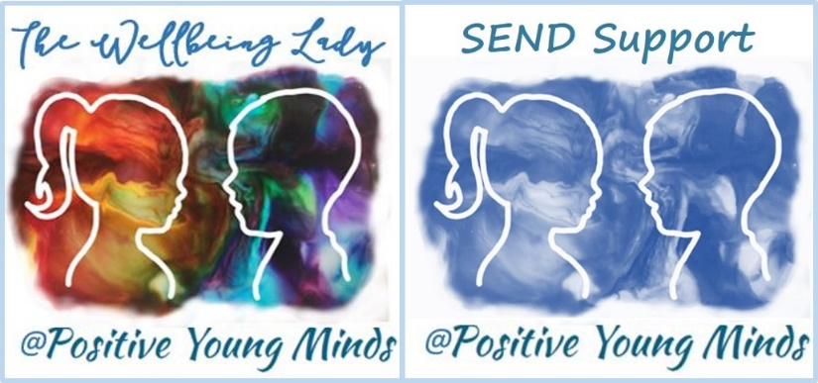

Lynn How
MA NASENCO NPQH
Educational Consultant

Find me at:
www.positiveyoungmind.com
Email: positiveyoungminds@outlook.com
@Positive_Y_Mind (Twitter)
Positive_young_minds (Instagram)
www.facebook.com/PositiveYoungMind
…. and for free teacher support
www.facebook.com/groups/coachingforteacherwellbeing

… also like and subscribe to my YouTube (example clips above)
https://www.youtube.com/channel/UC9egtRvu5XTiwKPPqLQ-VgQ

Support options include:
- Life, career and everything coaching.
- Bespoke school wellbeing packages.
- Bespoke SEND support and training for schools teachers and parents
Please refer to my website for details:
https://positiveyoungmind.com/send-wellbeing-consultancy/

Or just PM me

