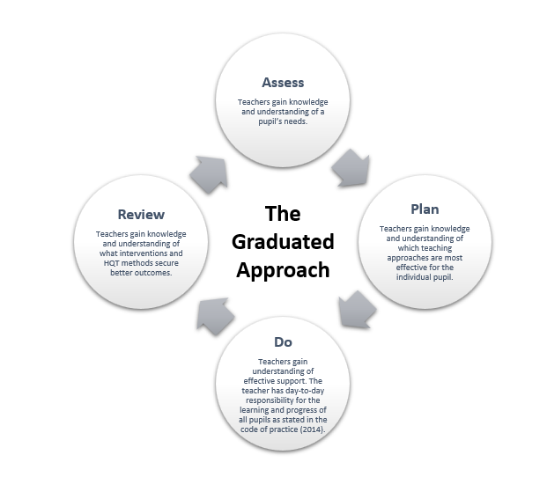
The Graduated Approach: the Assess-Plan-Do-Review cycle

