Chapter 2

- An index increases from 105 to 110. The change in the index is:
  - 5 points
  - 4.75 points
  - 110 points
- The Laspeyres' index uses:
  - Base year weights
  - Current year weights
  - Average expenditure as weights
- It has been decided to change the base of an index from 2008 to 2015. If the index in 2015 is 148, what would the index in 2008 become after the change?
  - 100
  - 32.4
  - 67.6
  - 148
- The CPI in November 2012 was 124.4 and by November 2014 it was 128.2. This represents a rise in the price of goods by:
  - 3.8%
  - 3.05%
  - 2.96%
  - 128.2%
- The turnover by a company in 2012 was £54.5m and in 2014 it was £75m. If the CPI has increased from 123 in 2012 to 128 by 2014, the real change in the turnover has been:
  - £20.5m
  - £16m
  - £18.1m
  - £17.6m
- If the price index for bananas was 100 in 2015 and that for apples was 110, then the price of a pound of bananas was:
  - Less than for apples
  - More than for apples
  - Impossible to compare with apples
- The CPI and RPI for January 2010 are 112.4 and 217.9 respectively. In January 2011 these two indices have become 116.9 and 229.0. The difference in the rate of inflation given by these two indices are:
  - 4.00
  - 1.1%
  - 5.1%
  - Can’t compare as they are different indices
- From the following table the Paasche's price index for 2000 using 1999 as the base is found by calculating:
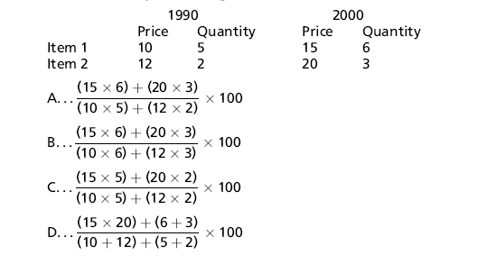
  - A
  - B
  - C
  - D

Chapter 3

- A sample which is chosen such that every member of the population has an equal chance of being selected is called:
  - a systematic sample
  - a simple random sample
  - a cluster sample
- A correct statement about quota sampling is that:
  - quota sampling requires random sampling within each quota
  - quota sampling does not involve any clustering
  - quota sampling involves some sort of stratification
  - quota sampling is generally cheaper and more reliable than simple random sampling
- Raffles are an example of:
  - simple random sampling
  - stratified sampling
  - systematic sampling
- The most expensive method of collecting data is:
  - postal questionnaires
  - telephone interviewing
  - face-to-face interviewing
- Multi-stage sampling is used when:
  - a sampling frame is unavailable
  - the population is geographically spread out
  - the population is very large

6. A correct statement about Cluster sampling is

- Is a probabilistic sampling method
- Requires a sampling frame
C. Does not require a sample frame

Chapter 4

- If a researcher is collecting information on the number of company cars owned each year by a company, what type of data is she or he collecting?
  - Interval data
  - Discrete data
  - Ratio data
  - Ordinal data
  - Nominal data
- Which of the following graphical methods would be most suitable to illustrate the occupations of 50 female adults?
  - Line graph
  - Pie chart
  - Histogram
  - Component bar chart
- Which of the following is a true statement when applied to a cumulative frequency curve (ogive)?
  - Mid points are plotted against cumulative frequencies.
  - Upper class boundaries are plotted against cumulative frequencies.
  - Lower class boundaries are plotted against cumulative frequencies.
  - Mid points are plotted against frequencies.
- The graph of a cumulative frequency distribution is called:
  - a line graph
  - a histogram
  - an ogive
- The difference between a histogram and a bar chart is:
  - A histogram represents the frequency, whereas a bar chart represents the number.
  - With a histogram, areas represent frequencies, whereas with a bar chart, heights represent frequencies.
  - Histograms are used for comparing categorical data.
- Nominal data is data that:
  - is obtained by measurement
  - is obtained by counting
  - does not have a numerical value
- A multiple bar chart is used to compare:
  - totals
  - changes to components
  - grouped data
- A frequency polygon is used in conjunction with a:
  - simple bar chart
  - component bar chart
  - multiple bar chart
  - histogram
- A frequency distribution that has its peak to the left is called:
  - left skewed
  - symmetrical
  - right skewed

Chapter 5
- Questions 1-8 refer to the series 3, 1, 4, 2, 3 represented by x
The value of 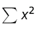is:
  - 39
  - 390
  - 1521
- Questions 1-8 refer to the series 3, 1, 4, 2, 3 represented by x
The value of 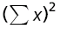is:
  - 1521
  - 39
  - 169
- Questions 1-8 refer to the series 3, 1, 4, 2, 3 represented by x
The MEAN of the series is:
  - 2.6
  - 3.0
  - 20.6
- Questions 1-8 refer to the series 3, 1, 4, 2, 3 represented by x
The MEDIAN of the series is:
  - 2.6
  - 3.0
  - 20.6
- Questions 1-8 refer to the series 3, 1, 4, 2, 3 represented by x
The RANGE of the series is:
  - 3
  - 5
  - 8
- Questions 1-8 refer to the series 3, 1, 4, 2, 3 represented by x
The STANDARD DEVIATION (using n-1) of the sample to one decimal place is:
  - 3.0
  - 1.1
  - 2.6
- Questions 1-8 refer to the series 3, 1, 4, 2, 3 represented by x
The COEFFICIENT OF VARIATION (to 1 decimal place) is:
  - 27.6%
  - 362.4%
  - 43.9%
- Questions 1-8 refer to the series 3, 1, 4, 2, 3 represented by x
If the number 10 is added to each value of x, the STANDARD DEVIATION of the series is:
  - 3.0
  - 1.1
  - 2.6
  - 2.0
- If a distribution has a positive (right) skew, and one mode, then
  - the Mode is greater than the Mean
  - the Mean is less than the Median
  - Median Mode
  - the Mean is greater than the Mode
- What is the approximate value of the interquartile range from the following box plot?
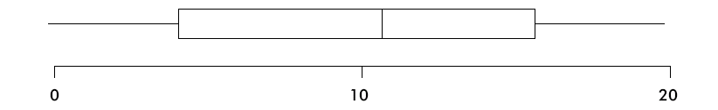
  - 12
  - 19
  - 3
  - 5
- The following data are for use in Questions 11-13:
The commission earned by 6 employees in a particular week was as follows:
£50 £120 £25 £80 £25 £175
The mean value of commission to 2 decimal places is:
  - £65.00
  - £80.00
  - £52.50
  - £25.00
  - £79.17
- The following data are for use in Questions 11-13:
The commission earned by 6 employees in a particular week was as follows:
£50 £120 £25 £80 £25 £175
The standard deviation (using n - 1) to 2 decimal places is:
  - £150.00
  - £125.00
  - £54.12
  - £59.28
  - £6.00
- The following data are for use in Questions 11-13:
The commission earned by 6 employees in a particular week was as follows:
£50 £120 £25 £80 £25 £175
The median is
  - £65
  - £52.50
  - £80
  - £50
- 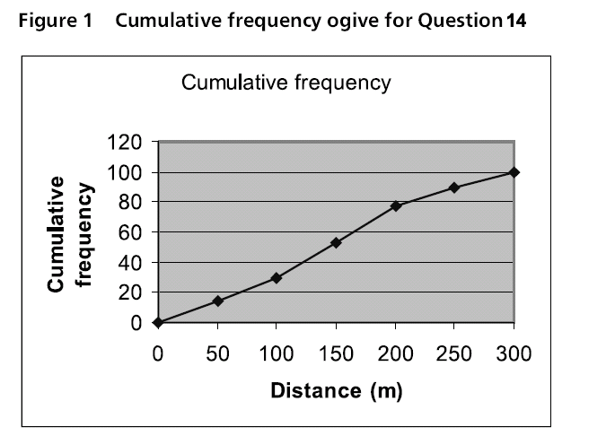
Figure 1 represents the distribution of distance travelled to work per week, for 100 workers.
Which of the following statements is true?
  - Approximately 40 workers travel 126 miles
  - Approximately 77 workers travel more than 200 miles
  - Approximately 100 workers travel at least 29 miles
  - Approximately 29 workers travel less than 100 miles
- 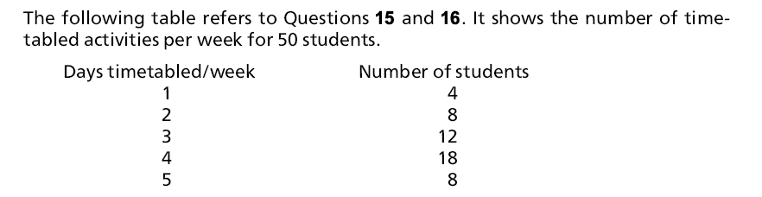
The mean number of days timetabled/week is:
  - 3.36
  - 10
  - 1.16
  - 3
- The standard deviation (using n- 1) for the number of days timetabled/week is:
  - 3.36
  - 10
  - 1.16
  - 3

Chapter 6
- P(B | A) means:
  - The probability of B divided by the probability of A
  - The probability of B given that A has occurred
  - The probability of A given that B has occurred
  - The probability of A times B
- If P(A) = P(A | B), the events A and B are
  - Mutually exclusive
  - Mutually exhaustive
  - Statistically independent
- If three coins are tossed, the probability of exactly one head occurring is:
  - 3/8
  - 2/3
  - 1/8
  - 1/4
- If two events, A and B, are statistically independent, the occurrence of A implies that the probability of B occurring will be:
  - 0
  - unchanged
  - 1
  - unknown
- If a fair coin is tossed 9 times and a head is obtained on each toss, the probability that the next toss of the coin will produce a tail is:
  - 0
  - 0.5
  - 1.0
  - less than 0.5
  - more than 0.5
- The probability that the 1600 train from Bristol Parkway station to Paddington is late is 0.6. The probability that the train will be late on at least one of the next two days is:
  - 0.36
  - 1.20
  - 0.84
  - 0.6
- Below are the results of a survey of 100 companies.
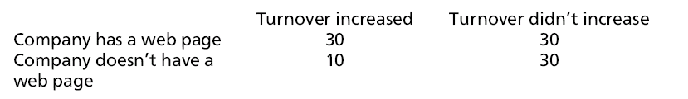
What is the probability that a company showed an increase in turnover given that they have a web page?
  - 30/100
  - 30/40
  - 40/60
  - 30/60
- Out of a group of 20 students there are 3 who play a musical instrument. Two students are picked at random. The probability that both students play a musical instrument is:
  - 6/380
  - 6/400
  - 9/400
  - 9/380
- If the prior probability is 0.4 and the corresponding conditional probability is 0.3, then the joint probability is:
  - 0.4
  - 0.3
  - 0.7
  - 0.12

Chapter 7

- The mean of a binomial process with the number of trials being 20 and the probability of success being 0.05 is
  - 0.05
  - 20
  - 1.0
- A binomial distribution with a p value of 0.4 and n of 20
  - can be approximated by the Poisson distribution
  - can be approximated by the normal distribution
  - cannot be approximated by either distribution
- A Poisson distribution with a mean of 16 has standard deviation of
  - 4
  - 16
  - 256
- The standard normal distribution has a mean of
  - 0
  - 1
  - 1.5
- The normal distribution is applicable to
  - discrete data
  - continuous data
  - ordinal data
- The weights of packets of biscuits is normal with a mean of 400 g and a standard deviation of 10 g. A packet was selected at random and found to weigh 420 g. How many standard deviations away from the mean does this weight represent?
  - 10
  - 1
  - 2
  - 20
- What proportion (approximately) of a normal distribution is covered by ±2 standard deviations?
  - 50%
  - 95%
  - 99%
- Questions 8 and 9 refer to the distribution of the weight of packets of biscuits. The weights follow a normal distribution with a mean of 400 g and a standard deviation of 10 g.
The probability that a packet chosen at random would weigh more than 425 g is:
  - 0.0668
  - 0.1587
  - 0.9938
  - 0.0062
- 2.5% of packets weigh less than a certain amount. This weight is:
  - 419.6 g
  - 402.5 g
  - 380.4 g
  - 350.0 g

Chapter 8
- Questions 1 to 4 refer to the sample 34.5, 25.7, 20.1, 38.9, 33.0, 33.2, 22.8 and 30.5,
denoted by x. This sample was taken from a large population denoted by P.
The mean of x (to 2 decimal places) is:
  - 25.26
  - 29.84
  - 39.55
- The standard deviation of x (to 2 decimal places) is:
  - 6.40
  - 5.99
  - 25.26
- The best estimate of the standard deviation of P is:
  - 5.99
  - 6.40
  - 25.26
- The value of SEM is:
  - 2.26
  - 2.12
  - 5.99
- The sampling distribution of the means follows:
  - a uniform distribution
  - a normal distribution
  - an empirical distribution
  - a t-distribution
- The standard deviation of the sampling distribution of the means is called:
  - SEM
  - SEP

- The standard deviation of the sampling distribution of a percentage is called:
  - SEM
  - SEP
- Questions 8 and 9 refer to a sample of 50 credit card holders who were questioned about how much they owed on all credit cards held. The average amount owed by all 50 people was £1300 with a standard deviation of £460. It can be assumed that this is representative of all credit card holders.
The 95% confidence interval is given by:
  - 1300 ±1:96 x 65:05
  - 1300 ±1:96 x 460
  - 1300 ±1:96 x 9:2
  - 1300 ±1:96 x 50
- 20% of the 50 people questioned had more than 3 credit cards. The 95% confidence interval of the percentage of all credit card holders who had more than 3 credit cards can be found from:
  - 20 ±1:96 x 4:47
  - 20 ±1:96 x 7:07
  - 20 ±1:96 x 3
  - 20 ±1:96 x 5:66
- To reduce the width of a confidence interval (that is, the difference between the upper and lower bounds) you would:
  - Increase the size of the sample
  - Decrease the size of the sample
  - Use a larger confidence level instead
  - Not possible
- As part of a quality control system, a simple random sample of 100 units was taken from a large batch of production and tested. Ten units were found to be faulty. Therefore the 95% confidence limits for the overall percentage of faulty items in the batch will be closest to 10% plus or minus:
  - 1%
  - 2%
  - 3%
  - 6%

Chapter 9

- The alternative hypothesis for a one tailed test can be of the form:
- The degrees of freedom for a t-test of a mean if the sample size is 10 is:
  - 10
  - 9
  - 11
- The degrees of freedom for a contingency table of size 2 by 5 is:
  - 10
  - 7
  - 4
  - 3
- Expected values in a contingency table should be:
  - greater than 5
  - less than 5
  - greater than 30
- The critical region is in:
  - The tails of a distribution
  - The middle of a distribution
  - Either the middle or the tails of a distribution
- The chi-square distribution is:
  - Symmetrical about a mean value
  - Right skewed
  - Left skewed
- If a significance level of 1% is used rather than 5%, the null hypothesis is:
  - More likely to be rejected
  - Less likely to be rejected
  - Just as likely to be rejected
- You want to find out if there are likely to be more car accidents on certain days of the week. You record the number of accidents on a given stretch of road over a long period of time and summarise the results by total number of accidents for each day of the week. What statistical test would you use to answer your question?
  - Z-test of a mean
  - Z-test of a proportion
  - Paired t-test
  - Chi-square `goodness of fit' test
  - Chi-square test of association
- Questions 9 to 11 refer to a manufacturer of fruit juices. Rumour has reached the Trading Standards Officer that the manufacturer is deliberately under filling his cartons of orange juice. It is decided that a sample should be taken to check this claim. The stated contents on the carton are 100 ml.
The null hypothesis is:
  - The mean is 100 ml
  - The mean is greater than 100 ml
  - The mean is less than 100 ml
  - The mean is not 100 ml
- The alternative hypothesis is:
  - The mean is 100 ml
  - The mean is greater than 100 ml
  - The mean is less than 100 ml
  - The mean is not 100 ml
- A sample of 36 cartons is measured and they are found to have a mean of 99 ml and a standard deviation of 6 ml. The test statistic is found from:
  - 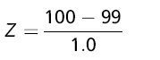
  - 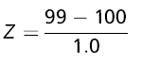
  - 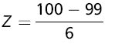
  - 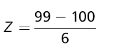
- Which of the following statements is true concerning the chi-square test of association?
  - The table must contain percentages
  - The expected values must all be the same
  - All the expected values must be at least 5
  - The expected values must be whole numbers
- Under what conditions would you use the paired t-test?
  - When there is a single sample of data
  - When the two samples of data are independent
  - When the two samples of data are not independent
  - When there are two proportions
- As part of a quality control system, a simple random sample of 10 units was taken from a large batch of production and tested to see if the mean weight had changed from the expected 10 g. The test you would use under these circumstances would be the:
  - Z-test of a proportion
  - t-test of a mean
  - Paired t-test
  - Chi-square `goodness of fit' test
  - Chi-square test of association
- Data has been obtained on the amount of alcohol consumed in a week by people of different ages. Consumption has been categorised as low, moderate or high. The test you would use to discover if there were any association between age and consumption is the:
  - Z-test of a mean
  - Z-test of a proportion
  - Paired t-test
  - Chi-square `goodness of fit' test
  - Chi-square test of association

Chapter 10

- If the increase in one variable causes an increase in the another variable, the form of the correlation between the variables must be:
  - positive
  - negative
  - perfect
- The dependent variable is plotted on the:
  - x-axis
  - y-axis
  - either axis
- If the value of r is 0.8, then the coefficient of determination is:
  - 0.8
  - 64%
  - 80
- If pairs of bivariate data all have equal rank, then Spearman's rank correlation coefficient must be:
  - 0
  - +1
  - -1
- If Spearman's rank correlation coefficient is -1 for a set of numerate bivariate data, then Pearson's product moment correlation coefficient for the same data must be:
  - +1
  - -1
  - 0
  - between 0 and 1
  - between 0 and -1
- If the coefficient b in the linear regression model is zero, then the correlation between the two variables must be:
  - 1
  - -1
  - 0
- If the p-value for the slope of a regression equation is 0.02 then
A H₀ cannot be rejected
B H₀ can be rejected
C Not possible to tell

- For multiple regression the independent variables should be
A correlated with each other
B not correlated with each other
C have a negative correlation with each other

Chapter 11
- 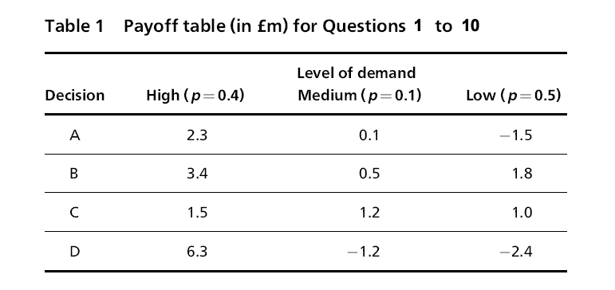
The maximax decision is ..........
  - A
  - B
  - C
  - D
- The maximin decision is
  - A
  - B
  - C
  - D
- The minimax regret decision is
  - A
  - B
  - C
  - D
- The decision using the Hurwicz criterion using an alpha of 0.7 is
  - A
  - B
  - C
  - D
- The decision using the EMV criterion is
  - A
  - B
  - C
  - D
- The decision using the EOL criterion is
  - A
  - B
  - C
  - D
- The value of perfect information (EVPI) is
  - 3.54
  - 2.31
  - 1.23
  - 0.18
- A decision-maker who is risk-averse would choose option
  - A
  - B
  - C
  - D
- A decision-maker who is a risk-seeker would choose option
  - A
  - B
  - C
  - D
- A decision-maker who is risk-neutral would choose option
  - A
  - B
  - C
  - D

Chapter 12

- If the average profits over the life of a project were £50 000 and the initial investment was £300 000, the ARR is:
  - 50%
  - 16.67%
  - 0.1667
  - 30%
- An investment of £10 000 is made at an interest rate of 5%. If all interest is re-invested the principal at the end of 10 years (to the nearest £) is:
  - £16 289
  - £162 890
  - £15 000
- The discount factor for a period of 5 years at a discount rate of 6.5% is:
  - 0.7299
  - -0.7299
  - 0.7282
  - 1.7299
- 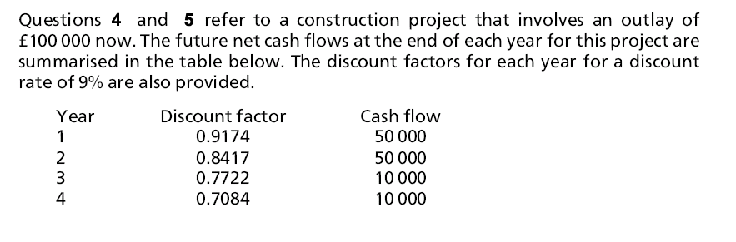
The payback period for the project is:
  - 1 year
  - 2 years
  - 3 years
  - 4 years
- The net present value (NPV) for the project is found by
  - Adding up the cash flow figures for all 4 years and subtracting £100 000
  - Adding up the discount factors for all 4 years and multiplying by the sum of the cash flows and subtracting £100 000
  - Calculating the present value of each cash flow, adding up these present values for all 4 years and subtracting £100 000
  - Finding the average profit, and then dividing by the initial capital
- Internal rate of return (IRR) refers to:
  - The discount rate that makes two NPVs the same
  - The discount rate that makes the NPV zero
  - The discount rate that makes the NPV negative
  - The largest NPV from a choice of projects
- 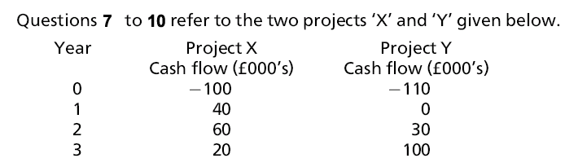
The payback period for Project X is:
  - 1 year
  - 2 years
  - 4 years
- On the basis of ARR the most profitable project is:
  - Project X
  - Project Y
  - No difference
- The NPV for Project Y at a discount rate of 9% is:
  - £20 000
  - -£7531
  - £10 000
- On the basis of IRR the most profitable project is:
  - Project X
  - Project Y
  - No difference
- A sinking fund allows you to calculate:
  - The present value of a series of future sums of money
  - The future sum of a series of cash flows
  - The annual instalment necessary to create a sum of money in the future
  - The constant payment that will pay off a loan taken out now
- The payments to pay off a mortgage is an example of
  - Depreciation of an asset
  - A sinking fund
  - Constant repayments
  - Continuous compounding
- An investment account paying 6% p.a. interest, compounded continuously, is opened with £1000. The amount in the account at the end of the year is nearest to:
  - £1060
  - £1061
  - £1062
  - £1063

Chapter 13

- A time series is made up of monthly data. The moving average is likely to be calculated using:
  - A 5-point moving average
  - A 10-point moving average
  - A 12-point moving average
- The sum of additive seasonal differences should be:
  - 0
  - 1
  - depends on the data
- Exponential smoothing allows a forecast for:
  - The next time period
  - The next two time periods
  - A full cycle ahead
- Three of the seasonal factors for a time series based on a quarterly cycle are 89%, 130%, and 75%. The fourth factor is:
  - 94%
  - 106%
  - 100%
- The seasonal difference for period 1 of a time series is 25.5. The next period 1 has a value of 185. The seasonally adjusted value for this period is:
  - 159.5
  - 210.5
  - 47.175
- The errors using a particular time series are: 2.5, -3.6, 5.8, 10.1, -6.3, -2.2, 10.2, -15.0, 0.3, -1.8. The MAD statistic for this data is:
  - 57.8
  - 5.78
  - 0.578
- The MSE statistic using the errors in Question 6 is:
  - 53.176
  - 5.3176
  - 531.76
- The sum of quarterly seasonal factors should be:
  - 4
  - 1
  - 0

Chapter 14

- The line y = 7x has a gradient of:
  - 1
  - 7
  - 0
- The line y + 3x = 9 passes through the point:
  - (0,9)
  - (9,0)
  - (0,3)
- To solve an LP model graphically it is best if the scales on each axes:
  - Are the same
  - Are different
  - Both start at zero
- A tight constraint will have a shadow price of:
  - Zero
  - More than zero
  - The value of the right hand side of the constraint
- The solution to a LP problem
  - Will be integers
  - Can be fractional values
  - Can have negative values
- The solution to a LP problem
  - Must be outside the feasible region
  - Must be on the boundaries of the feasible region
  - Must be inside the feasible region
- If in a maximisation problem, you increase the value of the RHS of a tight constraint by 1:
  - The objective function increases by 1
  - The objective function increases by the shadow price of that constraint.
  - Not possible to tell
- In a transportation algorithm:
  - The number of sources must equal the number of destinations
  - The number of sources must be greater than the number of destinations
  - A dummy source/destination is used if number of sources is not equal to number of destinations

Chapter 15

- A Gantt chart is used to:
  - Show how activities are related
  - Show when activities take place
  - Enable the critical path to be evaluated
  - Show resources used over time
- A resource histogram is used to:
  - Show how activities are related
  - Show when activities take place
  - Enable the critical path to be evaluated
  - Show resources used over time
- Crashing is the term used when:
  - The project time has to be reduced at minimum extra cost.
  - Insufficient resources are available for the project to be completed on time.
  - The cost of a project has to be reduced.
- If the EST and LST of an activity are 12 and 14 respectively, the float for this activity is:
  - zero
  - 2
  - 26
- If the optimistic time for the duration of an activity is 12 minutes and the pessimistic time is 20 minutes then the variance is
A 1.33
B 1.78
C 10.67

- An activity that has a float of zero means that
  - It can be ignored as it has no affect on the project time
  - Any delay in this activity means that the project is delayed
  - The activity is not critical
- If all activities are critical it means that:
  - Activities can be delayed by one unit of time without delaying the project
  - There is more than one critical path
  - A mistake has been made

Chapter 16

- If the order cost is £10 per order, then the total order cost if 5 orders are made per year is:
  - £10
  - £50
  - £15
- The minimum total costs occur when:
  - The order cost and holding cost are equal.
  - The order cost is at a minimum.
  - The holding cost is at a minimum.
- If the cost of holding stock is £5 per unit p.a., then the holding cost p.a. for an order quantity of 100 is:
  - £500
  - £5
  - £250
- If a buffer stock is used it is necessary to assume that the demand during the lead time is:
  - Constant
  - Normally distributed
  - Known
- If standard deviation of demand is 5 units per week, then the standard deviation during the lead time of 3 weeks is:
  - 15
  - 8.66
  - 75
- A buffer stock of 200 units is held. If the cost of holding one unit in stock for a year is £5, the holding cost (p.a.) of the buffer stock will be:
  - £1000
  - £500
  - £5

