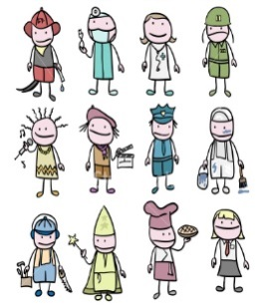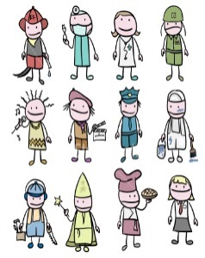Empleos / Jobs

Nombre:________________________

|  |  |  |  |
| --- | --- | --- | --- |
| **Spanish** | **English** | **Clue** | **Test** |
| abogado |  |  |  |
| albañil |  |  |  |
| azafata |  |  |  |
| amo de casa |  |  |  |
| bombero |  |  |  |
| cajero |  |  |  |
| camarero |  |  |  |
| camionero |  |  |  |
| carnicero |  |  |  |
| carpintero |  |  |  |
| cartero |  |  |  |
| cocinero |  |  |  |
| contable |  |  |  |
| dentista |  |  |  |
| dependiente |  |  |  |
| electricista |  |  |  |
| enfermero |  |  |  |
| escritor |  |  |  |
| granjero |  |  |  |
| hombre de negocios |  |  |  |
| ingeniero |  |  |  |
| jardinero |  |  |  |
| jefe |  |  |  |
| mecánico |  |  |  |
| médico |  |  |  |
| militar |  |  |  |
| panadero |  |  |  |
| peluquero |  |  |  |
| periodista |  |  |  |
| pintor |  |  |  |
| policía |  |  |  |
| recepcionista |  |  |  |
| secretario |  |  |  |
| traductor |  |  |  |
| veterinario |  |  |  |



**Finding this lesson difficult? You might just need a bit more practice.**

SCAN ME ☺

**Remember all of this vocabulary is on Memrise.**

**Extension:** ‘Trabajar’ means ‘to work’. In your grammar book, write out this verb in full for the present, imperfect, future + conditional tense. Use the Independent Learning Folder to help you with this.

100 Ideas for Secondary Teachers: Outstanding MFL Lessons © Dannielle Warren, 2019