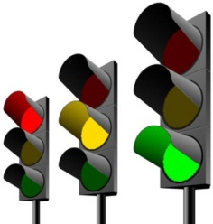

A f L

How did they/you

Assess progress?



Pupil Outcomes…

Worked/  
Didn’t work because …

Differentiation



What learning experiences worked?

How did the pupils know their starting points?





STARTER……

Objectives met?

The 5 Minute Lesson Evaluation