**Stickability** is a term used within the notable [5 Minute Lesson Plan](http://teachertoolkit.me/the-5-minute-lesson-plan/" \o "The 5 Minute Lesson Plan" \t "_blank).

I have decided to write a short post, based on the demand for clarification.

http://teachertoolkitdotme.wordpress.com/wp-includes/js/tinymce/plugins/wordpress/img/trans.gif

**Definition:**

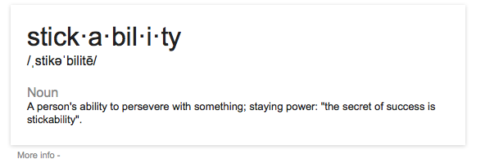

What is 'stickability'?

So, that's the definition (above quote). **Staying power!**

**Do your lessons have 'staying power?'**

(or preferably, 'sticking power'?)

[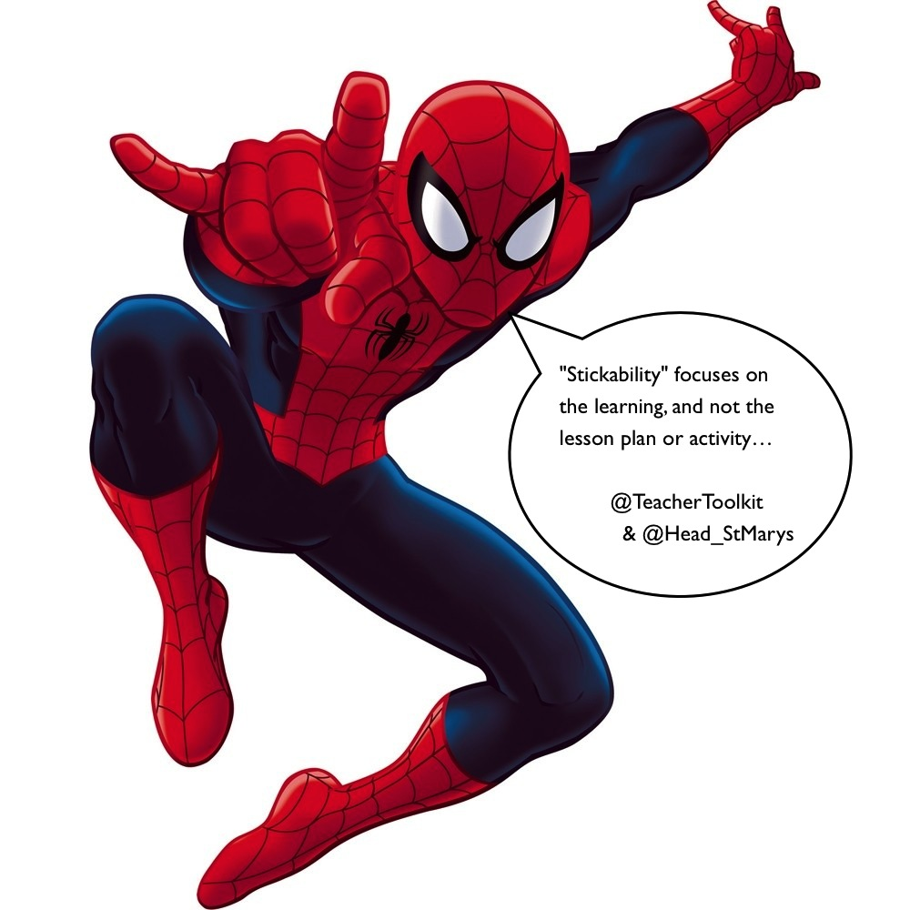](http://www.tes.co.uk/teaching-resource/The-5-Minute-Lesson-Plan-by-TeacherToolkit-6170564/http://)

**Do your lessons have 'sticking power?'**

Regardless of all the other content written within [The 5 Minute Lesson Plan](http://www.tes.co.uk/teaching-resource/The-5-Minute-Lesson-Plan-by-TeacherToolkit-6170564/" \o "The original " \t "_blank), 'Stickability' is fundamentally what learning and lesson planning should be all about. With relation to lesson planning, it can be defined as the following:

1. What is the fundamental aspect of the lesson, you need students to learn?
2. What key skill, knowledge or understanding, should students grasp?
3. What should students leave your classroom knowing/understanding?
4. What should students return to class knowing/understanding?
5. Why should this 'stick' with students?
6. How will you make it stick?

**And questions to ask yourself (the following lesson)?**

1. How will you know that it has stuck?
2. And if students become unstuck, then what?
3. How and when should you focus on 'sticking' learning?

**Twitter-collaboration:**

I would like to quote a Twitter-colleague [Stephen Tierney](https://twitter.com/Head_stmarys" \o "Stephen Tierney" \t "_blank), Headteacher of [St. Mary's Catholic College](http://www.st-mary.blackpool.sch.uk/" \o "St Mary's Catholic College" \t "_blank) in Blackpool. We have formed an excellent dialogue via Twitter and are now co-collaborating on producing teaching and learning resources for the schools we both work in. This is exciting news in itself, never mind the exciting projects we are working on!

[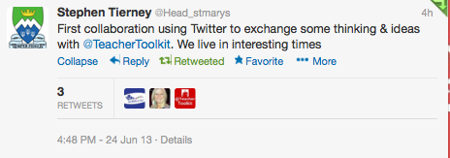](https://twitter.com/Head_stmarys/statuses/349192269812875266)

Developments via Twitter

I make reference to [@Head\_StMarys](https://twitter.com/Head_stmarys" \o "@Head_StMarys" \t "_blank) and a photo-quote - shown below - due to the following lesson planning structure Stephen has shared:

[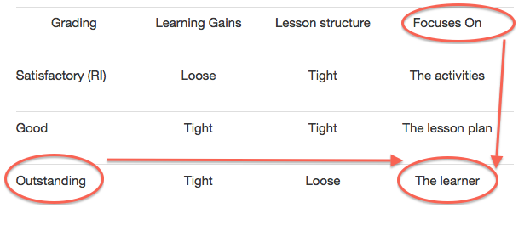](http://headstmary.wordpress.com/2013/06/15/consistently-good-to-outstanding/)

'Outstanding' teaching focuses on 'the learning' and not the planning, or activities.

This was produced [here](http://headstmary.wordpress.com/2013/06/15/consistently-good-to-outstanding/" \o "Consistently Good to Outstanding" \t "_blank), in a response to my popular [Good in Ten](http://teachertoolkit.me/2013/06/07/goodinten-requires-improvement-cpd-programme-by-teachertoolkit-sltchat/" \o "#GoodinTen – Requires Improvement CPD programme, by @TeacherToolkit #SLTchat" \t "_blank) (Requires Improvement) CPD programme for teaching and learning. A model that can be applied in all schools. You can read more of his fantastic work on his blog here: [http://headstmary.wordpress.com](http://headstmary.wordpress.com/" \o "http://headstmary.wordpress.com/" \t "_blank)

The learning and lesson-planning model is a gem!

**It is all about 'stickability'. Why?**

As Stephen has rightly highlighted, that all 'Outstanding' lessons focus on 'the learning' and not 'the activity'. Where, learning gains are tight, the lesson plan can remain loose and adaptable. In lessons that are judged 'Good' or not, the planning and learning are more rigid (or tight) and have more emphasis on the lesson plan or activities. This is the golden nugget for outstanding teaching.

- - -

**Plan you lessons based on learning - not the activity or lesson plan!**

- - -

Stickability fundamentally asks the teacher (the person planning the lesson) to indicate 'what should stick?" This is ultimately 'the learning' sequence planned for the learners (the students) and I hope clarifies for the reader, the terminology used in [The 5 Minute Lesson Plan](http://www.tes.co.uk/teaching-resource/The-5-Minute-Lesson-Plan-by-TeacherToolkit-6170564/" \o "5 Minute Lesson Plan " \t "_blank) and subject title. Good luck!

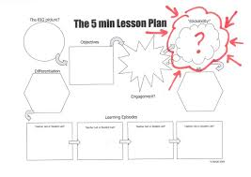

It's all about Stickability!

**Further reading:**

What to get started on 'outstanding' teaching and lesson planning? All you need to know is [here](http://teachertoolkit.me/the-5-minute-lesson-plan/" \o "The 5 Minute Plan" \t "_blank).

Video highlighting 'Stickability':

<http://youtu.be/HPPkwfLbzkM?t=45s>

Written by @TeacherToolkit

<http://teachertoolkit.me/2013/06/24/so-what-is-stickability-by-teachertoolkit-head_stmarys/#more-3890>

Ross Morrison McGill