 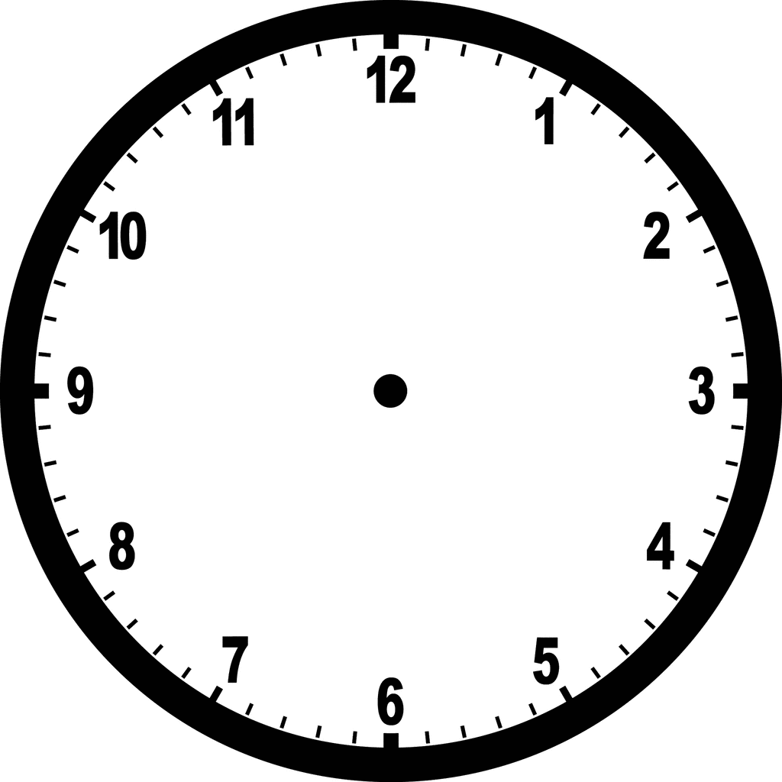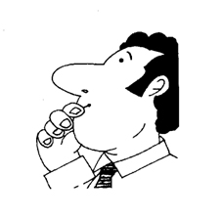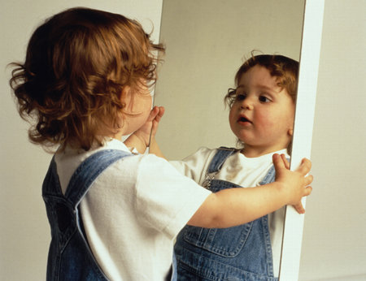

With/Without music? Which door?

Sombre or pleasing?

Resources needed?

R.M.McGill 2013 - [@TeacherToolkit](https://twitter.com/teachertoolkit)

The context/audience?

***… print and scribble your way to an assembly-plan with impact*!**

**ICT/Sound requirements?**

Who will set this up?

Plan B if equipment is not available?

Plan B if equipment doesn’t work?

Cause for celebration?

Entrance/Exit?

(Careers / Media)

Reflective Moments (along the way / including worship)…

Timings planner:

Real-life references?

Themes?

What should students take away?

Stick-ability!

The 5 Minute Assembly Plan

Audience Participation?