Primary Job Wheel
All jobs are editable. Print two copies of this sheet (in A3 colour works best). Cut out the outer circle on one, and the inner circle on the other. Write on the names of your class in the inner segments and then laminate both. Pin together on a board and rotate daily. For any technical help, please see me on Twitter @mrlockyer or email mr.lockyer@gmail.com
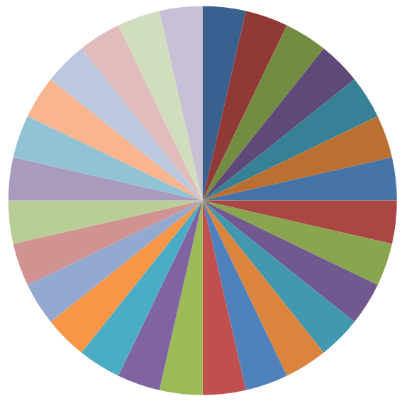
Music
M
Mugs
M
Playtime
M
Tissues
M
Library
M
Wet Play
M
Stickers
M
Lights
M
Windows
M
Bottles
M
Chairs
M
Desk
M
Scissors
M
Glue
M
Energy
M
Green
M
Box PM
M
Pegs
Pegs
Door B
Door T
Snacks
Box AM
Milk
Line T
Line L
Letters
Books

